MODULE
EQuIP for Science v3.0
10

Culminating
Task
Module 10: Culminating Task
Module 10 provides participants an opportunity to examine a lesson or unit specific to their grade, grade band, and/or science discipline. Participants also have a chance to reflect on this task as well as the overall professional learning encompassed by the ten modules.
Materials Needed
- Module 10 PowerPoint slides or slides 190–199 of the full PowerPoint
- Locally-developed or identified lessons and units for participants to examine
- Handout 11: Module 10, “Culminating Task Debrief Questions”
- Additional copies of Handout 7: Module 4, “EQuIP Rubric, Version 3.0”* or a computer or tablet with the electronic version of the rubric (At least one person per table should record their group’s findings electronically.)

*Introduced in a previous module.
Introduction to Module 10
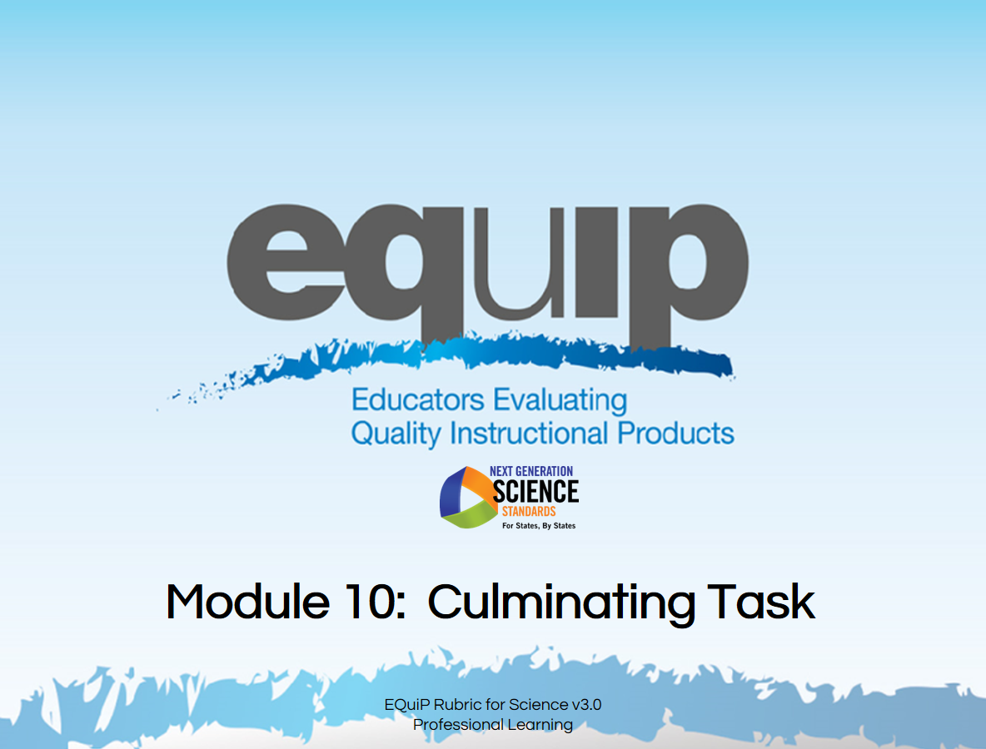
Slide 190
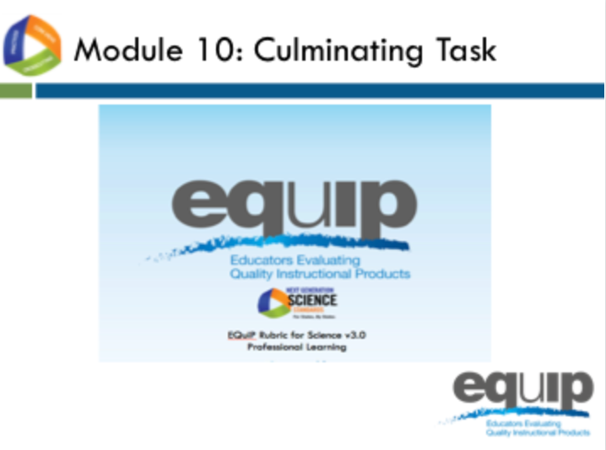
Slide 191
Talking Points
- We’re now ready for the culminating task where you will apply all of the learning from the previous nine modules of this professional learning to examine instructional materials directly related to a specific grade, grade band, or science discipline.
- This is an opportunity for you as reviewers to examine locally-developed or identified instructional materials.

The Task
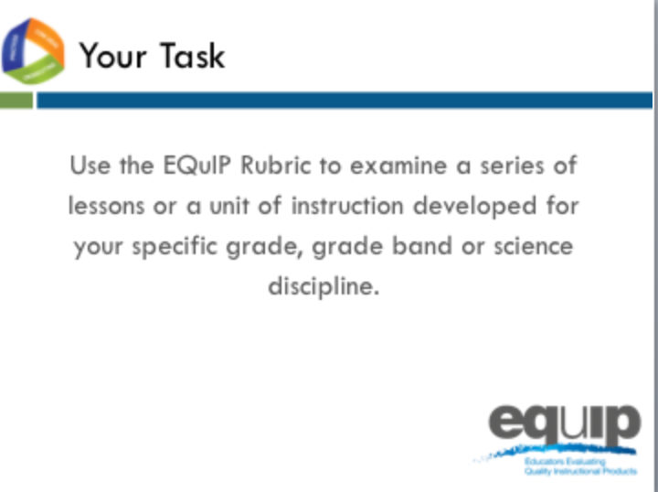
Slide 192
Talking Points
- For this task, each group has a different set of instructional materials to examine.
- In addition, you will need:
  - The EQuIP Rubric, specifically the response forms for Categories I, II, and III;
  - A computer loaded with an electronic version of the EQuIP Rubric to record group responses;
  - If available, a small projector to allow group members to view the group responses as they are recorded. A screen-sharing application could also be used.
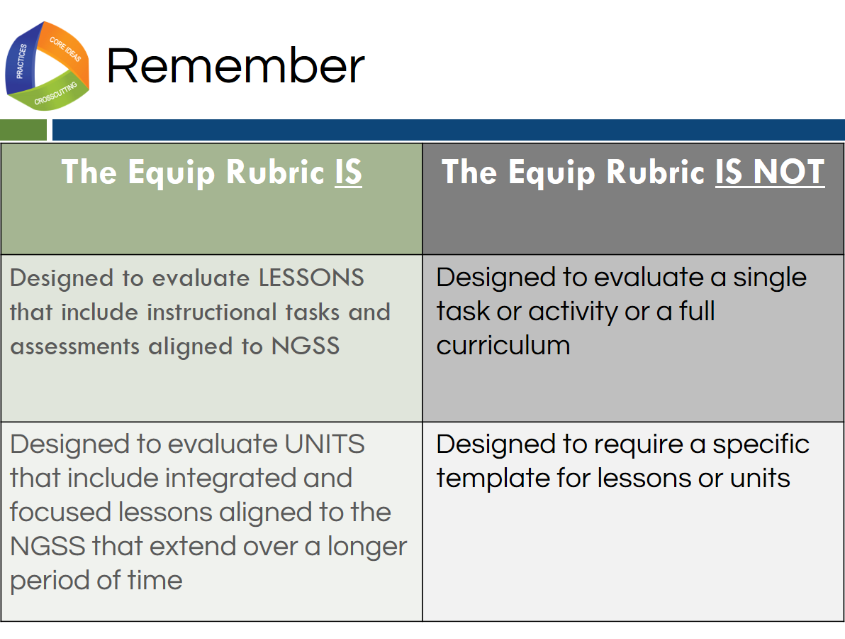
Slide 193
Talking Points
- Remember, as defined by the EQuIP Rubric:
!
  - A lesson is a coherent set of instructional activities and assessments aligned to the NGSS that may extend over a few to several class periods or days; and
  - A unit is a coherent set of lessons aligned to the NGSS that extend over a longer period of time.
- An integrated instructional sequence is rooted in an explanatory question aimed at making sense of a phenomenon and/or designing a solution to a problem.
- With these definitions in mind, it is important to note that the lessons the EQuIP Rubric is designed to evaluate may extend over a few to several class periods or days.
- Any single task, activity, or mini-lesson would not be suitable for use with the EQuIP Rubric as it would likely not include instructional supports and assessments, two of the categories of the rubric.
- Likewise, the EQuIP Rubric is not appropriate for reviewing a full curriculum; however, the rubric could be used to review specific lessons or units within the curriculum. A tool is available here http://www.nextgenscience.org/resources/peec-alignment-ngss-publishers-criteria to look at full curricula.
- Finally, the EQuIP Rubric does not require that lessons or units be put into a specific format in order to be evaluated against the rubric criteria.
!
- [Note to facilitator: If participants bring lessons or units that do not list the targeted performance expectations, take time to consider what performance expectations the lesson may be building toward.]
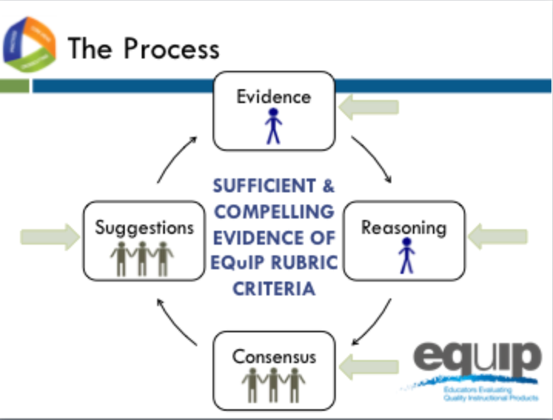
Slide 194
Talking Points
- Follow the same process you used during the previous practice sessions.
  - Individually, closely examine the materials through the lens of the criteria for the EQuIP Rubric and record this evidence on the response form. Use the Arabic and Roman numerals associated with the rubric criteria to code the evidence you locate.
  - Individually, use reasoning to connect the evidence you locate to the rubric criteria and record your reasoning on the response form.
  - As a group, share, discuss, and work collaboratively toward consensus as to whether there is sufficient clear and compelling evidence to say that the rubric criteria have been met, and assign evidence of quality ratings for each of the criteria as well as for each category.
  - As a group, provide suggestions for improvement on the response form.
  - Finally, transfer your team’s ratings from each category to the following chart and add the scores together for the overall score.
- Keep in mind that the comments you make on the response form will provide feedback, evaluation, and guidance for the developer(s) or user(s) of these instructional materials.
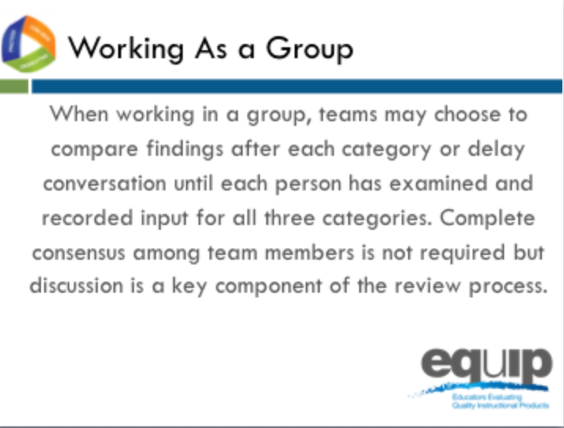
Slide 195
Talking Points
- For this culminating task you will be working through all three categories of the rubric with a lesson or unit specific to your group’s discipline and grade band.
- Prior to beginning, decide how your group would like to approach this task.
- You may elect to work through the process as a group one category at a time, or you may choose to work through all three categories individually before beginning your discussion as a group.
- Before you begin the group discussion, designate a recorder for your group.
- Your recorder should use an electronic version of the EQuIP Rubric response form to record your comments electronically.
- You also may find it helpful to designate other roles for members of your group. These roles might include:
  - One group member to monitor time,
  - One group member to facilitate the discussion, etc.
- [Note to facilitator: Pass out lessons and units if participants do not already have them.]
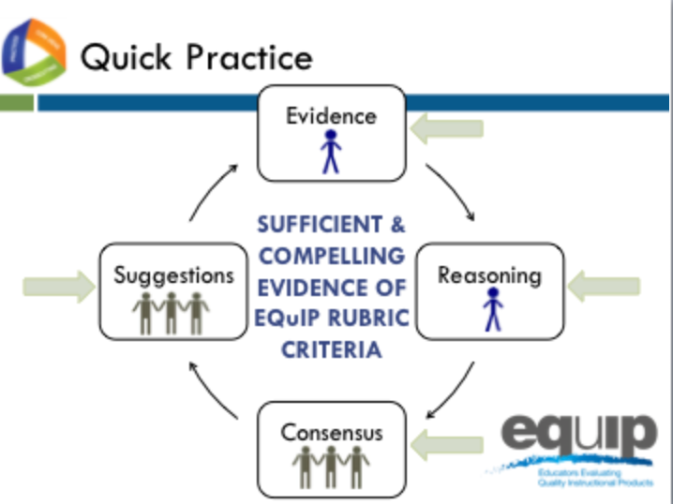
Slide 196
Talking Points
- Each group should now have a packet of instructional materials that includes copies of these materials for each member of your group.
- Here again is the examination process.
- Be thoughtful about your time. You have approximately two hours of relatively uninterrupted time to complete your examination. Pace yourself so you can make it through the entire rubric.
- Allow approximately one hour for Category I, 30 minutes for Category II, and 30 minutes for Category III.
- We’ll keep you posted periodically regarding how much time is remaining.
- Because you have a limited amount of time for this task, you may not be able to list all of the evidence that supports a criterion; rather, you may need to cite examples.
- If your examination does not take the full time allotted, you may begin responding to the debriefing questions for the training, which are located on Handout 11.
- Please remember that the comments you record on the response sheet will provide feedback, evaluation, and guidance for the developer(s) or user(s) of these instructional materials.
- [Notes to facilitator: 1) Leave this slide up and set a separate timer or alarm. Provide frequent time updates to allow groups to monitor progress. Allow more or less time as needed to complete the task before moving on to the reflection. 2) If, as you monitor the progress of the groups, you notice common issues or places where multiple groups are having difficulty, briefly interrupt the process and address all the groups simultaneously to clarify or get groups back on track.]

Reflecting on the Culminating Task
Slide 197
Facilitator Notes
Refer participants to Handout 11, Module 10, “Culminating Task Debrief Questions.”
Talking Points
- So how did it go?
- Take a few minutes to reflect on your experience using the EQuIP Rubric for the culminating task.
- At your tables you should have a list of questions to discuss as you debrief on this culminating task. You have ten minutes to discuss these questions before we share our reflections. [Note to facilitator: Allow ten minutes.]
- Let’s share some of your thoughts. [Note to facilitator: Ask each set of questions separately, allow several tables to share, and then move on to the next set of questions.]
  - On a scale of one to four, to what extent did your group share a common language and understanding of EQuIP criteria as you reviewed this lesson? Why this rating?
  - Are there any criteria or evidence about which you disagreed? If so, did you disagree about what you considered evidence of a criterion, about whether the evidence was sufficient to meet a criterion, or about both?
  - What differences arose among your group members when checking criteria? How did you resolve those differences? What do you think caused those differences? Were there differences that remained unresolved? What were some of those unresolved differences?
  - Where in the review process did you experience the most difficulty or the greatest disagreements? What suggestions do you have regarding resolving differences among reviewers?
  - How did having collaborative discussions move individual group members or the group as a whole toward a decision?
Reflecting on this Professional Learning
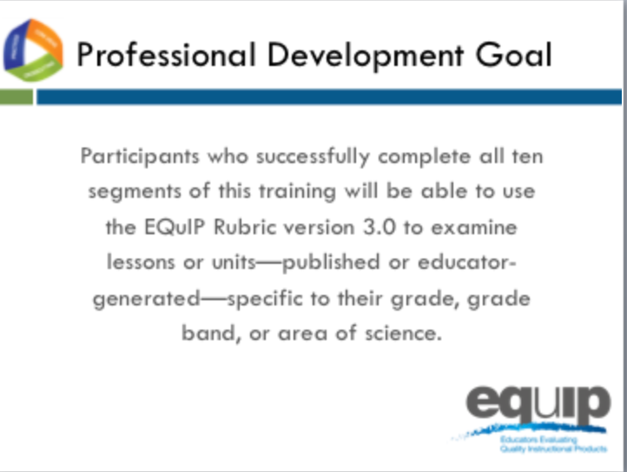
Slide 198
Talking Points
- Overall, what has been your experience with this professional learning?
- [Note to facilitator: Ask each of the questions below, one at a time, and allow groups/individuals to respond.]
  - What will be your next steps as a group?
  - How will you use this professional learning in your role/job/position?
    - What are your plans for using the EQuIP Rubric and the review process to examine instructional materials?
    - How will you use the EQuIP Rubric to inform the development of new instructional materials?
    - Will you be redelivering this professional learning to other science educators? If so, when and to whom?
    - How else might you use this professional learning?

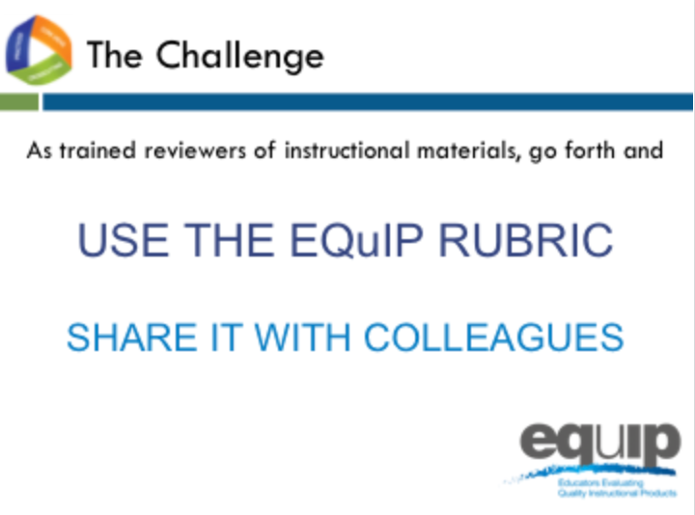
Slide 199
Talking Points
- As we conclude this training, we’d like to challenge each of you newly trained reviewers of instructional materials to:
  - [Note to facilitator: Click for animation.] Use the Equip Rubric to examine instructional materials for use with the NGSS; and
  - [Note to facilitator: Click for animation.] Share your knowledge and expertise in using the EQuIP Rubric to examine instructional materials with your colleagues.
- For more information about NGSS resources, visit http://www.nextgenscience.org/equip.
- This concludes the EQuIP version 3.0 Rubric training.

