MODULE
EQuIP for Science v3.0
3

A Three-
Dimensional
Learning

Module 3: Three-Dimensional Learning
This module addresses what three-dimensional learning is, what it looks like in a classroom, and why it is essential for students to engage in three-dimensional learning to help them build toward proficiency of performance expectations. This is an important module, as understanding how to determine whether or not a lesson or unit provides an opportunity for students to engage in three-dimensional learning is crucial to using the EQuIP Rubric to examine lessons and units and their alignment to the NGSS. Three-dimensional learning will be emphasized again in Module 6 and will be discussed in all the remaining modules.
Materials Needed
- Module 3 PowerPoint slides or slides 79–89 of the full PowerPoint
- Handout 5: Module 3, “Sample Performance Expectation” (1 page, preferably color copies)
Facilitator Notes
This module has an optional immersion experience where participants will be able to experience 3 dimensional learning within a lesson, create a student product, and then analyze products from the K–12 students to gain an understanding of the integration of the three dimensions. The focus on phenomena and use of student products also provides connections between the 3 segments of the training (3D Design, instructional supports, and monitoring student progress). In this way, this optional immersion experience engages the participant, provides a context for asking questions, and serves as a touchstone that can be revisited throughout the training. If, due to time constraints or other issues, the facilitator chooses not to use the immersion experience, he or she should use the non-immersion discussion of 3-dimensional learning. Facilitators who open the day with the Introduction and Immersion module can choose to skip this module or use it for review.
Introduction to Module 3
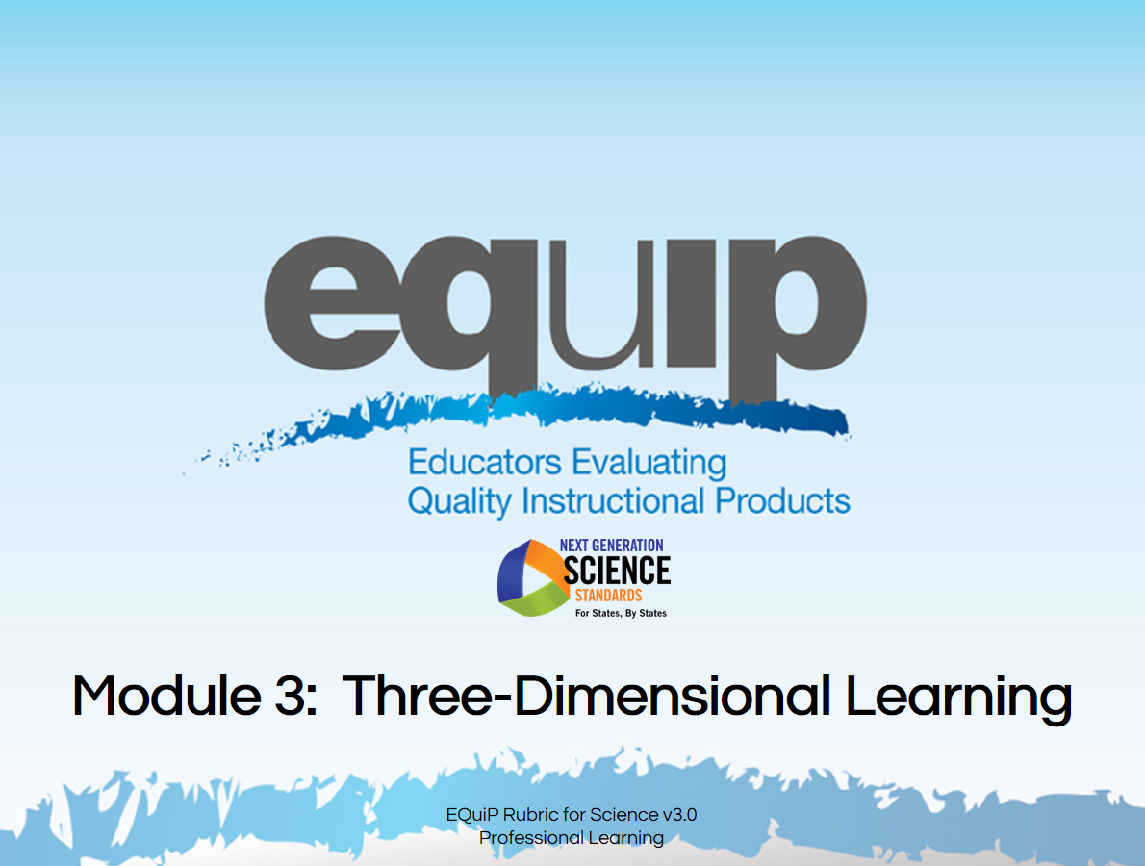
Slide 79
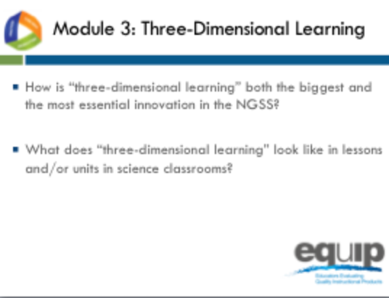
Slide 80
Talking Points
- The third module of this EQuIP training includes two essential questions that all participants should be able to answer by the conclusion of the module:
  - How is three-dimensional learning both the biggest and the most essential shift in the NGSS?
  - What does three-dimensional learning look like in lessons and units in science classrooms?
- Understanding how to determine whether or not a lesson or unit embodies three-dimensional learning is crucial to using the EQuIP Rubric to examine lessons’ and units’ alignment to the NGSS, as well as to the development of aligned lessons and units.

What is Three-Dimensional Learning?
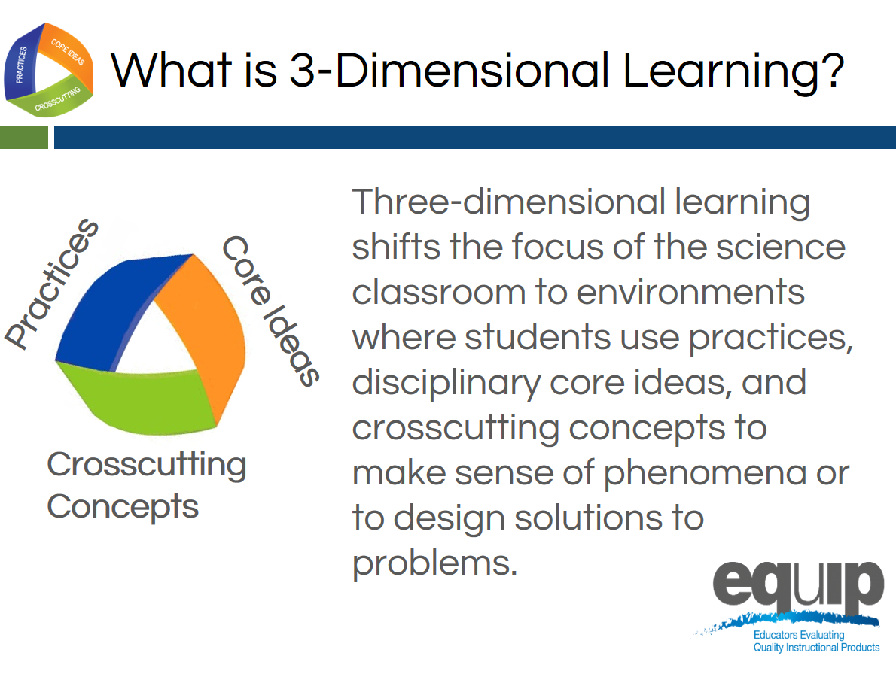
Slide 81
Talking Points
- As discussed in Module 1, three-dimensional learning happens when the three dimensions—practices, core ideas, and crosscutting concepts—work together.
!
- Three-dimensional learning shifts the focus of the science classroom to environments where students use practices, disciplinary core ideas, and crosscutting concepts together to make sense of phenomena or to design solutions to problems.

Why is Three-Dimensional Learning Essential to the NGSS?
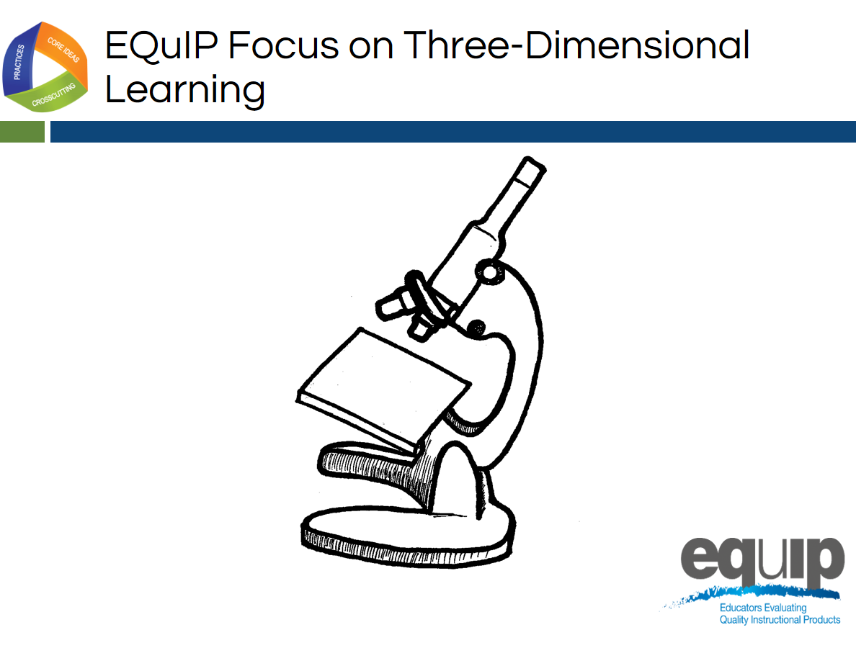
Slide 82

Talking Points
- Just as we use tools to examine objects carefully and in detail, we will use the EQuIP Rubric to examine NGSS materials—lessons and units—carefully and in detail to determine whether or not they align with one or more of the conceptual shifts of the NGSS.
- As noted by Joe Krajcik, “If the lessons or units you are judging don’t meet this criterion, there is no need to go on with an evaluation to discern if the materials align with NGSS or not. As such, you really need to understand the concept of three-dimensional learning. It represents an entirely new way of thinking about and enacting science teaching. It’s not as simple as using the practices and crosscutting concepts to help students understand the disciplinary core ideas. Rather, the three work together to help students make sense of phenomena or design solutions. Making sense of phenomena and designing solutions drives the teaching and learning process.” (http://nstacommunities.org/blog/2014/04/25/equip/).
- Consequently, before actually using the EQuIP rubric to examine lessons and units, we need to have a deep understanding of three-dimensional learning.

Analogies: Three-Dimensional Learning is Like...
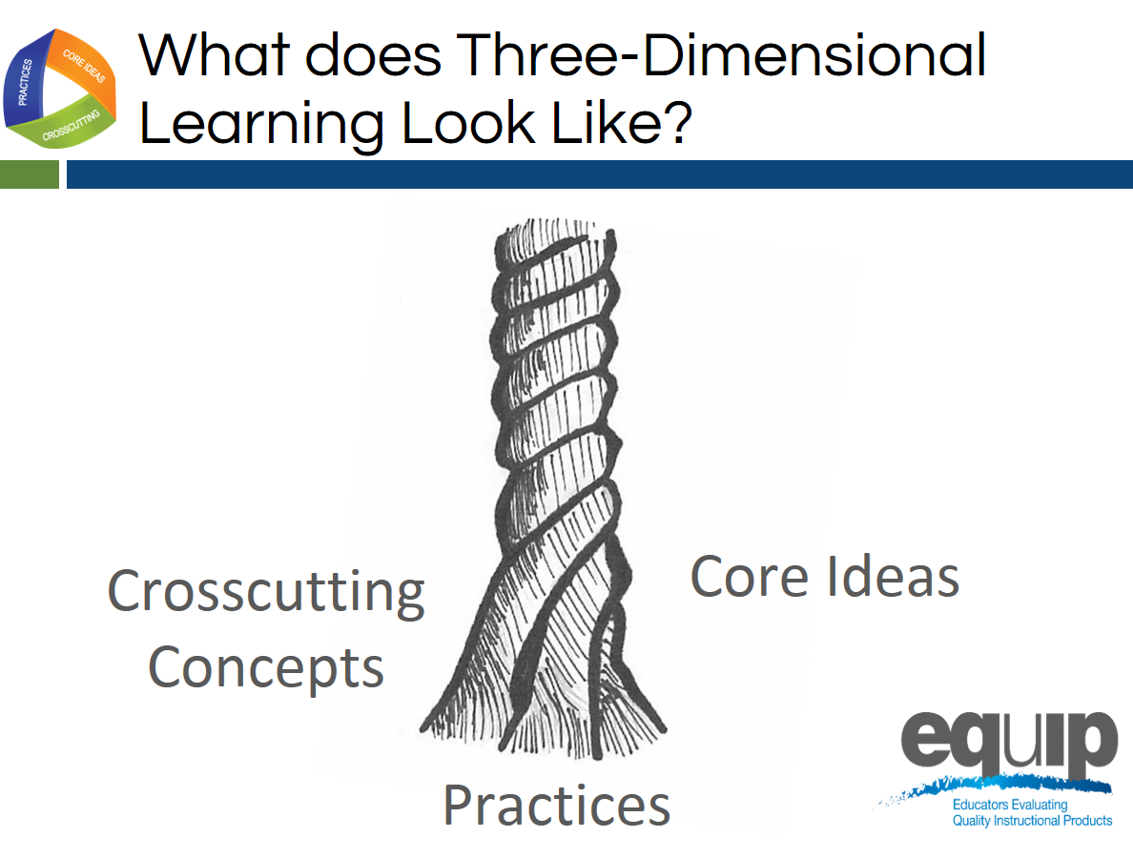
Slide 83
Talking Points
- Think of the three components of three-dimensional learning as three intertwining stands of a rope. While the rope can be separated into its three different strands, the strength of the rope is determined by the strands working together; separating the strands weakens the rope so that it is no longer effective for our intended use.
- Likewise, while in the past we may have separated out the knowledge and skills students need in the study of science, in actuality, knowing and doing cannot be separated if our goal is the kind of usable, conceptual understanding students need to think, act, and learn like scientists.
- Three-dimensional learning—practices, core ideas, and crosscutting concepts working together—is therefore a non-negotiable for NGSS lessons and units.
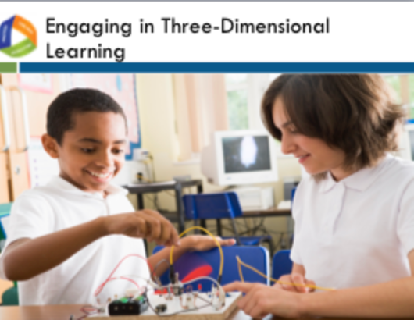
Slide 84
Talking Points
- Scientific ideas are best learned when students engage in practices.
- Three-dimensional learning allows students to use core ideas, through the lens of crosscutting concepts, while engaging in practices to solve problems, make decisions, explain real-world phenomena, and integrate new ideas.
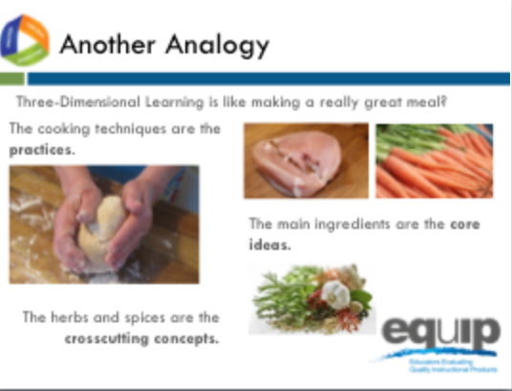
Slide 85
Talking Points
- Let’s continue thinking about three-dimensional learning metaphorically for a minute.
- As stated by Joe Krajcik, “To use the EQuIP rubric, you first need a solid understanding of the disciplinary core ideas, science and engineering practices, and crosscutting concepts, each of which is described in detail in the Framework and NGSS Appendices. Understanding each of these dimensions is essential, but real transformation comes with understanding how these dimensions blend and work together; this is the critical and perhaps most important shift in the NGSS. The EQuIP rubric refers to this blending of DCIs, practices, and CCCS as three-dimensional learning” (http://nstacommunities.org/blog/2014/04/25/equip/).
- Borrowing an idea from Ted Willard at NSTA, Joe often compares three-dimensional learning to making a really good meal.
- As Joe says so well, “Think of knowing how to do various techniques in the kitchen like kneading bread, cutting tomatoes, beating an egg, frying or roasting, and so forth as the practices. You could know how to do all of these things and still not be able to prepare a really good meal.

“Now think of picking out really good ingredients for the meal. You want to pick out a high-quality piece of fish or poultry or excellent pasta for the meal. These are your core ideas. A disciplinary core idea is essential to explaining a number of phenomena. Your main ingredient is essential to the meal. But just as the [disciplinary core idea] works with practices to make sense of phenomena and design solutions, you need to know how to cook that main ingredient. But something is still missing. The meal tastes bland. What is missing? To make a really good meal, we need to use spices and herbs to enhance the flavor of the main ingredients.”

Crosscutting concepts are like these spices and herbs—they enhance learning by providing a familiar lens to use to examine and understand phenomena. Because the same spices and herbs are used in many different dishes, we recognize them even when we have them in a new or unfamiliar dish. Consequently, we can use our familiarity with a spice or herb to examine a new meal and understand what was used to make it. Likewise, crosscutting concepts can be found in all scientific disciplines, and we can use our familiarity with crosscutting concepts in one discipline of science to examine phenomena and enhance understanding and learning in other disciplines of science.

“To make a really wonderful meal, good main ingredients are necessary, but you need to know how to use various techniques to prepare them, and you must have the spices and herbs to enhance the flavors. All three work and blend together to make a great meal. Similarly, to foster three-dimensional learning where all learners can make sense of phenomena and design solutions, all three dimensions need to work and blend together” (http://nstacommunities.org/blog/2014/04/25/equip/).
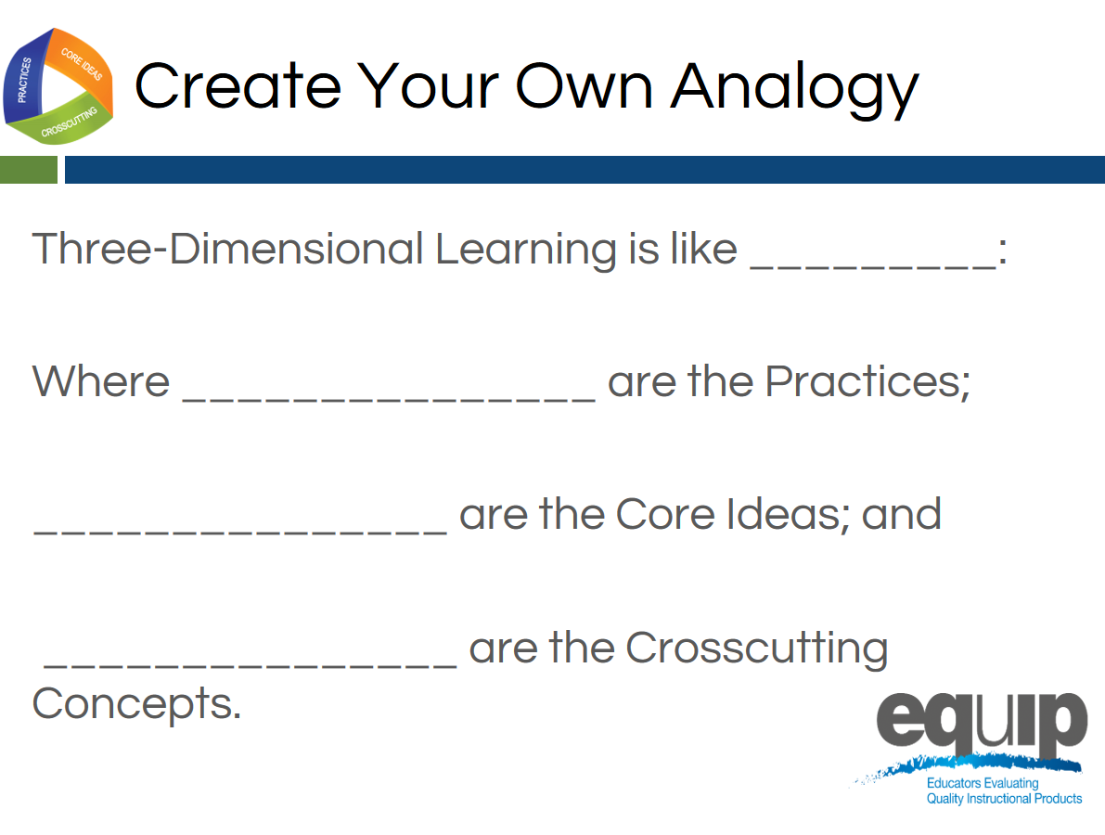
Slide 86
Talking Points
- Now, take a few minutes and create your own analogy for three-dimensional learning. [Note to facilitator: Allow 10–15 minutes for participants to create an individual analogy and share out at their tables, and then ask for a few to share their analogies with the whole group.]

Visualizing Three-Dimensional Learning
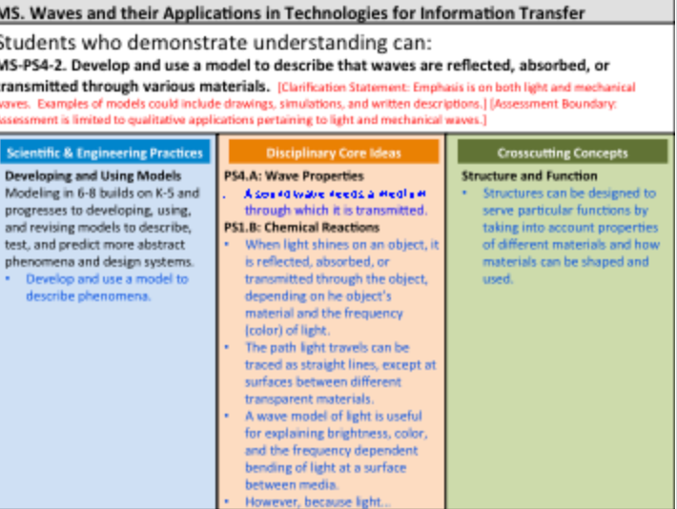
Slide 87
Facilitator Notes
- These talking points reference the immersion experience within the text that is in parentheses. If you did not present the immersion and introduction module, then omit these portions of the talking points.
- For slide 87, refer participants to Handout 5, Module 3, “Sample Performance Expectation,” which is displayed on this slide.
Talking Points
- Thinking back to Module 2 (and our immersion experience), three-dimensional learning will support students in demonstrating the understanding demanded by the performance expectations. (The immersion experience lesson was using this performance expectation.)
- So, let’s analyze a performance expectation to see how the three dimensions provide its essential structure.
- First, let’s look at the actual expectation [Note to facilitator: Click for animation.]: “Students who demonstrate understanding can… Develop and use a model to describe that waves are reflected, absorbed, or transmitted through various materials.” MS-PS4-2
- Being able to do this requires students to incorporate practices, disciplinary core ideas, and crosscutting concepts.
- [Note to facilitator: Click for animation.] So, in order to meet this performance expectation, students are required to incorporate the specific science and engineering practice of “developing and using models to describe phenomena”, which is an element of the science and engineering practice of developing and using models. As noted previously, however, during instruction, other practices will also be used.
- In addition, students must incorporate disciplinary core ideas. [Note to facilitator: Click for animation.] This performance expectation specifies two component ideas of the disciplinary core idea MS-PS4 Waves and their Applications for Technologies for Information Transfer. What are these two component ideas? [Note to facilitator: Solicit responses from participants. Refer them to the handout if necessary.]
- Finally, to meet this performance expectation, students will need to incorporate the specific crosscutting concept of “structures can be designed to serve particular functions by taking into account properties of different materials, and how materials can be shaped and used”, which is an element of the crosscutting concept of Structure and Function. [Note to facilitator: Click for animation.]
- You can see, then, that for all performance expectations, the whole is truly greater than the sum of its parts.
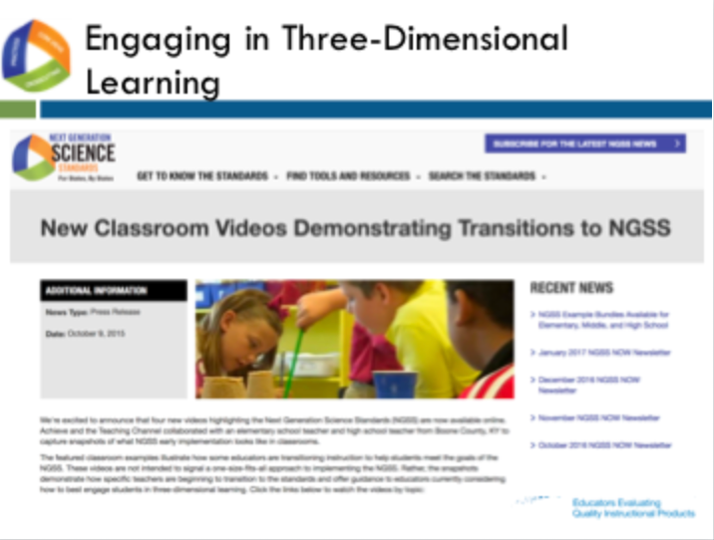
Slide 88
Facilitator Notes
- For the video clip, please choose between the high school video (9th grade classroom) or Elementary video (2nd grade classroom) and cue the video from the links below:
  - High School: http://www.nextgenscience.org/resources/video-energy-matter-across-science-disciplines
  - Elementary: http://www.nextgenscience.org/resources/video-making-claims-evidence
Talking Points
- Now, let’s take a look at what this looks like in an actual classroom. This is a classroom that is beginning to transition to the NGSS, so all of the components might not be implemented yet. As you watch this short video clip, note how and where you see students engaged in three-dimensional learning. Remember, it’s not enough to have practices, disciplinary core ideas, and crosscutting concepts. These must work together to help students make sense of phenomena or design solutions to problems. [Note to facilitator: Show video of classroom that illustrates steps toward three-dimensional learning. Depending on time constraints, you may elect to show all or a portion of the video. Following the video clip, ask participants to share what they noted in the video and explain how the three dimensions work together.]
- Finally, let’s move to your own experiences.
- Where have you seen students engaged in three-dimensional learning in science lessons and units? What did that look like? How did the practices, disciplinary core ideas, and crosscutting concepts work together so that students could make sense of phenomena or design solutions to problems?
- Take about three minutes to think of lessons or units you’ve seen or experienced where practices, disciplinary core ideas, and crosscutting concepts have worked together for effective learning to occur. Again, this does not mean that students passively receive content, and then apply it, or that there is an implicit crosscutting concept that does not support student learning. Rather, all three dimensions work together. [Note to facilitator: After about three minutes, ask participants to take an additional five to seven minutes to share and compare at their tables, and then ask two or three table groups to provide examples of three-dimensional learning from their experiences.]

Concluding Slide for Module 3
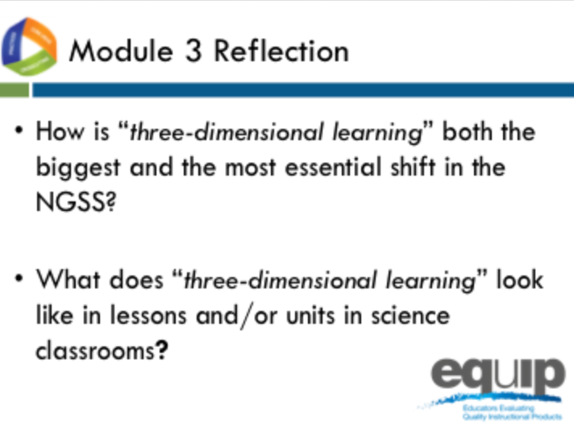
Slide 89
Talking Points
- At your tables, quickly review two essential questions from Module 3 to ensure your understanding before going on to Module 4.
- Identify and be prepared to ask any clarifying questions you still have. [Note to facilitator: Allow approximately five minutes, and then address any remaining questions. If it is apparent that participants are still having trouble clearly understanding three-dimensional learning, do not move on until they have reached this understanding.]

