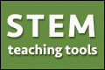
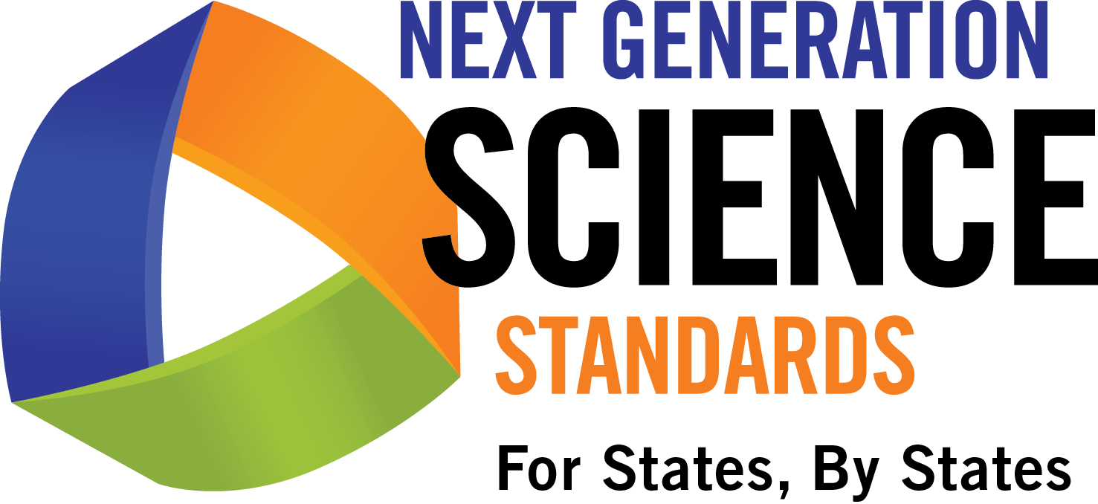
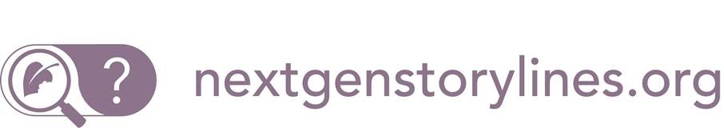
Handout 2: Module 1: Using Phenomena

Using Phenomena in NGSS-Designed
Lessons and Units
What are phenomena in science and engineering?
- Natural phenomena are observable events that occur in the universe and that we can use our science knowledge to explain or predict. The goal of building knowledge in science is to develop general ideas, based on evidence, that can explain and predict phenomena.
- Engineering involves designing solutions to problems that arise from phenomena, and using explanations of phenomena to design solutions.
- In this way, phenomena are the context for the work of both the scientist and the engineer.
Why are phenomena such a big deal?
- Despite their centrality in science and engineering, phenomena have traditionally been a missing piece in science education, which too often has focused on teaching general knowledge that students can have difficulty applying to real world contexts.
- Anchoring learning in explaining phenomena supports student agency for wanting to build science and engineering knowledge. Students are able to identify an answer to "why do I need to learn this?" before they even know what the “this” is. In contrast, students might not understand the importance of learning science ideas that teachers and curriculum designers know are important but that are unconnected from phenomena.
- By centering science education on phenomena that students are motivated to explain, the focus of learning shifts from learning about a topic to figuring out why or how something happens. For example, instead of simply learning about the topics of photosynthesis and mitosis, students are engaged in building evidence-based explanatory ideas that help them figure out how a tree grows.
- Explaining phenomena and designing solutions to problems allow students to build general science ideas in the context of their application to understanding phenomena in the real world, leading to deeper and more transferable knowledge.
- Students who come to see how science ideas can help explain and model phenomena related to compelling real world situations learn to appreciate the social relevance of science. They get interested in and identify with science as a way of understanding and improving real world contexts. Focusing investigations on compelling phenomena can help sustain students’ science learning.
How are phenomena related to the NGSS and three-dimensional learning?
- The Next Generation Science Standards (NGSS) focus on helping students use science to make sense of phenomena in the natural and designed world, and use engineering to solve problems.
- Learning to explain phenomena and solve problems is the central reason students engage in the three dimensions of the NGSS. Students explain phenomena by developing and applying the Disciplinary Core Ideas (DCIs) and Crosscutting Concepts (CCCs) through use of the Science and Engineering Practices (SEPs).
- Phenomena-centered classrooms also give students and teachers a context in which to monitor ongoing progress toward understanding all three dimensions. As students are working toward being able to explain phenomena, three-dimensional formative assessment becomes more easily embedded and coherent throughout instruction.
Published September 2016
View Creative Commons Attribution 3.0 Unported License at http://creativecommons.org/licenses/by/3.0/.
Educators may use or adapt. If modified, please attribute and re-title.
How do we use phenomena to drive teaching and learning?
- The point of using phenomena to drive instruction is to help students engage in practices to develop the knowledge necessary to explain or predict the phenomena. Therefore, the focus is not just on the phenomenon itself. It is the phenomenon plus the student-generated questions about the phenomenon that guides the learning and teaching. The practice of asking questions or identifying problems becomes a critical part of trying to figure something out.
- There could potentially be many different lines of inquiry about the same phenomenon. Using the phenomenon of tree growth, a middle school teacher might want middle school students to develop and apply DCIs about photosynthesis and mitosis; alternately, a 3rd grade teacher might want students to learn and apply DCIs about life cycles. In each case, teachers should help students identify different aspects of the same phenomenon as the focus of their questions.
- Students also might ask questions about a phenomenon that motivate a line of investigation that isn’t grade appropriate, or might not be effective at using or building important disciplinary ideas. Teacher guidance may be needed to help students reformulate questions so they can lead to grade-appropriate investigations of important science ideas.
- It is important that all students—including English language learners and students from cultural groups underrepresented in STEM—are supported in working with phenomena that are engaging and meaningful to them. Not all students will have the same background or relate to a particular phenomenon in the same way. Educators should consider student perspectives when choosing phenomena, and also should prepare to support student engagement in different ways. While starting with one phenomenon in the classroom, it is always a good idea to help students identify related phenomena from their lives and their communities to expand the phenomena under consideration. For example, when teaching toward Kindergarten DCI PS3.B about how sunlight warms the surface of the Earth, a teacher could notice that students don’t have experience with hot sand and instead engage the group in observations of hot concrete. When necessary, teachers can engage the class in a shared experience with a relevant phenomenon (e.g., by watching a video).
- Not all phenomena need to be used for the same amount of instructional time. Teachers could use an anchoring phenomenon or two as the overall focus for a unit, along with other investigative phenomena along the way as the focus of an instructional sequence or lesson. They may also highlight everyday phenomena that relate investigative or anchoring phenomena to personally-experienced situations. A single phenomenon doesn’t have to cover an entire unit, and different phenomena will take different amounts of time to figure out.
What makes phenomena effective for use in instruction?
- The most powerful phenomena from an educational perspective are culturally or personally relevant or consequential to students. Such phenomena highlight how science ideas help us explain aspects of real world contexts or design solutions to science-related problems that matter to students, their communities, and society.
- An appropriate phenomenon for instruction should help engage all students in working toward the learning goals of instruction. The phenomenon needs to be useful for teachers to help students build the target pieces of the DCIs, SEPs, and CCCs. For example, engaging in discussions about redshifts of light from galaxies is unlikely to be helpful in moving 5th grade students to a grade-appropriate understanding of DCI ESS1.A, which, at the 5th grade level, focuses on the relationship between star brightness and distance from Earth.
Published September 2016
View Creative Commons Attribution 3.0 Unported License at http://creativecommons.org/licenses/by/3.0/.
Educators may use or adapt. If modified, please attribute and re-title.
- The process of developing an explanation for a phenomenon should advance students’ understandings. If students already need to know the target knowledge before they can inquire about the phenomenon, then the phenomenon is not appropriate for initial instruction (although it might be useful for assessment).
- Students should be able to make sense of anchoring or investigative phenomenon, but not immediately, and not without investigating it using sequences of the science and engineering practices. With instruction and guidance, students should be able to figure out, step by step, how and why the phenomenon works.
- An effective phenomenon does not always have to be flashy or unexpected. Students might not be intrigued by an everyday phenomenon right away because they believe they already know how or why it happens. It takes careful teacher facilitation to help students become dissatisfied with what they can explain, helping them discover that they really can’t explain it beyond a simple statement such as “smells travel through the air” or a vocabulary word, such as “water appears on cold cans of soda because it condenses.”
Prior Thinking About Phenomena | Thinking About Phenomena Through the NGSS
If it’s something fun, flashy, or involves hands-on activities, it must be engaging. | Authentic engagement does not have to be fun or flashy; instead, engagement is determined more by how the students generate compelling lines of inquiry that create real opportunities for learning.
Anything students are interested in would make a good “engaging phenomenon” | Students need to be able to engage deeply with the material in order to generate an explanation of the phenomenon using target DCIs, CCCs, and SEPs.
Explanations (e.g., “electromagnetic radiation can damage cells”) are examples of phenomena | Phenomena (e.g., a sunburn, vision loss) are specific examples of something in the world that is happening—an event or a specific example of a general process. Phenomena are NOT the explanations or scientific terminology behind what is happening. They are what can be experienced or documented.
Phenomena are just for the initial hook | Phenomena can drive the lesson, learning, and reflection/monitoring throughout. Using phenomena in these ways leads to deeper learning.
Phenomena are good to bring in after students develop the science ideas so they can apply what they learned | Teaching science ideas in general (e.g., teaching about the process of photosynthesis) may work for some students, but often leads to decontextualized knowledge that students are unable to apply when relevant. Anchoring the development of general science ideas in investigations of phenomena helps students build more usable and generative knowledge.
Engaging phenomena need to be questions | Phenomena are observable occurrences. Students need to use the occurrence to help generate the science questions or design problems that drive learning.
Student engagement is a nice optional feature of instruction, but is not required | Engagement is a crucial access and equity issue. Students who do not have access to the material in a way that makes sense and is relevant to them are disadvantaged. Selecting phenomena that students find interesting, relevant, and consequential helps support their engagement. A good phenomenon builds on everyday or family experiences: who students are, what they do, where they came from.
Published September 2016
View Creative Commons Attribution 3.0 Unported License at http://creativecommons.org/licenses/by/3.0/.
Educators may use or adapt. If modified, please attribute and re-title.

