Graphic Example of Coherence
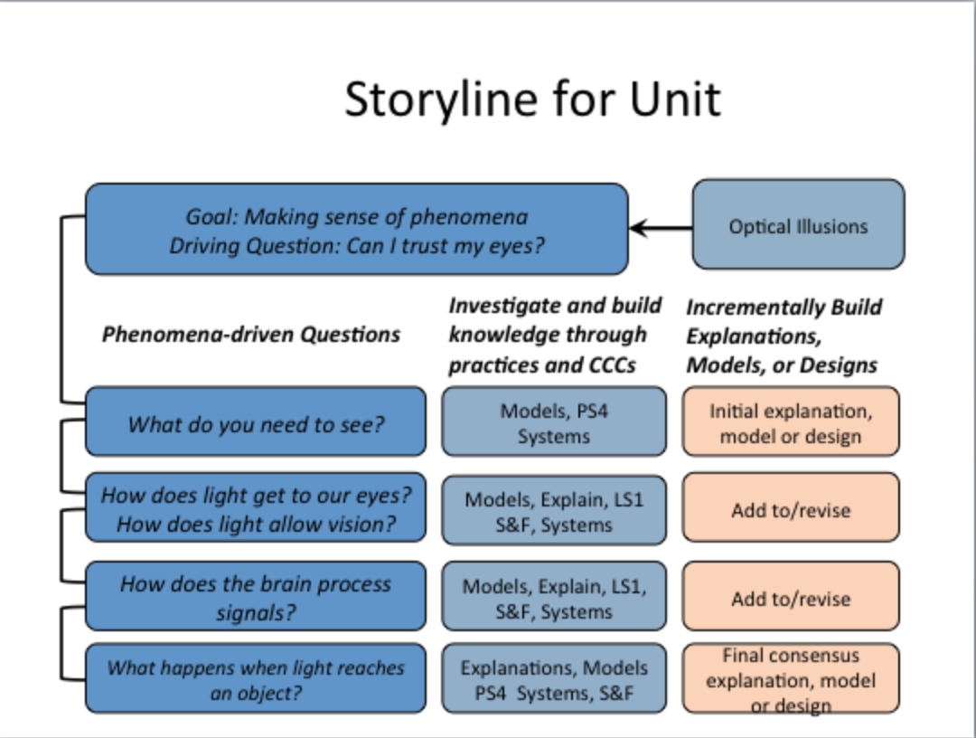
Provided by Brian Reiser

