NGSS EQuIP
MODULE
1

A Quick
Overview of the Framework for K-12 Science Education

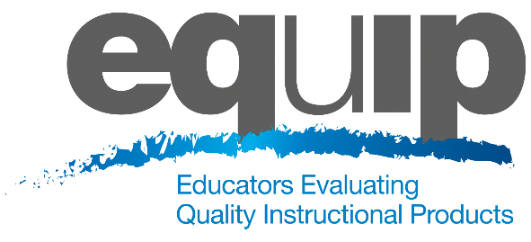
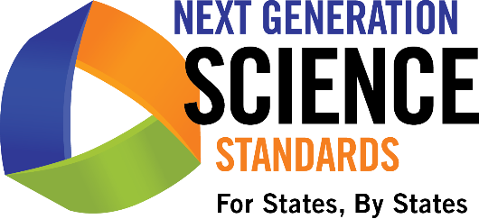
Module One: A Quick Overview of the Framework for K–12 Science Education
This module provides a brief background on the Framework for K-12 Science Education and should not be considered a thorough review of the Framework. Participants should have an understanding of the Framework and the Next Generation Science Standards (NGSS) before engaging in this professional learning. While this module does provide a brief background on these topics, ideally, participants will not need to spend much time on it since they should already be comfortable with the Framework and the NGSS. If this module is skipped or given to participants prior to the meeting, the first introductory slides may need to be pulled and added to a later module.
Materials Needed
- Module One PowerPoint slides or slides 1–19 of the full PowerPoint
- Handout 1: Module One, Slide 7, NRC Framework
General Information
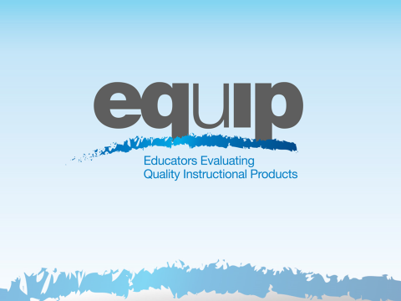
Slide 1
Talking Points
- This professional learning is designed to provide participants with the knowledge and conceptual understanding necessary to examine teaching and learning materials related to the Next Generation Science Standards (NGSS).
- Training is divided into ten modules: nine instructional modules followed by a culminating task where participants apply what they’ve learned through these first nine modules.
- The first three modules provide a brief overview of the Framework, the NGSS Performance Expectations, and a major shift in the NGSS—three-dimensional learning.

Slide 2
Talking Points
- The implementation of the Next Generation Science Standards requires instructional materials that align with the shifts and increased rigor of these new standards.
- While we might be inclined to assume that there will be an initial shortage of materials for the NGSS, in fact we may find ourselves inundated with materials claiming to be NGSS aligned.
- As noted by Joe Krajcik, Professor of Science Education and Director of the CREATE for STEM Institute at Michigan State University, “Many developers and publishers of science materials claim that their materials align with the NGSS and feature the NGSS performance expectations. And while some publishers will make legitimate attempts at modifying their materials to do an appropriate alignment, you will need to have the appropriate tool to judge which materials better represent the intent of the NGSS and which materials just really don’t match up” (http:// nstacommunities.org/blog/2014/04/25/equip/).
- Case in point, Bill Schmidt of Michigan State University reviewed roughly 700 math textbooks used by 60% of US public school children and found that many claiming Common Core alignment were “page by page, paragraph by paragraph” the same as older versions, resulting in textbooks that reflect the standards minimally, if at all. In some of the texts, less than a quarter of the content matched the standards of the grade in question. As Schmidt notes, “It’s hard to imagine how this could support instruction” (http://www.hewlett.org/blog/posts/curriculum-core).
!
- As this research indicates, too often new labels may be placed on old materials without any substantive changes having been made to those materials.
- To ensure the quality of the teaching and learning materials used with the NGSS, we need a common basis for examining and evaluating these materials.
- The EQuIP Rubric provides this common basis and allows educators to select the best and most appropriate instructional materials—published or educator-generated—for effective teaching and learning.
- The development of the EQuIP Rubric for NGSS was managed by Achieve in partnership with NSTA. It was written and reviewed by groups of educators in several states, math and ELA EQuIP developers, standards writers, and other science and engineering education experts.
- The EQuIP Rubric for Science has also been tested with teacher focus groups.
- We want science educators to be critical evaluators and/or developers of quality science materials. Consequently, we want to train as many science educators as feasible to use the EQuIP Rubric effectively.

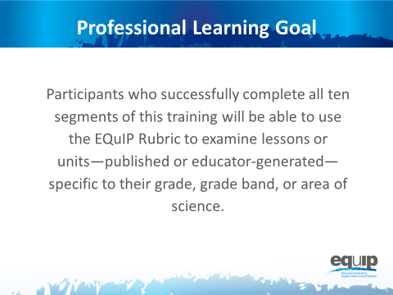
Slide 3
Talking Points
- While, for purposes of the training, all participants may be working in common with a sample lesson or unit, the knowledge, skills, and understandings acquired are transferable to materials in all disciplines of science.
- Here, and throughout this training, when we refer to the different disciplines of science, we mean physical sciences; life sciences; earth and space sciences; and engineering, technology, and applications of science.
- Finally, the training provides participants with a process for reviewing materials and engaging in meaningful discussions about materials with their peers. These are rich discussions that require reviewers to use evidence and reasoning.
Introduction to Module One
Slide 4
Talking Points
- The NGSS are not just “new”; they represent major shifts in how we expect students to demonstrate their understanding of science.
- Before we begin, take a couple of minutes to list what you think are the biggest shifts in the NGSS. [Allow 2-3 minutes and then ask a few people to share.]
- Put your list aside for now, but revisit it throughout this training to confirm or adjust your thinking.

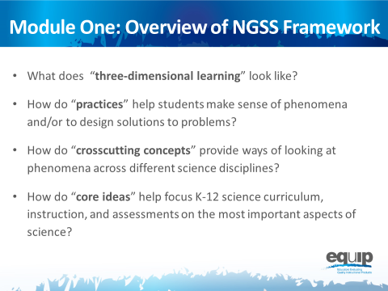
Note to Facilitator: Much of Modules One and Two may constitute a review for many participants and be fairly new information for others. Facilitators may speed up or slow down the delivery of these two modules as determined by the needs of the participants.
Slide 5
Talking Points
- This module includes questions about the Framework that participants should be able to answer by the end of this module:
  - What does “Three-Dimensional Learning” look like?
  - How do “Practices” help teachers and students make sense of phenomena or design solutions to problems?
  - How do “Crosscutting Concepts” provide ways of looking at phenomena across different science disciplines?
  - How do “Core Ideas” help focus K-12 science curriculum, instruction, and assessments on the most important aspects of science?

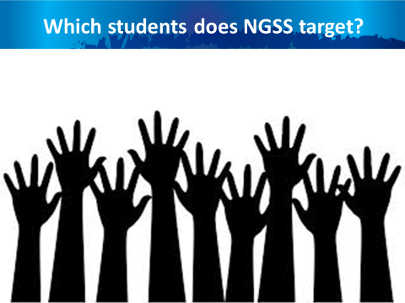
Slide 6
Talking Points
- The NGSS and the Framework are about science for ALL students.
- In today’s world, science, engineering, and technology are not a luxury to be experienced by only SOME students.
- A strong science education equips students with skills necessary for all careers. Science develops students’ abilities to think critically and to innovate. All students need strong foundational knowledge in science to tackle difficult and/or long term issues that face both our generation and future generations.
- Science, engineering, and technology:
  - Serve as cultural achievements and a common good across societies;
  - Permeate modern life and as such are essential at the individual level;
  - Are critical to participation in public policy and good decision-making; and
  - Are essential for ensuring that future generations will live in a society that is economically viable, sustainable, and free.

Three-Dimensional Learning
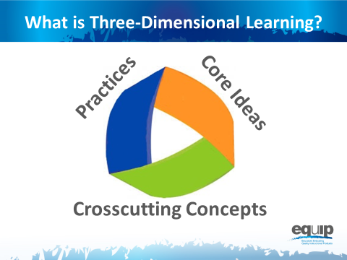
Note to Facilitator: Participants will need Handout 1, Module 1, Slide 7: NGSS Framework, for the remaining portion of Module One.
Slide 7
Talking Points
- Perhaps the most important shift in the NGSS is Three-Dimensional Learning. This shift is defined here in Module One; however, it addressed in more detail in the third module of the professional learning.
- The three dimensions are practices, crosscutting concepts, and disciplinary core ideas.
- When you hear the term “three-dimensional learning,” what does it mean to you? Take 2–3 minutes to talk about this at your tables. Be prepared to share.
- [Allow 2–3 minutes, and then ask a few tables to share.]
- Three-dimensional learning is when these three dimensions work together to support students in making sense of phenomena and/or to design solutions to problems.
- Before looking at how the dimensions work together, we’ll look at the three separately to ensure our common understanding of each.
Practices
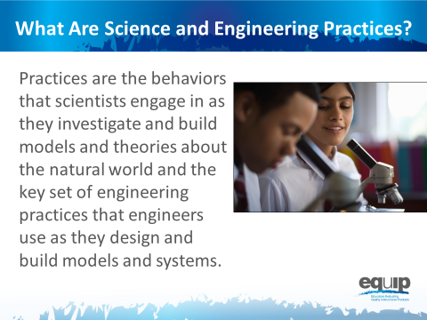
Slide 8
Talking Points
- Practices are the behaviors that scientists engage in as they investigate and build models and theories about the natural world and the key set of engineering practices that engineers use as they design and build models and systems.
- The term practices is used instead of “skills” to emphasize that engaging in scientific investigation requires not only skill but also knowledge that is specific to each practice.
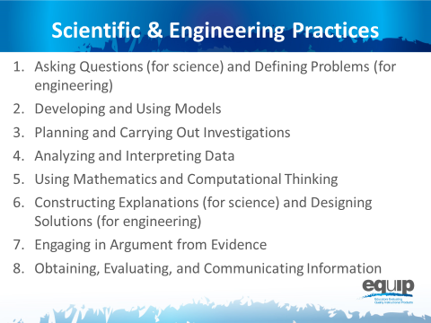
Slide 9
Talking Points
- The Framework identifies scientific and engineering practices that occur throughout the different disciplines of science. Descriptions of these practices and how they should become more complex over time can be found in the Framework and the NGSS.
- These practices are:
  - Asking questions (for science) and defining problems (for engineering);
  - Developing and using models;
  - Planning and carrying out investigations;
  - Analyzing and interpreting data;
  - Using mathematics and computational thinking;
  - Constructing explanations (for science) and designing solutions (for engineering);
  - Engaging in argument from evidence; and
  - Obtaining, evaluating, and communicating information.
- Let’s watch Joe Krajcik in this video explain how practices work together.
- Now, take 5 minutes at your table to discuss how you’ve observed these practices in science lessons and units.
- [After 5 minutes, have a few tables share.]

Crosscutting Concepts
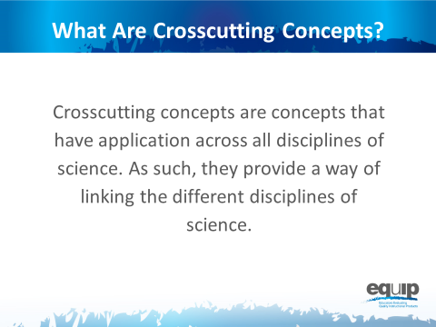
Slide 10
Talking Points
- Crosscutting concepts have applications across all disciplines of science. As such, they are a way of linking the different disciplines of science by providing ways of looking at and making sense of phenomena and/or of designing solutions to problems.
!
- The Framework emphasizes that these concepts need to be made explicit for students because they provide an organizational schema for interrelating knowledge from various science fields into a coherent and scientifically-based view of the world.

Slide 11
Talking Points
- Think, for example, about weather, a phenomenon in nature.
- Could you describe this phenomenon through the lens of
  - Patterns? How/why or why not? [Allow one or two participants to respond.]
  - Cause and effect? How/why or why not? [Allow one or two participants to respond.]
  - Scale, proportion, and quantity? How/why or why not? [Allow one or two participants to respond.]
  - Systems and system models? How/why or why not? [Allow one or two participants to respond.]
  - Energy and matter? How/why or why not? [Allow one or two participants to respond.]
  - Structure and function? How/why or why not? [Allow one or two participants to respond.]
  - Stability and change? How/why or why not? [Allow one or two participants to respond.]

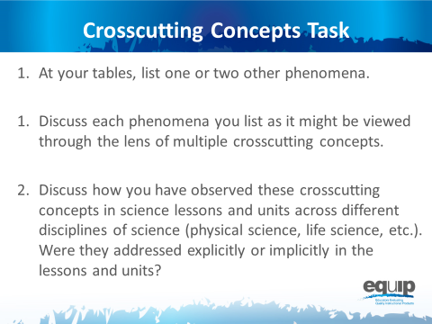
Slide 12
Talking Points
- Refer back to Handout 1 where you’ll see that the Framework lists the following crosscutting concepts:
  - Patterns;
  - Cause and effect;
  - Scale, proportion, and quantity;
  - Systems and system models;
  - Energy and matter;
  - Structure and function; and
  - Stability and change.
- Now, take 10 minutes at your table to:
  - List one or two other phenomena;
  - Discuss each phenomena you list as it might be viewed through the lens of multiple crosscutting concepts;
  - Finally, discuss how you have observed these crosscutting concepts in science lessons and units across different disciplines of science (physical science, life science, etc.). Were they addressed explicitly or implicitly in the lessons and units?
- [After 10 minutes, have a few tables share.]

Disciplinary Core Ideas
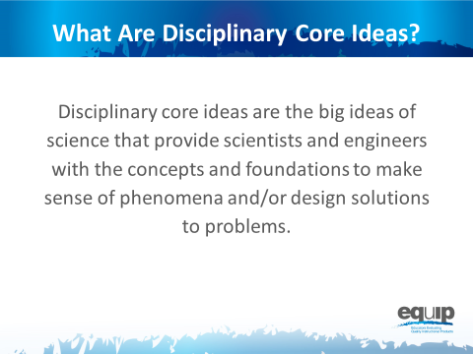
Slide 13
Talking Points
- Disciplinary core ideas are the big ideas—the most important aspects—of science that provide scientists and engineers and students with the concepts and the foundations to make sense of phenomena and/or to design solutions to problems.
- They can be used to focus K–12 science curriculum, instruction, and assessments on the most important aspects of science.
- According to the Framework, to be considered core, the ideas must meet at least two of the following criteria and ideally all four:
  - Have broad importance across multiple sciences or engineering disciplines or be a key organizing concept of a single discipline;
  - Provide a key tool for understanding or investigating more complex ideas and solving problems;
  - Relate to the interests and life experiences of students or be connected to societal or personal concerns that require scientific or technological knowledge;
  - Be teachable and learnable over multiple grades at increasing levels of depth and sophistication.
- Disciplinary core ideas are grouped in four disciplines:
  - The physical sciences;
  - The life sciences;
  - The earth and space sciences; and
  - Engineering, technology, and applications of science.
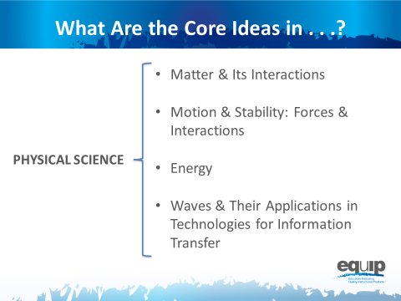
Slide 14
Talking Points
- The physical sciences include four core ideas:
  - Matter and its interactions
  - Motion and stability: forces and interactions
  - Energy
  - Waves and their applications in technologies for information transfer

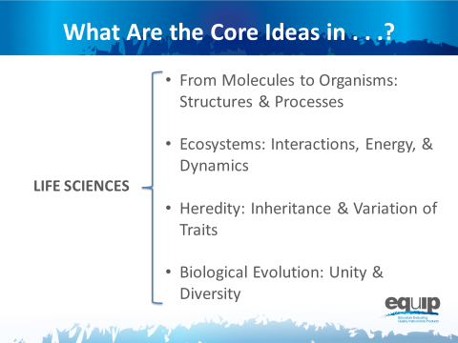
Slide 15
Talking Points
- The life sciences include four core ideas as well:
  - From molecules to organisms: structures and processes
  - Ecosystems: interactions, energy, and dynamics
  - Heredity: inheritance and variation of traits
  - Biological evolution: unity and diversity
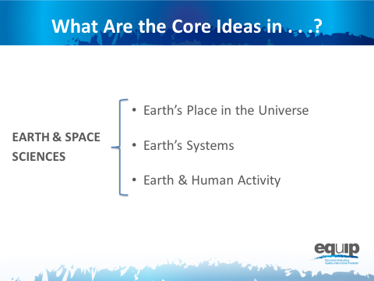
Slide 16
Talking Points
- The earth sciences include three core ideas:
  - Earth’s place in the universe
  - Earth’s systems
  - Earth and human activity
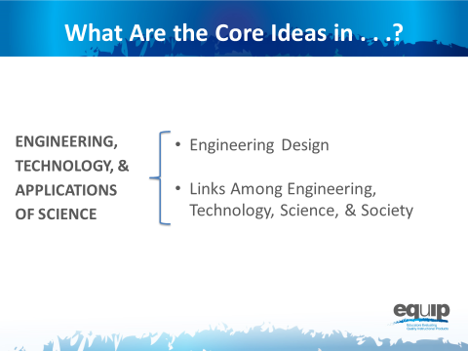
Slide 17
Talking Points
- Engineering, technology, and the applications of science include two core ideas:
  - Engineering design
  - Links among engineering, technology, science, and society
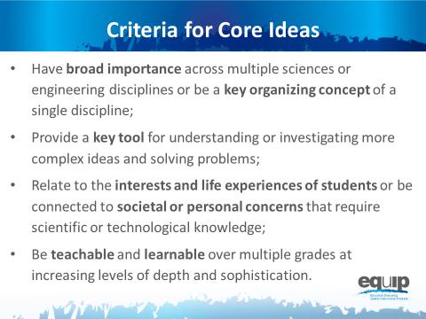
Note to Facilitator: Remind participants that the core ideas for the different science disciplines are listed on the handout for this module. They may wish to refer to this handout for this task.
Slide 18
Talking Points
- Now, take 10 minutes at your table to discuss how the core ideas in one discipline of science meet two or more of the criteria for a core idea:
  - Have broad importance across multiple sciences or engineering disciplines or be a key organizing concept of a single discipline;
  - Provide a key tool for understanding or investigating more complex ideas and solving problems;
  - Relate to the interests and life experiences of students or be connected to societal or personal concerns that require scientific or technological knowledge;
  - Be teachable and learnable over multiple grades at increasing levels of depth and sophistication.
- [After 10 minutes, have a few tables share.]

Concluding Slide for Module One
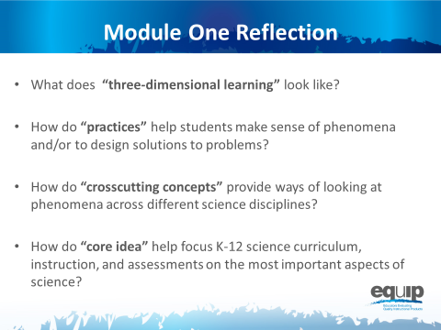
Slide 19

Talking Points
- In order to use the EQuIP Rubric to examine and evaluate NGSS lessons and units, it’s imperative that we have a common understanding of the practices, crosscutting concepts, and disciplinary core ideas as they relate to the Framework.
- Look back at the questions we began with in this module. Where are you now in terms of being able to respond to these questions with confidence?
- Take 5 minutes to jot down your reflections and your take-a-ways from this first module:
  - Where are you now in terms of being able to respond to these four questions with confidence?
  - Has your thinking changed as a result of this module?
  - What did you hear that was new?
  - What’s still rolling around in your head that you need to know more about?
- [After 5 minutes, ask a few people to share their reflections.]
- As we conclude this first module, keep in mind that practices, crosscutting concepts, and disciplinary core ideas do not function in isolation.
- The key shift in the NGSS is three-dimensional learning. That is, lessons and units where practices, crosscutting concepts, and disciplinary core ideas work together to help students make sense of phenomena and/or to design solutions to problems.
- We’ll talk more about three-dimensional learning in a subsequent module.
- If you would like more information about the NGSS Framework, visit the NGSS website: http://www.nextgenscience.org/
- Keep in mind that you may wish to refer to the handout from Module One when you begin to use the rubric itself.

