Using the
EQuIP Rubric for Science v3.0

Professional Learning
Facilitator’s Guide

About This Professional Learning
The Educators Evaluating the Quality of Instructional Products (EQuIP) Rubric for science is a tool that provides criteria by which to examine the alignment and overall quality of lessons and units with respect to the Next Generation Science Standards (NGSS). Completing this professional learning will provide science educators with the processes and procedures necessary to use the EQuIP Rubric to review science lessons and units, to provide effective feedback and suggestions for improvement to developers of these instructional materials, to identify model or exemplar lessons and units, and to inform the development of new instructional materials. In addition, this professional learning also helps educators understand the NGSS, identify shifts in instruction that may be needed to better target the NGSS, and transition teaching and learning.
As noted by Joe Krajcik, professor of science education and director of the CREATE for STEM Institute at Michigan State University, “Many developers and publishers of science materials claim that their materials align with the NGSS and feature the NGSS performance expectations. And while some publishers will make legitimate attempts at modifying their materials to do an appropriate alignment, you will need to have the appropriate tool to judge which materials better represent the intent of the NGSS and which materials just really don’t match up” (http://nstacommunities.org/blog/2014/04/25/equip/). The EQuIP Rubric serves as this tool not only for published materials, but also for educator-developed lessons and units.
This professional learning consists of an Immersion and Introduction module followed by 10 modules that may be used separately or with two or more modules grouped together. These modules are designed sequentially to build participants’ proficiency in using the EQuIP Rubric version 3.0.
All modules include one or more specific learning outcomes.
Most modules will take 15 minutes to an hour to complete; however, Modules 6 and 10 will take longer. Timing is important, so Craig Gabler, regional science coordinator and co-director of LASER Alliance, explains more about thoughtful timing of the training in this video.
After completing the immersion, introduction and first nine modules, participants will apply their learning and complete a culminating task in Module 10.
Note: This guide accompanies EQuIP rubric 3.0. A summary of changes and revisions from version 2.0 to version 3.0 can be found here. All EQuIP materials can be accessed online at nextgenscience.org/equip.
The Modules
- Immersion and Introduction Module
- Module 1: Overview of the Framework for K–12 Science Education
- Module 2: Overview of Performance Expectations
- Module 3: Three-Dimensional Learning
- Module 4: Overview of the EQuIP Rubric
- Module 5: Providing Feedback, Evaluation, and Guidance
- Module 6: Category I: NGSS 3D Design
- Module 7: Determining Coherence and Connections
- Module 8: Category II: Instructional Supports
- Module 9: Category III: Monitoring Student Progress
- Module 10: Culminating Task
The Facilitator’s Guide
This guide includes each slide from the professional learning PowerPoint, talking points for each slide, and instructions for all tasks (the learning tasks and the culminating task). When appropriate, facilitator notes are included to set up and support the discussion of the activity or slide. In addition, participant takeaways highlighting points of emphasis may be included.
A number of symbols are used throughout the Facilitator’s Guide to signal specific features of the training:
The clock signals a timed task.
!
The exclamation mark signals a very important point that needs to be emphasized.

The video camera signals a video clip.

The double arrow signals an opportunity to differentiate to meet the needs of your audience.
Materials and Other Considerations
- Participants should have an understanding of the Framework for K–12 Science Education and the Next Generation Science Standards (NGSS). Modules 1 and 2 do provide a brief background on these topics, but ideally participants will not need to spend much time on these modules since they should already be comfortable with the Framework and the NGSS. If the facilitator determines the audience does not need to review the information in modules 1 and 2, then the facilitator should begin with the Immersion and Introduction modules and then proceed directly to module 4. If the facilitator determines that the audience would benefit from a review of the Framework for K–12 Science Education and the Next Generation Science Standards (NGSS), then the facilitator should begin with the Immersion and Introduction module and then proceed to modules 1, 2, and 3.
- Participants will need hard copies of the following handouts:
  - Handout 1: Module 1, “The Framework” (4 pages)
  - Handout 2: Module 1, Using Phenomena in NGSS-Designed Lessons and Units (3 pages)
  - Handout 3: Module 2, “Format of Performance Expectation” (1 page, preferably color copies)
  - Handout 4: Module 2, “How to Read the NGSS” (5 pages, preferably color copies)
  - Handout 5: Module 3, “Sample Performance Expectation” (1 page, preferably color copies)
  - Handout 6: Module 4, “EQuIP Agreements with Table Facilitator Guidelines on back” (2 pages)
  - Handout 7: Module 4, “EQuIP Rubric, Version 3.0” (14 pages)
  - Handout 8: Module 7, “Graphic Example of Coherence” (1 page, preferably color copies)
  - Handout 9: Module 7, “Debriefing Questions for Module 7” (1 page)
  - Handout 10: Module 9, “Formative Assessment Vignettes” (2 pages)
  - Handout 11: Module 10, “Culminating Task Debriefing Questions” (1 page)
  - Common Lesson for use in Module 6: Intermediate version of Urban Heat (12 pages, shared with participants prior to training)
  - Common Lesson for use in modules 7, 8, and 9: “Final” Version of Urban Heat (10 pages)
- Participants may want to have laptops in order to be able to type into the rubric. This is highly recommended. It will allow them to capture more of their ideas and group discussions. A fillable PDF version and a Microsoft Word version of the EQuIP rubric can be found at www.nextgenscience.org/equip).
- Participants may want to have blue, green, and orange highlighters to highlight the three dimensions when examining a lesson or unit.
- Participants will need to be able to look up standards and NGSS appendices.
- The facilitator will need to prepare the Storyline Cards for the task in Module 7, Slide 154 These cards are located on the Facilitator’s Resource—Storyline Cards, which is included with the handouts.
- Ideally, participants will be in teams of four to six members. This size gives everyone an opportunity to be part of the team discussion. Each team will need to have an assigned Table Facilitator. The roles and responsibilities of the table facilitator can be found on the back of Handout 6.
- If the resources are available to provide each group with a projector, the group can then see what the recorder is writing, allowing the group to more fully engage in the process and ensuring that recorded feedback, evaluation, and guidance represent the group’s consensus. Screen-sharing applications also can be used for this. With or without a projector, it is helpful to have a recorder to type a consensus response into the rubric. It can be helpful to assign the Table Facilitator and Recorder roles to different participants at a table.
- For Module 10, materials to be evaluated by teams will need to be coordinated. The professional learning facilitator will need to make instructional materials available for groups of participants to examine or ensure that participants will be bringing the appropriate number and types of materials. Ideally, participants will have the opportunity to evaluate lessons and units for their respective grade bands and disciplines. Additionally, the ideal materials will state the NGSS performance expectations to which they are aligned and, if possible, the foundation boxes and any additional practice, core idea and crosscutting concept elements that are included; however, this is not required. Finally, the facilitator should be thoughtful about grouping participants for the culminating task.

Handouts and Materials for Optional Introduction and Immersion Module
- If the Facilitator chooses to do the optional introduction and Immersion module with participants (description on page 10), participants will need hard copies of the following handouts:
  - Immersion Handout A, B, C, D Student Work Samples
  - Immersion Handout E: MS-PS4-2
  - Immersion Handouts F and G: Grade-banded views of the science and engineering practices (2 pages each MS and HS)
- Participants will also need post-it notes (1–2 per person), Light boxes (1 per table), adhesive chart paper (4 sheets plus 1 per table group of 4–6 people), and 11 by 18-inch paper (1 per person)

Acknowledgements
In a process coordinated by Achieve, the following team wrote, adapted, and contributed to the EQuIP v2.0 Professional Learning Facilitator’s guide:
Jennifer Arnswald Educational Consultant, Kent ISD, Michigan
Kristoffer R. Carroll K–12 Regional Science Trainer, Southern Nevada Regional Professional Development Program
Mary Colson Earth Science Teacher, Horizon Middle School, Minnesota
Zoe Evans Assistant Principal, Central Middle School, Georgia
Mike Fumagalli Science Teacher and Assistant Dean, Leyden High School, Illinois
Craig Gabler Regional Science Coordinator and LASER Alliance Co-Director
Joe Krajcik Professor of Science Education and Director of the CREATE for STEM Institute at Michigan State University
Sally Pardue Associate Professor of Mechanical Engineering at Tennessee Technological University and Director of the Oakley STEM Center
Tricia Shelton Science Teacher, Boone County Schools, Kentucky
Cynde Snider Consultant, Cynde Snider Consulting, LLC
Reviews and feedback for the v2.0 Facilitator’s Guide were provided by the National Science Teachers Association (NSTA), members of the Council for State Science Supervisors, and science education experts in Delaware, Minnesota, and Rhode Island.
The EQuIP Rubric was revised in 2016 to add scoring guides and incorporate feedback from educators. A full description of the changes made to the EQuIP v3.0 rubric is online here. To reflect the rubric changes, this Facilitator Guide was revised and adapted in 2017 by Tricia Shelton.

Contents
About This Professional Learning 2
The Modules 2
The Facilitator’s Guide 3
Materials and Other Considerations (Modules 1-10) 3
Materials for Optional Introduction and Immersion Module 4
Acknowledgments 5
Introduction and Immersion Module (optional) 7
Module 1: Quick Overview of the Framework for K–12 Science Education 41
Module 2: Quick Overview of Performance Expectations 54
Module 3: Three-Dimensional Learning 63
Module 4: Overview of EQuIP Rubric 73
Module 5: Providing Feedback, Evaluation and Guidance 84
Module 6: Category I: Determining Alignment to NGSS 94
Module 7: Determining Coherence and Connections 115
Module 8: Category II: Instructional Supports 130
Module 9: Category III: Monitoring Student Progress 138
Module 10: Culminating Task 152

MODULE
EQuIP for Science v3.0
Immersion and Introduction

NGSS 3D Design
Immersion and Introduction Module: NGSS 3D Design
This module sets the foundation for the collaboration that drives the EQuIP review process. The NGSS lesson immersion experience serves as a kind of formative assessment for the facilitator. The facilitator will gain an understanding of where the participants are in their understanding of the three dimensions of the NGSS. The participants will work to establish productive review teams as they begin the EQuIP process with an activity where they take on roles of learner and evaluator using the elements of the three dimensions. This lesson immersion will also serve as a touchstone experience for 3 dimensional learning in service to phenomena that the facilitator may use later to build understanding of the rubric criteria.
Facilitator Notes
In the immersion lesson, students are trying to explain why perception does not match reality when it comes to optical illusions. This phenomenon was chosen because it resonated with 9th students in the classroom, and it could be connected to multiple disciplinary core ideas. The immersion lesson was chosen as a touchstone experience for NGSS 3D Design for the following reasons:
- This unit was taught at the beginning of the school year to students who had very little experience with the NGSS. In the lesson used in our training today, scaffolding is provided to support students in the practice of developing and using models. Participants in this EQuIP training may productively struggle as the students in the classroom do, and see the importance of that scaffolding.
- The phenomenon in this lesson was interesting to the students in the room. Because they were engaged, they were able to generate many questions to drive their inquiry and persistence. This lesson and phenomenon were chosen to provide participants an opportunity to see how questions can be used to drive both unit and lesson discovery and thinking.
- This phenomenon has complexity and requires multiple disciplinary core ideas to be explained. There are opportunities for teachers to see how to facilitate an explanation of a phenomenon that crosses the domains of the NGSS as well as spans grade bands. In this particular example, it was determined that students did not come to this 9th grade classroom demonstrating proficiency in the middle school DCIs needed as foundational knowledge in this unit. This became an opportunity to combine middle school and high school elements of the dimensions in one unit, which can be a common situation at this stage in implementation in many classrooms.
- This lesson was chosen because it has student work samples matching the participant work samples they will create in the lesson. This can give training participants a lens into how to evaluate student work, give feedback, and use student work to inform next steps. At the same time, participants are engaged in deepening an understanding of the elements of the dimensions and integration of the 3 dimensions that are needed for using the EQuIP rubric evaluation process.
Note: The lesson and student work are not considered to be exemplars, but are used to facilitate discussion among participants for areas where NGSS may be evident as well as areas that need improvement.
Participant Takeaway
Participants will gain an understanding of how to use the elements of the three dimensions to inform instruction and assessment while they experience what the integration of the three dimensions can look like in the classroom. Participants will also see examples of some qualities of good phenomena that drive instruction.

Slide 1
Talking Points
- This professional learning is designed to provide participants with the knowledge and conceptual understanding necessary to examine teaching and learning materials related to the NGSS.
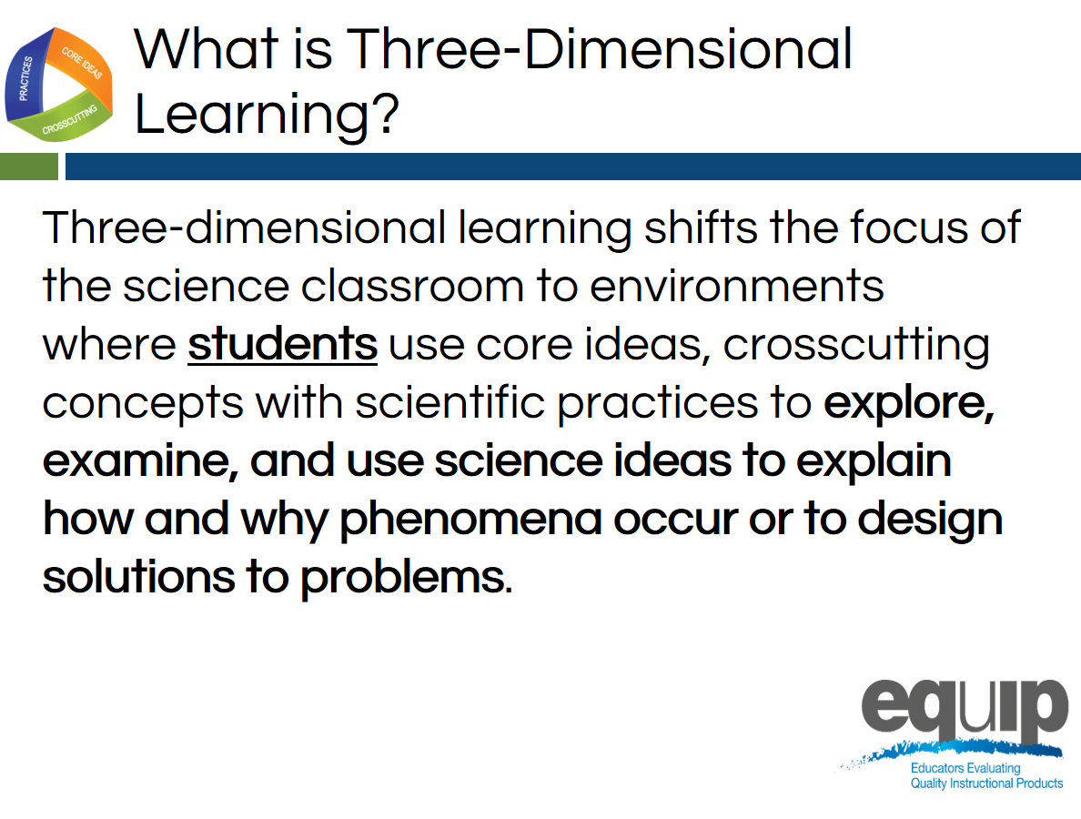
- The training is divided into an optional introduction and immersion module followed by 10 modules. These are divided into nine instructional modules followed by a culminating task in Module 10 where participants apply what they’ve learned through the first nine modules.

Slide 2
Talking Points
- We are going to begin our day thinking about a major innovation in the NGSS, 3-dimensional learning.
- Please take a moment to read the description of 3-dimensional learning pictured in the screen. [Note to facilitator: pause for 30 seconds.]
- We are going to provide you with an opportunity to experience 3-dimensional learning today.
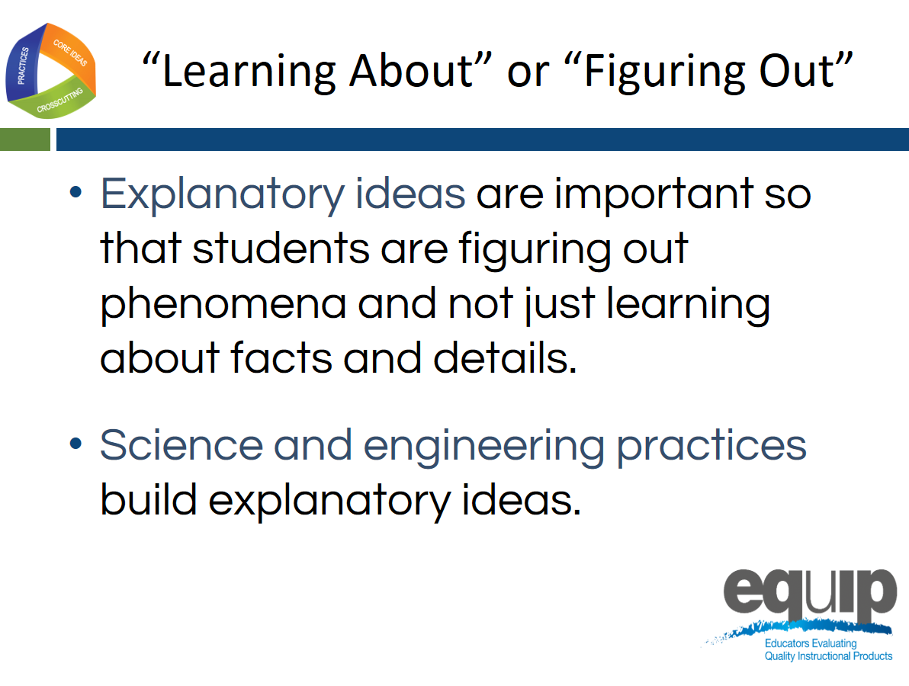
Slide 3
Talking Points
- In an NGSS classroom, the focus shifts from simply learning about science ideas that students often have difficulty applying to real-world contexts to figuring out or making sense of phenomena in the world that students are motivated to explain.
- Students are not just learning about a topic, but figuring out why or how something happens in the world.
- Students can then use these explanations to make sense of new contexts and transfer this working knowledge to new situations.
- Students build this working knowledge by engaging through the practices, by using the crosscutting concepts to organize and connect thinking, and by using the disciplinary core ideas to explain their world and develop solutions to problems.
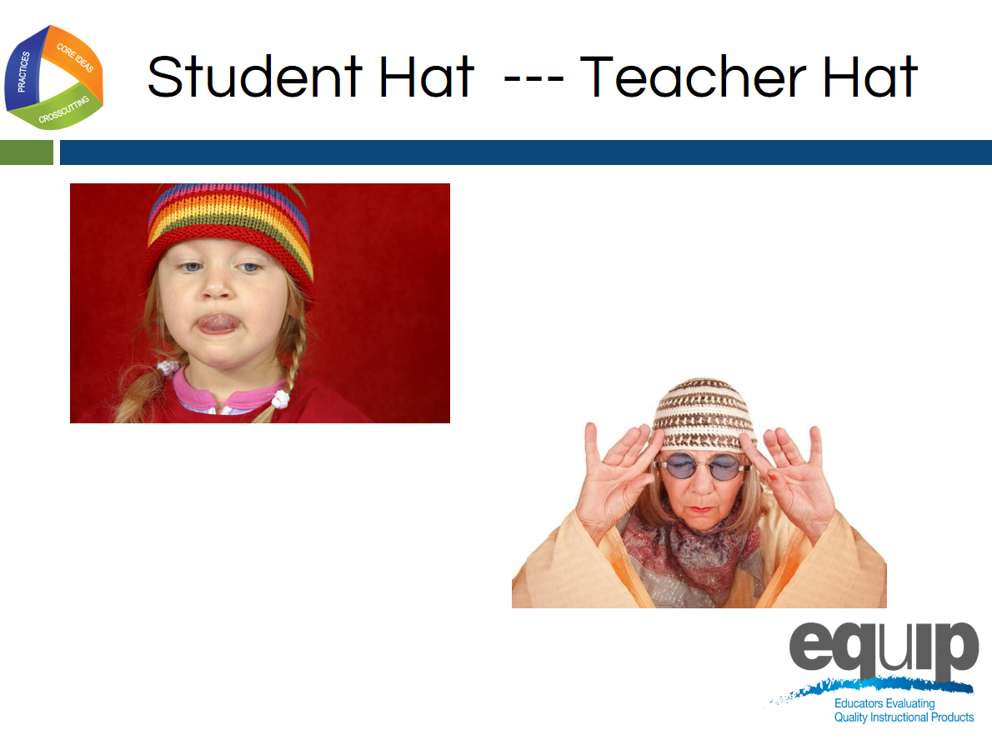
- Figuring out or making sense of phenomena supports 3-dimensional learning.

Slide 4
Talking Points
- Let’s experience figuring out by engaging in 3-dimensional learning together.
- In this immersion experience into the 3 dimensions, you will be wearing two hats.
- First we will wear our student hat as we productively struggle with a phenomenon.
- Second, we will put on our teacher hat, and look of evidence of student thinking and learning in student products.
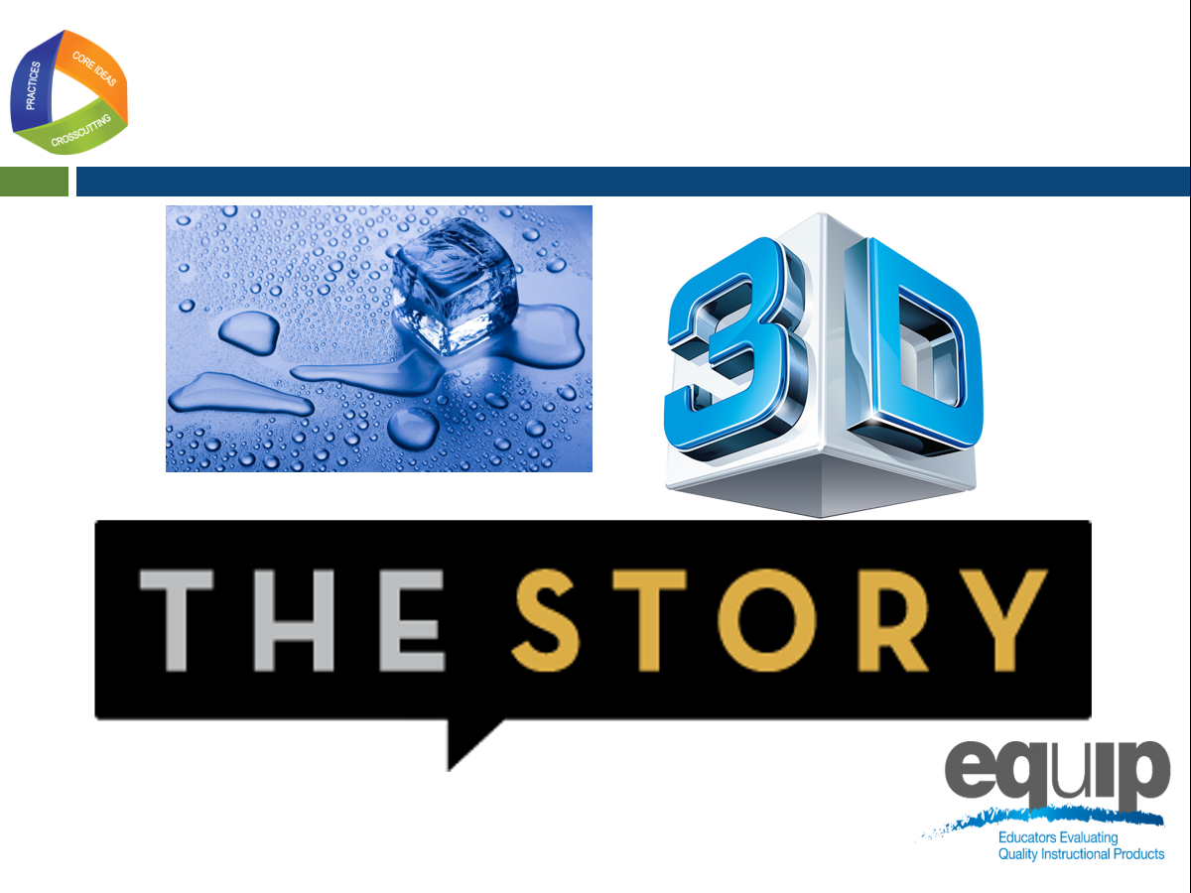
- Examining the three dimensions from both the creation and evaluation perspective will deepen our understanding of how students build an understanding that they can use to explain the world.

Slide 5
Talking Points
- As the vision A Framework for K-12 Science Education suggests, students need to be active constructors of their understanding by engaging in the SEPs while applying one or more CCC to make connections between discrete pieces of knowledge using disciplinary core ideas, to create that full picture of why or how something is happening in the world.
- Today, as we engage in this immersion experience, let’s ask ourselves: “How does the lesson help students make meaning of the phenomena as they engage in the three dimensions targeted by the lesson and build toward proficiency of the performance expectations?”
- Just as we are motivated to experience the next event in a story, when instruction is anchored in figuring out phenomena through active engagement in the 3 dimensions, students are hungry for more evidence to explain their world in a way that is personally relevant to them.
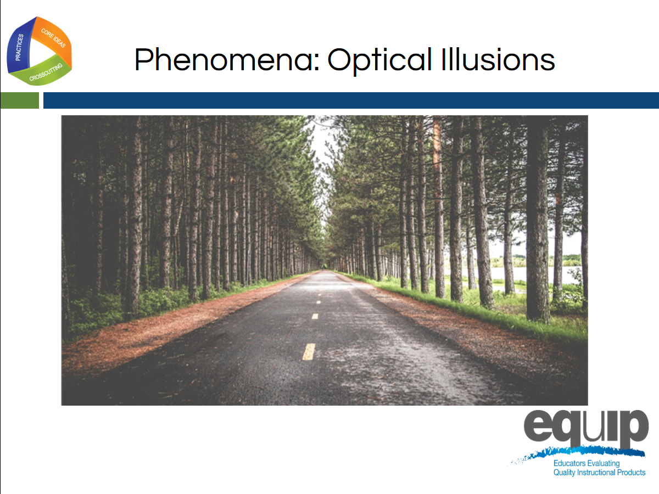
Slide 6
Facilitator Notes
- Slides 6–10 provide an opportunity for participants to engage with the phenomena (3 optical illusions) and to generate their own questions about what we need to figure out to be able to explain why we cannot trust our eyes. Student-generated questions will create multiple lines of inquiry that will create multiple lessons or opportunities for learning.
Talking Points
- Due to time constraints, we will experience the introduction and first lesson of a unit where students are working to explain optical illusions.
- This unit used a common phenomenon to make connections between the physical and life science domains.
Participant Takeaway
The world is interdisciplinary, meaning the phenomena we observe often need multiple domains of science to be explained. This is an opportunity to encourage participants to consider the value in not narrowing our focus of instruction to one domain when there are opportunities to provide students with a more interdisciplinary experience.
Slide 7
Facilitator Notes
- When participants view this slide, they should see moving circles.
- It is important to test this slide in your presenting space prior to the presentation.
- Sometimes, depending on the projector and the size of the projected image, the movement of the circles is not obvious.
- If this happens, you can provide a link to the image, and ask participants to view the image on their personal device, which works very well: http://bluestar209.deviantart.com/art/Spinning-Circle-Illusion-71755761
Talking Points
- As we know, acting and thinking like scientists has a foundation in making careful observations and recording this data to reference later.
- As students, I would you like you to make observations:
  - What do you see?
  - Do you observe anything moving or changing?
- Please record these observations on a piece of paper or on a document on your device.

Slide 8
Facilitator Notes
- This is a video clip from ASAP Science: Can You Trust Your Eyes? (https://youtu.be/ZflIMBxyIak).
- Play the video with the sound off.
- The video has been cut to start at 51 seconds and end at 1:51.
Talking Points
- Let’s make observations of a second optical illusion.
- As you view the image, please consider this question: Are squares A and B the same shade of gray? Record your observations. [Note to facilitator: play the video and leave the 2 squares side by side on the screen at the end of the video clip so participants can make observations.]
- Now that the green cylinder has been removed, record observations after this subtraction.
- Are squares A and B the same shade of gray? Record your observations.
Slide 9
Facilitator Notes
- The final video in the series shows an image where Marilyn seems to change to Einstein. The video can be found at this link https://www.youtube.com/v/gfvMU36fgKw
Talking Points
- Let’s consider one more optical illusion.
- After start the video, I would like you to record your observations about the changes in this optical illusion. What do you notice? [Note to facilitator: Show the video so that the participants see the image approach and then return to starting position in the distance. Ask them to record what they noticed. Then continue with the talking points.]
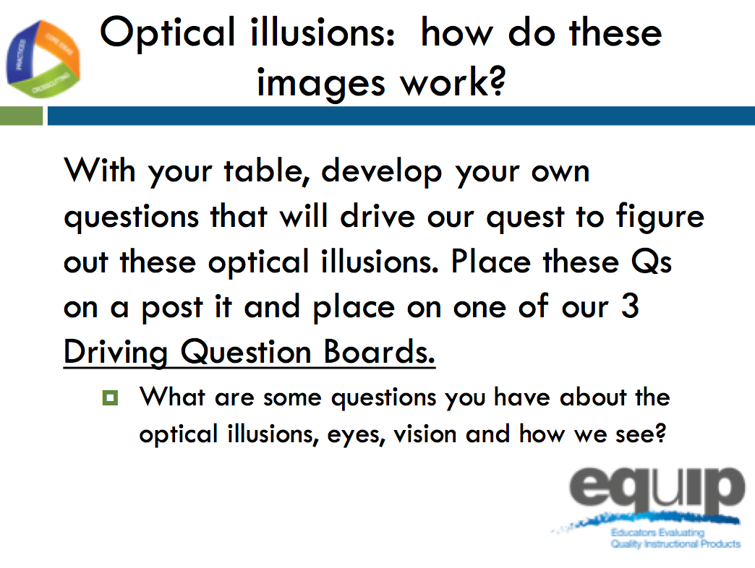
- I am going to show you the approaching image again. This time, I would like you to indicate by yelling out “NOW” when you see Einstein change back to Marilyn on the return (fade). Record what you notice about the “yells” from individuals. Do you notice any differences? [Note to facilitator: play video a second time.]

Slide 10
Facilitator Notes
- For this slide, you will need to prepare 3 driving question boards and a 4th “outlier” board on chart paper. Label the chart paper with the following questions written along the top of the chart paper leaving ¾ of the space for participants to place post it notes.
  - Chart Paper 1: label What do you need to see an object?
  - Chart Paper 2: label How does light get into our eyes? How does light allow vision?
  - Chart Paper 3: label How does the brain process signals?
  - Chart Paper 4: label Outlier board
- Hang the chart paper in a common area where participants can easily leave their seat and post their questions.
- Post-it notes are needed on each table for participants to use to record questions. Each participant will need approximately 1–2 post it notes.
Participant Takeaway
The point of using phenomena to drive instruction is to help students engage in practices to develop the knowledge necessary to explain or predict phenomena. Therefore, the focus is not just on the phenomena itself. It is the phenomena plus the student-generated questions about the phenomena that guides the teaching and learning. The practice of asking questions or identifying problems becomes a critical piece in trying to figure something out. This paragraph is an excerpt from the NGSS resource Using Phenomena in NGSS-Designed Lessons and Units, which is also Handout 2.

Talking Points
- After observing the three optical illusions, how would you answer the question: Can you trust your eyes? How do you know?
- Can you provide an explanation for optical illusions?
- Take a minute and generate questions stemming from observing these three optical illusions. Generate questions that are specific enough such that if you figured each of them out, you would be closer to answering the big question: Can we trust our eyes and thus explain optical illusions?
- Place each question on a separate post-it note. I am asking that everyone create at least 1 question from your observations.
- After you construct your question, come up to the driving question boards and place your question on the board that you think it could best connect with.
- After careful consideration, if you feel your question does not fit nested under any of these 3 questions (pointing to area with the 4 boards), then place your question on the outlier board.
- After placing your question on one of the 4 boards, please return to your seat. [Note to facilitator: Give participants 3–4 minutes to construct at least 1 question and place it on the Driving Question Board.]
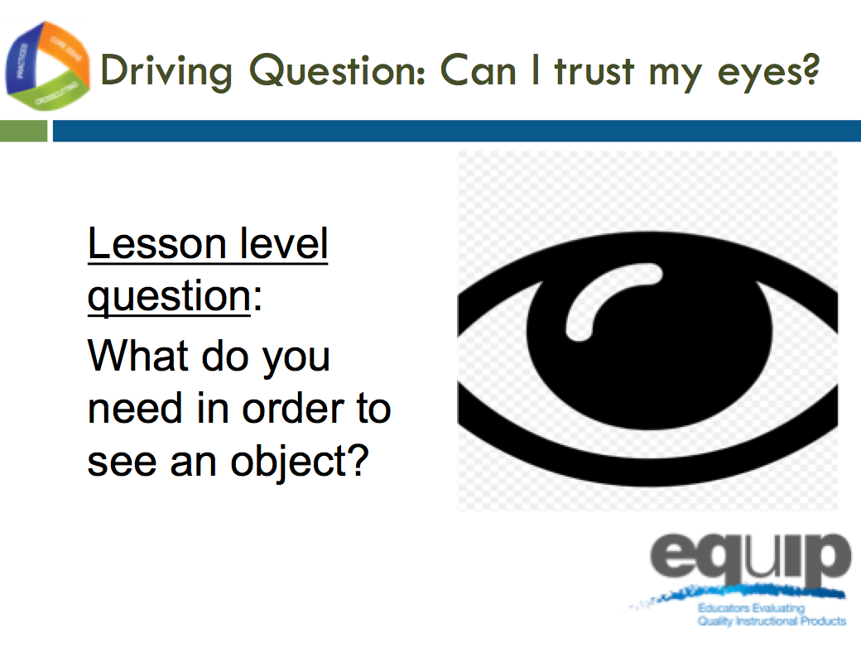
Slide 11

Facilitator Notes
- Slides 11–23 are the slides that guide lesson 1 of the optical illusions unit. Training participants should be reminded to put on their “student hat” and engage in this lesson as a learner.
Talking Points
- Not all phenomena need to be used for the same amount of instructional time. The optical illusions are our anchoring phenomena that drive the whole unit.
- Just as the students did in class, you generated science questions, which will drive our learning in each lesson and which are now posted on our driving question boards.
- We will now participate in the first lesson of this unit.
- The lesson level question is: “What do you need in order to see an object?”
- You will notice that this was one of the questions at the top of one of the driving question boards. We will begin to answer your questions posted on this board with this lesson.
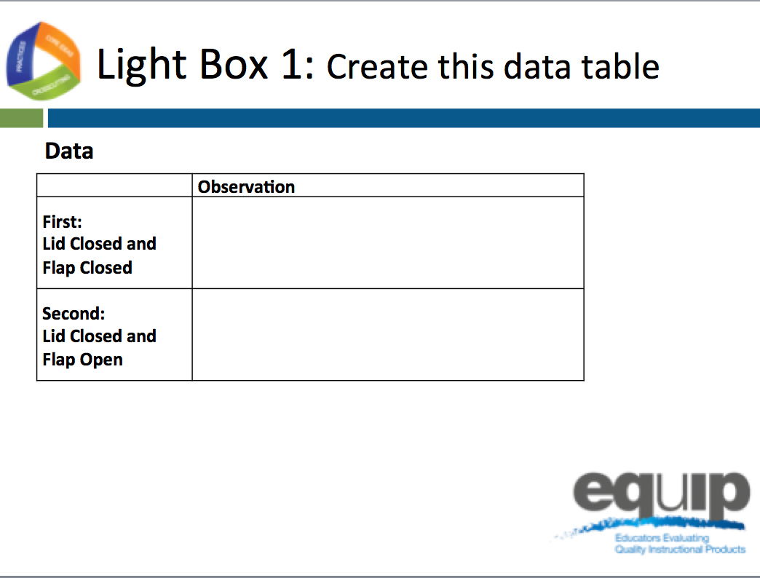
Slide 12
Talking Points
- We will work to find an answer to our lesson-level question: “What do you need in order to see an object?” by making observations with a light box.
- Before we begin, please create this data table on your paper. [Note to facilitator: Give participants 1 minute to create the table.].
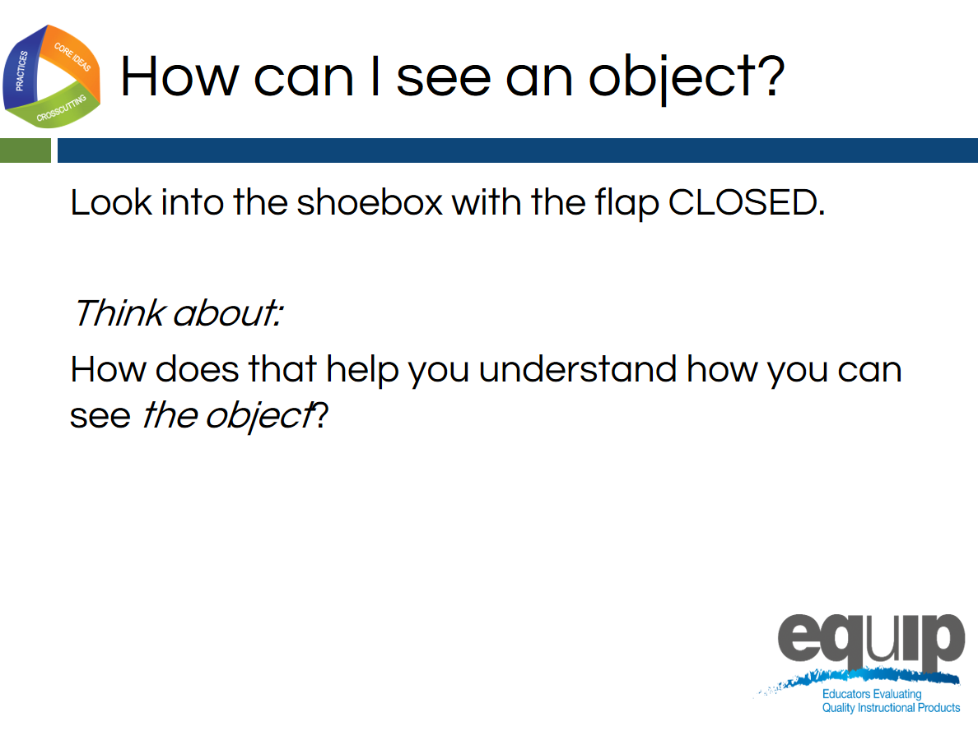
Slide 13
Facilitator Note
- Please distribute the light boxes at this time.
- Be sure that each light box has an upright object placed in one end of the box according to the directions provided, and that the divider is not placed in the box.
- The participants should keep the lid on the shoebox at all times and for slide 13, and keep the side flap closed so no light enters the box.
- You will need 1 light box for every 4–8 participants.
Talking Points
- I have provided you with a light box.
- It is important that you keep the lid on the box at all times.
- Right now, be sure to keep the side flap closed.
- One at a time, please look through the hole at the end of the box and record in words what you notice or observe.
- Record your observations in your data table in the row labeled “Lid closed flap closed”.
- After you make your observations, please pass the light box to the next person at your table without talking.
- You may place the box in different orientations or positions as you explore and make observations as long as the lid stays on and the flap stays closed.
- Note to Facilitator: After each person in the group has had an opportunity to observe the light box with the flap closed, click forward on the animation to step into the next statement on the slide. Ask the participants to think about (not record) how what they just observed helps them understand how we see.
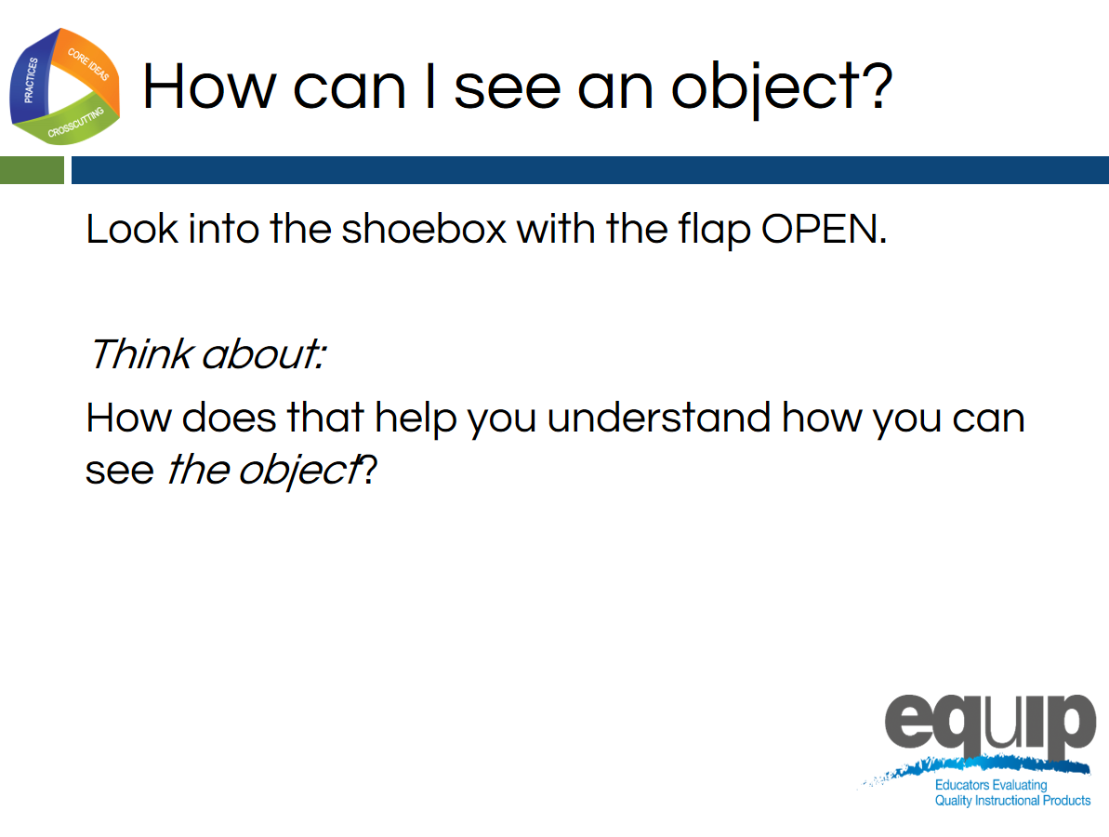
Slide 14
Talking Points
- Now I am asking you to open the side flap on your box.
- One at a time, please look through the hole at the end of the box and record in words what you notice or observe.
- Record your observations in your data table in the row labeled “Lid closed flap open”.
- After you make your observations, please pass the light box to the next person at your table without talking.
- You may place the box in different orientations or positions as you explore and make observations as long as the lid stays on and the flap stays open.
- Note to Facilitator: After each person in the group has had an opportunity to observe the light box with the flap open, click forward on the animation to step into the next statement on the slide. Ask the participants to think about (not record) how what they just observed helps them understand how we see.
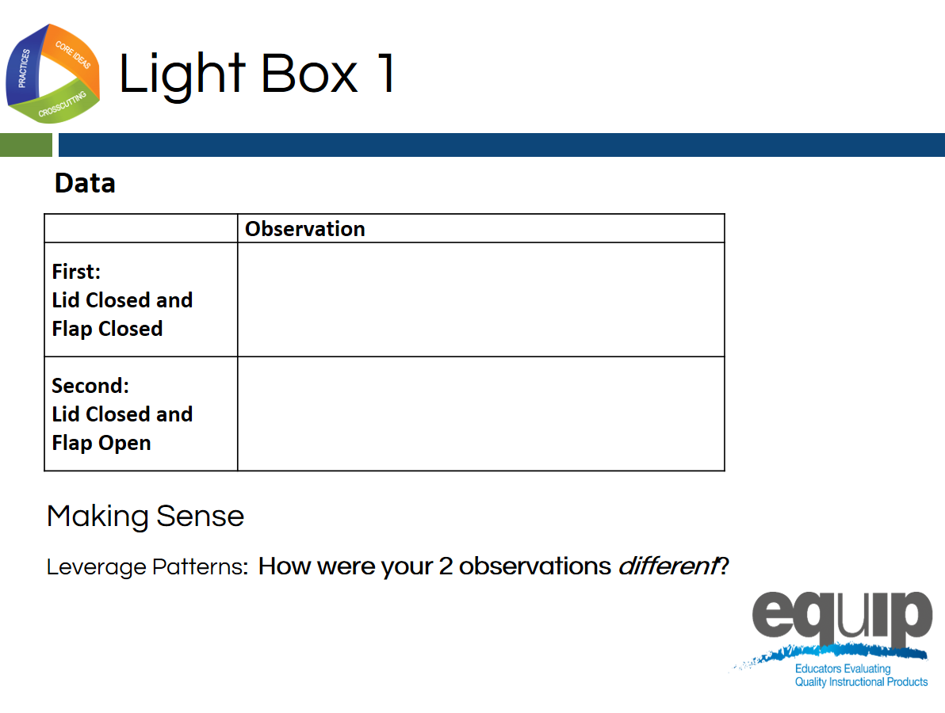
Slide 15
Talking Points
- Now that you have recorded observations with the flap closed and the flap open, let's make sense of our observations before moving on.
- Let’s use the concept of patterns to record how these 2 observations are different.

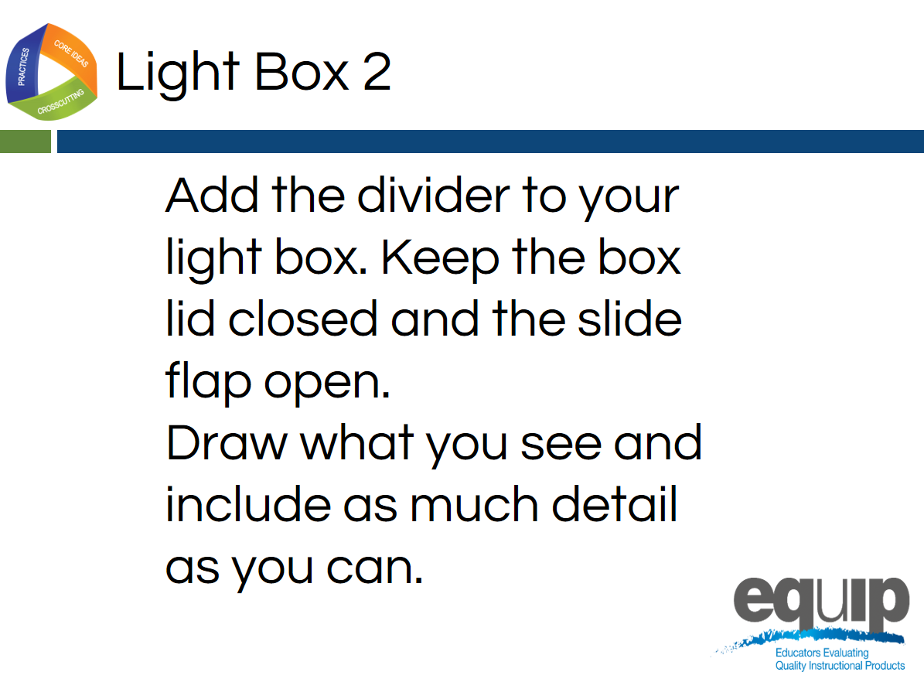
Slide 16
Facilitator Notes
- Before participants can make the next set of observations, the dividers must be added to the light boxes.
Talking Points
- Now let’s add the dividers to the light boxes.
- Remove the lid and add the divider. On the slides of the box, there should be guide lines made with a hot glue gun. Slide the divider in between these guides and put the lid back on the box.
- With the flap open, the lid closed, and the divider in place, make your observations.
- This time, draw what you see on your paper instead of describing it in words. [Note to facilitator: Give participants time to examine the light box with the divider in and the flap open.]

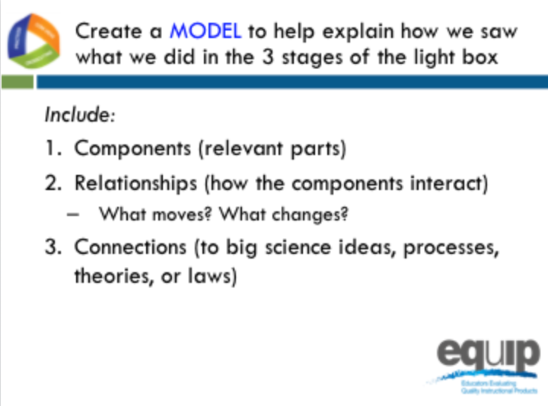
Slide 17

Facilitator Notes
- For this part of the lesson, each participant will need a piece of 11 by 18-inch paper.
- Participants will most likely struggle with knowing what to draw.
- Be patient and wait at least 2 minutes before giving them guidance.

Talking Points
- It is time to make sense of our observations and create a model to help explain how we see an object.
- We are creating a model that represents the process of vision using the observations and thinking we did during the 3 stages of the light box.
- These three stages were: flap closed, flap open, and divider in with flap open.
- Using the piece of 11 by 18 inch drawing paper provided, please represent your model of vision, including the criteria on the screen.
- Your model should contain the components or relevant parts required for us to see.
- Your model should include the relationships between these relevant parts. When thinking about relationships, you may want to consider the questions: What moves? What changes?
- Finally, think about the how your representation could connect to and use science ideas. [Facilitator Note: Participants may really struggle here and want more guidance. Please wait at least 2 minutes before moving to the next slide, which provides some support for sense-making.]
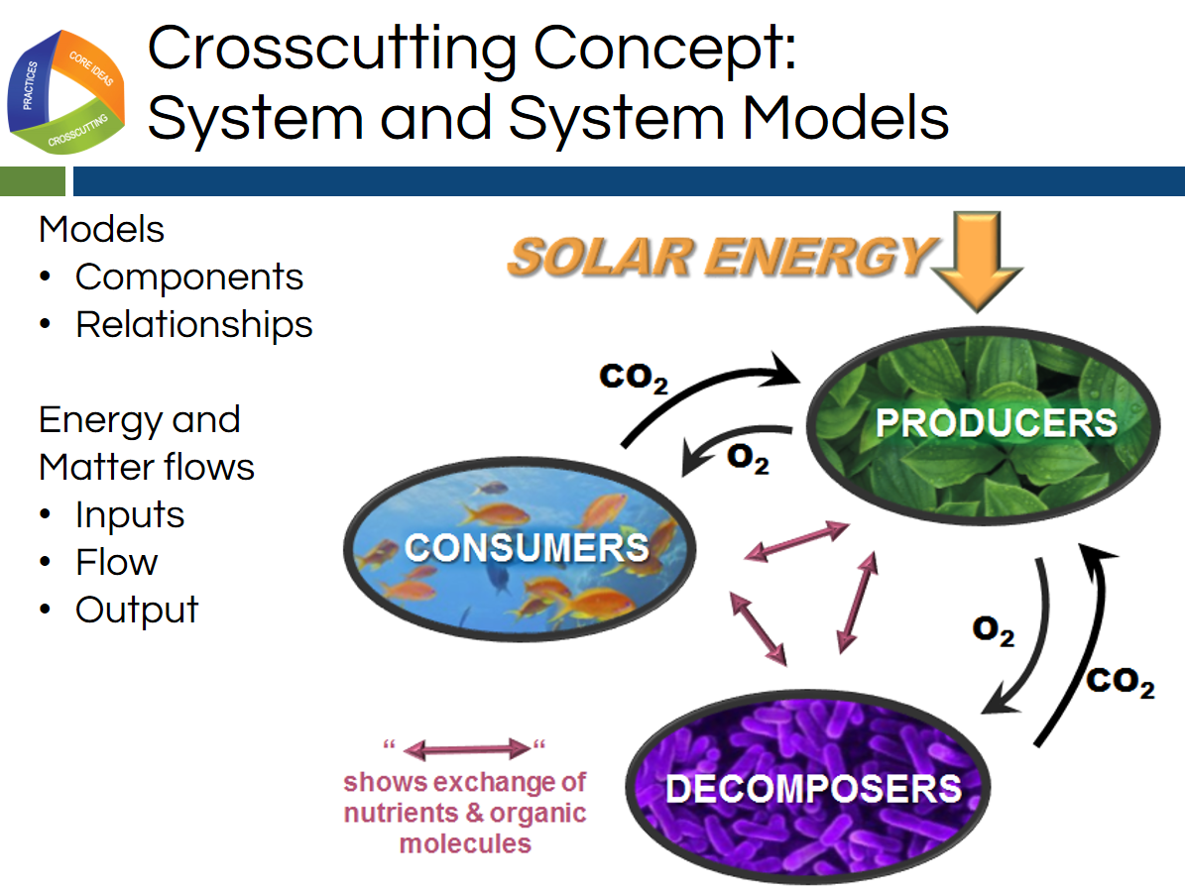
Slide 18

Facilitator Notes
- This slide provides support for drawing the model of the process of vision using the observations from the light box.
- This slide also serves to make the crosscutting concept of system and system models more explicit for the learner.
Talking Points
- We have used this light box lesson with hundreds of students and hundreds of adults. One thing is the same all around: most of the group struggles with this task.
- This struggle probably is a result of lack of experience with this kind of thinking, and in using scientific models to make sense of phenomena.
- Let’s first articulate our purpose for using the model. We are using the model to make our thinking visible to ourselves. By doing this, we are deepening our understanding of both the crosscutting concept of a system and the disciplinary core ideas we need to use to explain vision.
- Let’s consider this model on the screen. A model is a representation of a system that makes its central features visible and explicit.
- Let's consider the commentary to the side of the model on the screen. [Facilitator note: use a laser pointer to point this out on the slide.] First, it is reminding us that NGSS models have components or relevant parts and that the model should make visible the relationships between the components.
- To help learners with thinking about a system and a model, let's consider the commentary about energy and matter flows as we respond to the following questions.
  - How did this model’s creator show the relationships between components of this system? (arrows)
  - What similarities and differences (patterns) do you notice about the arrows? (some are purple, some are black, one is orange, some are labeled, they are different sizes, some arrows are double sided and some single, etc.…)
  - What is the model creator trying to communicate to us about this system based on this representation? [Note to facilitator: Discuss the reasons for this intentionality, emphasizing that every decision, every line, color, and label is intentionally and deliberately communicating the thinking of the model creator as it relates to the phenomenon.]
  - What are the components of this model? How does the creator show us these are the parts that are relevant and important to understand? How do the components interact in this system? (labels)
- Now that we have used a model in another context to understand how we might think about representing a system and making our thinking visible to ourselves and others, let’s return to our task.
Slide 19
- Let's remember, we are creating a model that represents the process of vision using the observations and thinking we did at the 3 stages of the light box.
- These three stages were: flap closed, flap open, divider in and flap open.
- Use your observations and our discussion about components and relationships to create your model of vision. [Facilitator note: give participants another 2–3 minutes of struggle. Most participants will begin to draw something, but a few may still be hesitant.]
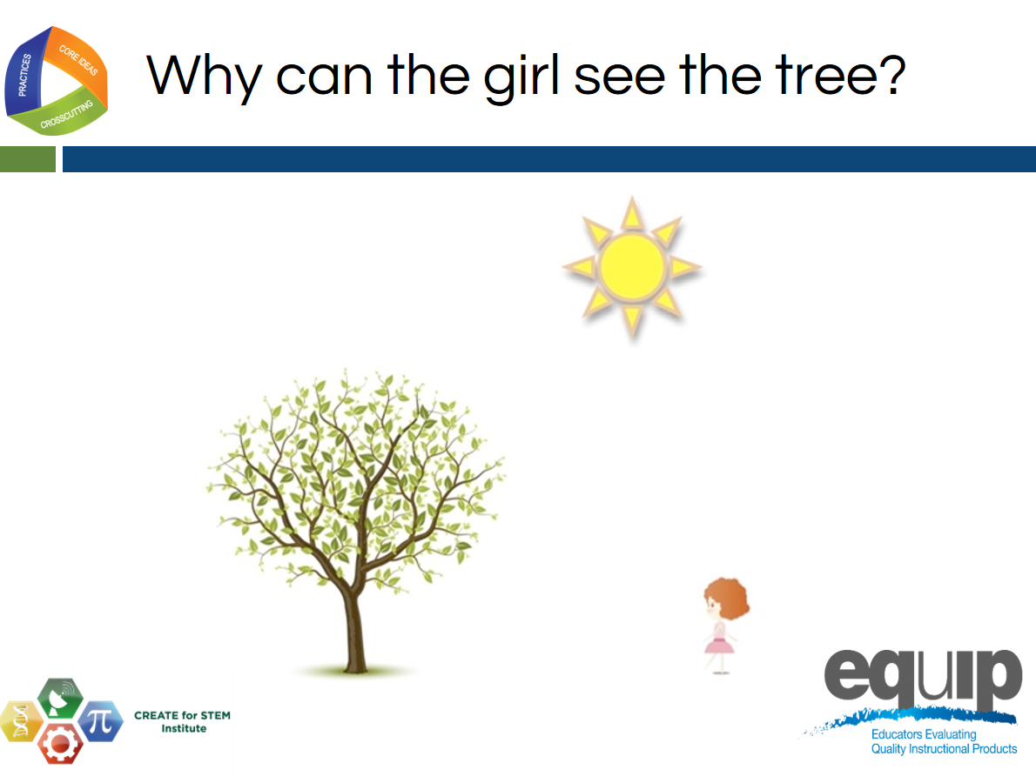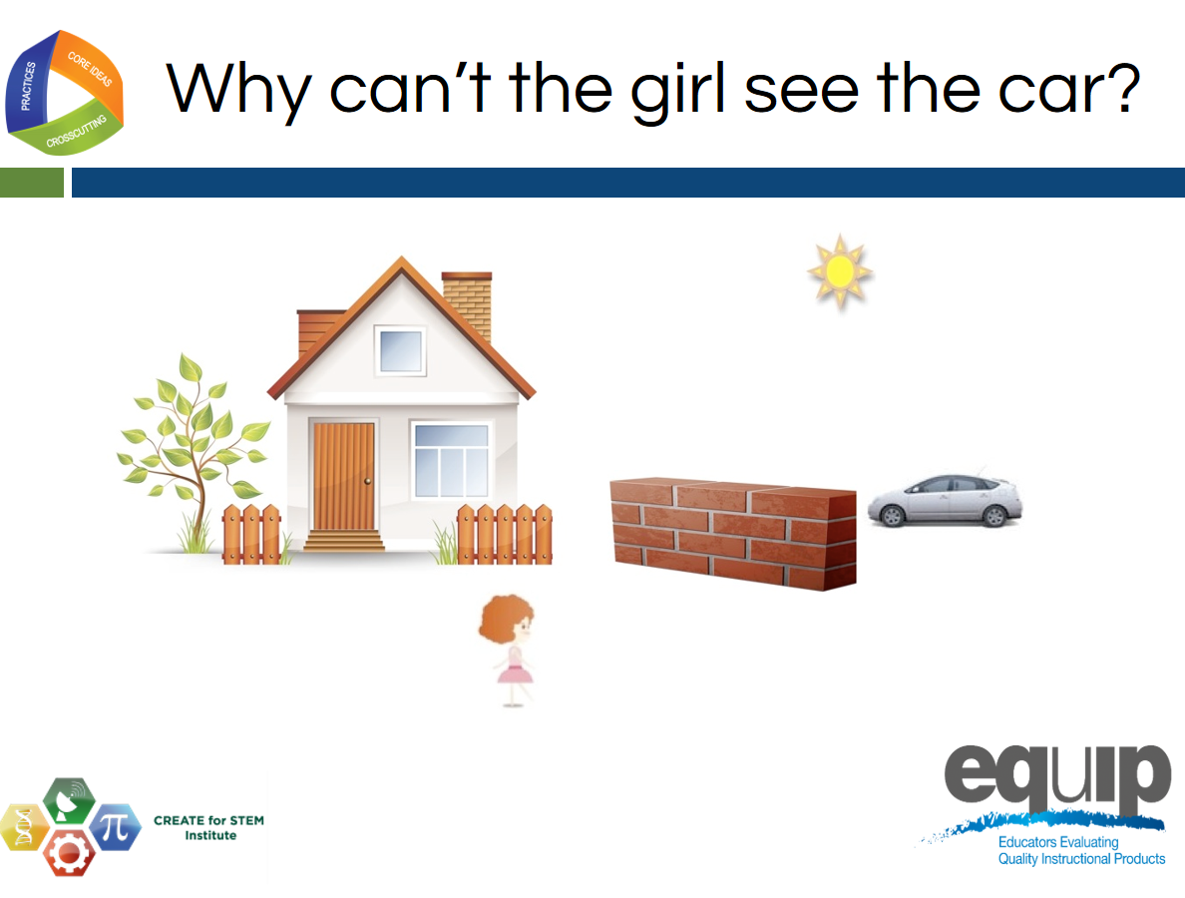
Slides 20–21
Talking Points
- Let's provide one more piece of guidance for affirmation or for support for those still struggling.
- For the next 2 slides, I want you to think about the question written at the top of each slide as well as the differences between the pictures.
- You may notice a Create for STEM Institute logo on the corner of the slide. We want to thank them for permission to use these images.
- [Facilitator Note: Show slide 20 and 21, reading the question at the top of the slide for each. Toggle back and forth between them a few times.]
Slide 22
Talking Points
- Let's take a few more minutes to complete our models.
- We will be bringing these models into a group discussion with our table. [Note to facilitator: give participants a few more minutes to finish the models. Move on to the next part when most have finished working.]
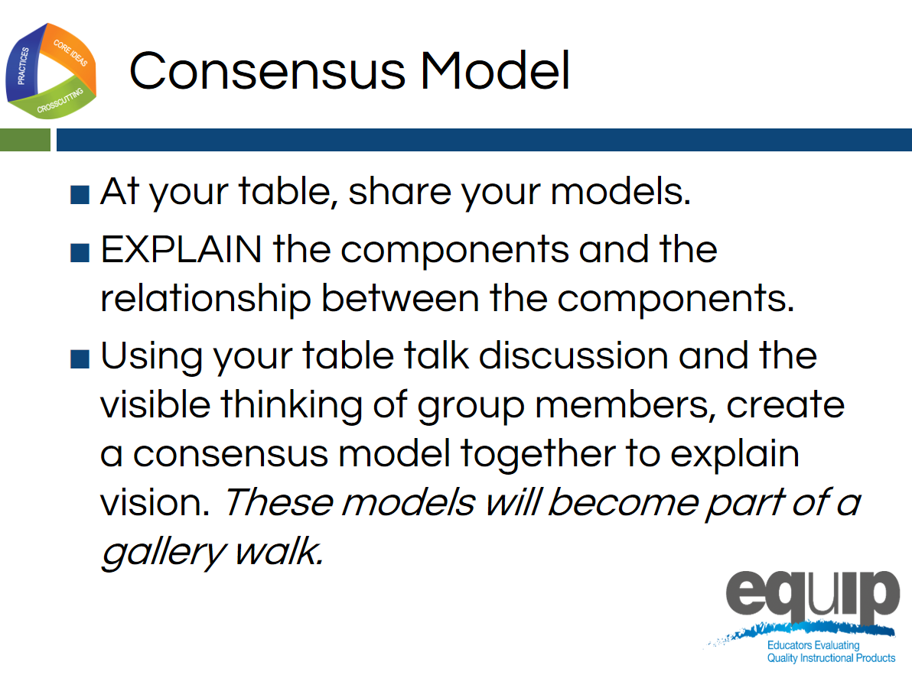
Slide 23
Facilitator Guide
- Each group will need a piece of chart paper (the paper with adhesive already present works best).
- This is a good time for groups to take a break after displaying their consensus model in a gallery walk and before the debrief of the immersion.
Talking Points
- Let's share our thinking with our table with the purpose of offering our thinking and ideas to our community and accepting what the community offers us.
- Our goal is to create a consensus model representing vision.
- Please follow this protocol. Each person should take a minute or two to share their model by holding it up to the group and talking about how he or she chose to represent the components and relationships within the system.
- After each person shares, the group should use the chart paper to create one consensus model that will be displayed in a gallery walk.
- Once you hang up your group’s chart paper consensus model, your group may take a break.
- Please return for discussion at ____________.
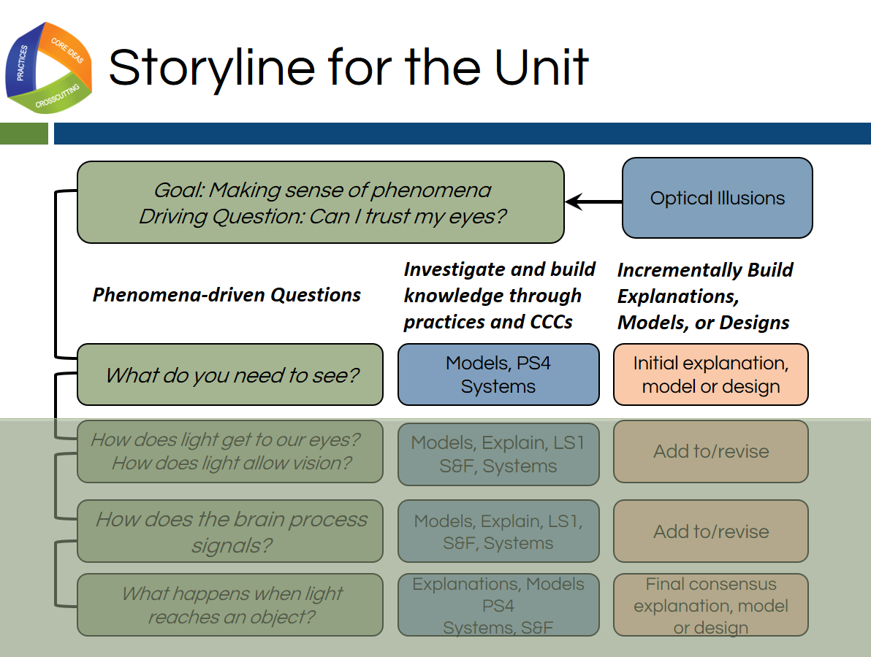
Slide 24
Talking Points
- Let's think about where we started today. Our immersion experience gives us an example of how working to explain phenomena is the central reason why students engage in 3-dimensional learning.
- Since we could not immediately explain the phenomena of optical illusions, we had many questions about them that are still displayed on our Driving Question Board.
- These questions drive the lessons, learning, and monitoring throughout the unit.
- We can see that idea represented here in this graphic organizer.
- Each row of the organizer is a different lesson in the unit.
- Today, we experienced lesson one using the light box.
- As learners, we created an artifact of that learning in our individual models as well as our group consensus models.
!
- Sense-making and making thinking visible through the models enabled us to further our understanding of both the core ideas and concepts as well as the practice of modeling itself.
- Let’s evaluate some examples of the models created by 9th grade students in order to deepen our understanding of the 3 dimensions and how students use the dimensions together to build usable knowledge.
Facilitator Notes
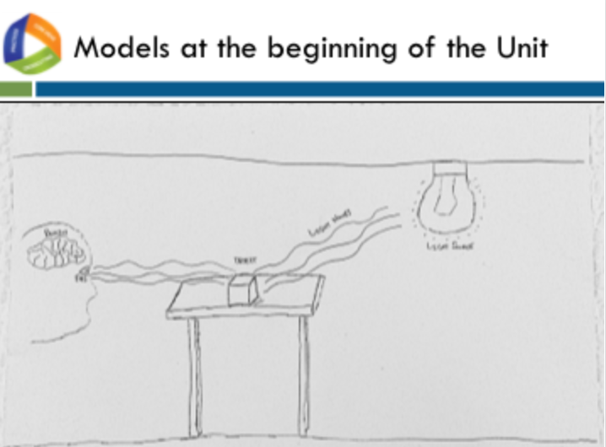
Each group will need a set of models (A–D) for the evaluation of student understanding section of this module starting with slide 25. The models are included as Immersion and Introduction Handouts A, B, C, and D.

Slide 25
Talking Points
- You will be provided with a set of models.
- The first model marked “Beginning” is the consensus model developed by a group suing the same lesson you experienced today.
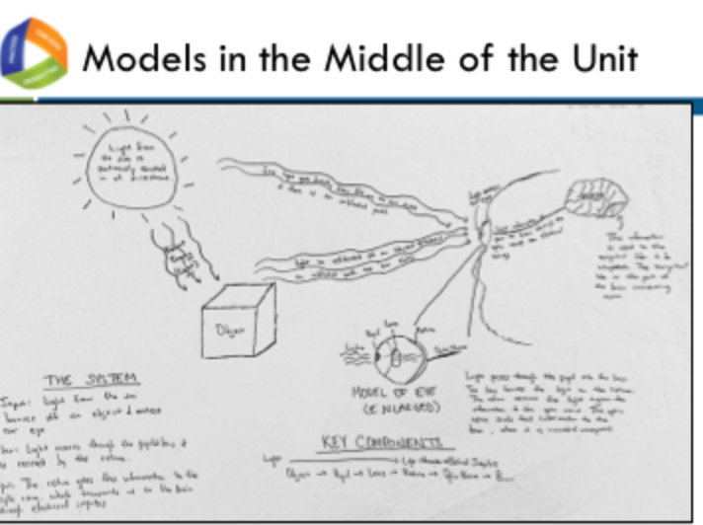
Slide 26
Talking Points
- The second model (marked mid-unit), is an individual model made after 3 lessons where students were working to build an understanding of optical illusions so that they could explain why their perception was different from reality.
- The sets were formed by combining the individual model with the consensus model of which the individual student was a member. For example, you could have Joey’s model that is a mid-unit model and the consensus model for which Joey was a member at the beginning of the unit.
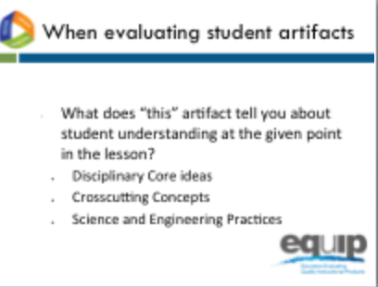
- The model sets are identified as A through D. Each table has all 4 sets.

Slide 27
Talking Points
- When evaluating each model, we need to ask ourselves “What does this artifact tell us about student understanding at a given point in the lesson?”
- We have 2 data points for each student: a beginning consensus understanding and an individual mid-unit understanding.
- We will look to the appendices of the NGSS for guidance about how to determine observable evidence of 3-dimensional learning.
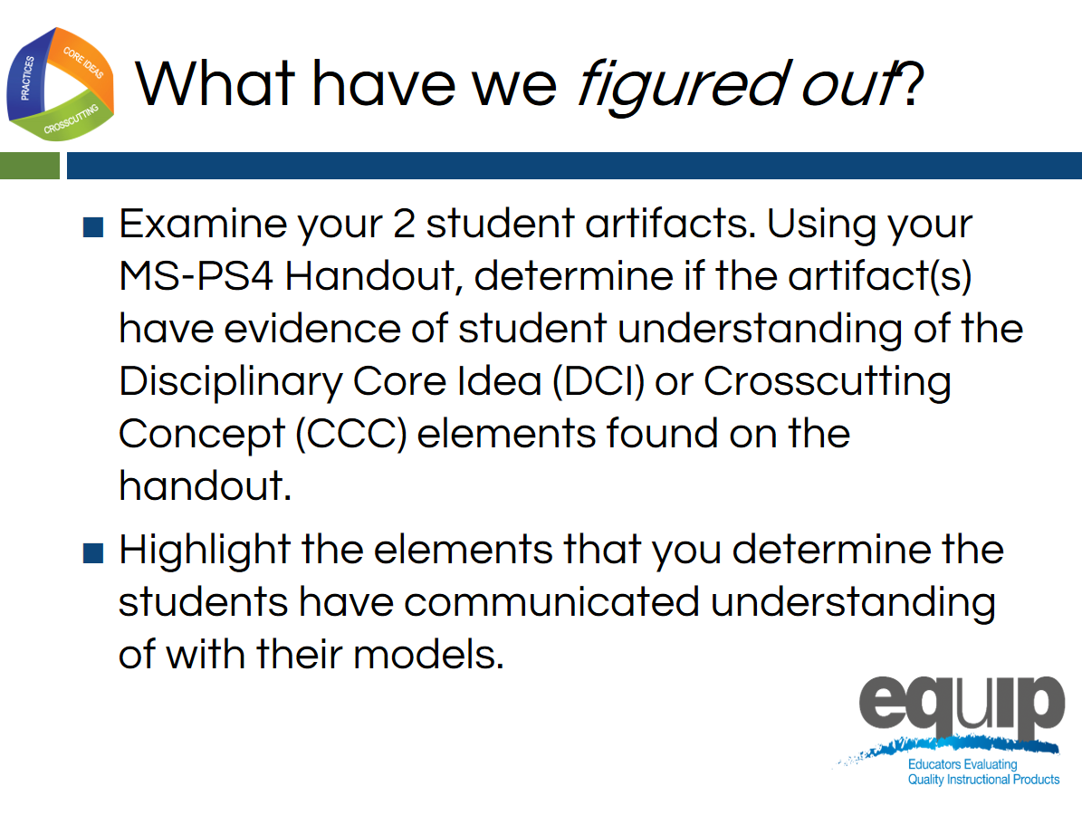
Slide 28
Talking Points
- Please find a partner and as a pair, examine your 2 student artifacts. Using your Middle School disciplinary core idea and crosscutting concept handout (MS-PS4-2 Handout), determine if your student artifacts can count as evidence of student understanding of any of the bullets in the handout.
- Each one of these bullets is called an element in the NGSS.
!
- The NGSS identifies the capabilities students should demonstrate when using each dimension (science and engineering practices, crosscutting concepts, and disciplinary core ideas) by the end of each grade band. These capabilities are called elements, and are represented by the bullets in your handout.
- Your job is to work with your partner and highlight the elements that you determine there is some evidence of in the student work.
- Facilitator Note: Give participants about 10 minutes to complete this task.

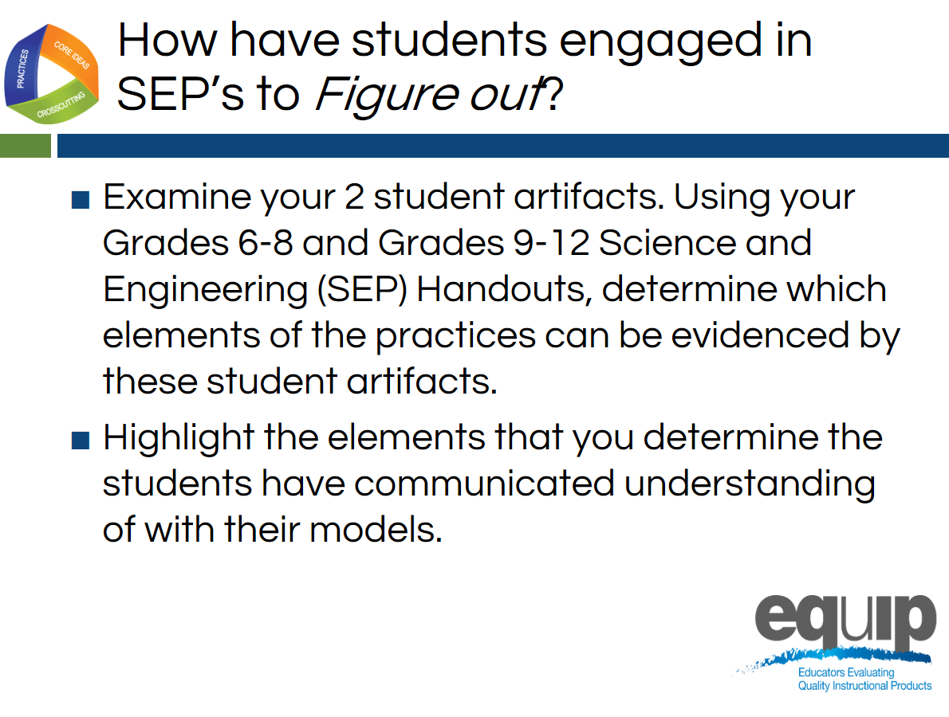
Slide 29
Talking Points
- Let’s take a look at the dimension of science and engineering practices.
- This unit was taught in a 9th grade Integrated Science class.
- Through pre-assessment, the conclusion was made that the students did not have the foundational knowledge of the disciplinary core ideas and concepts from middle school necessary to explain the phenomenon of optical illusions. Because of this, the teacher made the decision to use elements of both middle school and high school DCIs and CCCs in this unit.
- Most of the students in this class were new to the NGSS. They did not have prior experience with using and developing scientific models. Because of this, the teacher made decisions to provide scaffolding of this science and engineering practice within the lesson,
- Your task is to determine if the student used elements from the science and engineering practice of developing and using models at the middle school grade band, at the high school grade band, or both.
- Please have a discussion with your partner and evaluate your set of artifacts to determine which elements of the science and engineering practice of modeling you see evidence of in the student work.
- In addition, please discuss any other evidence of other science and engineering practices at the element level that you feel you experienced in the lesson today.
- Facilitator Note: Give participants an additional 5 minutes to conclude their discussion.

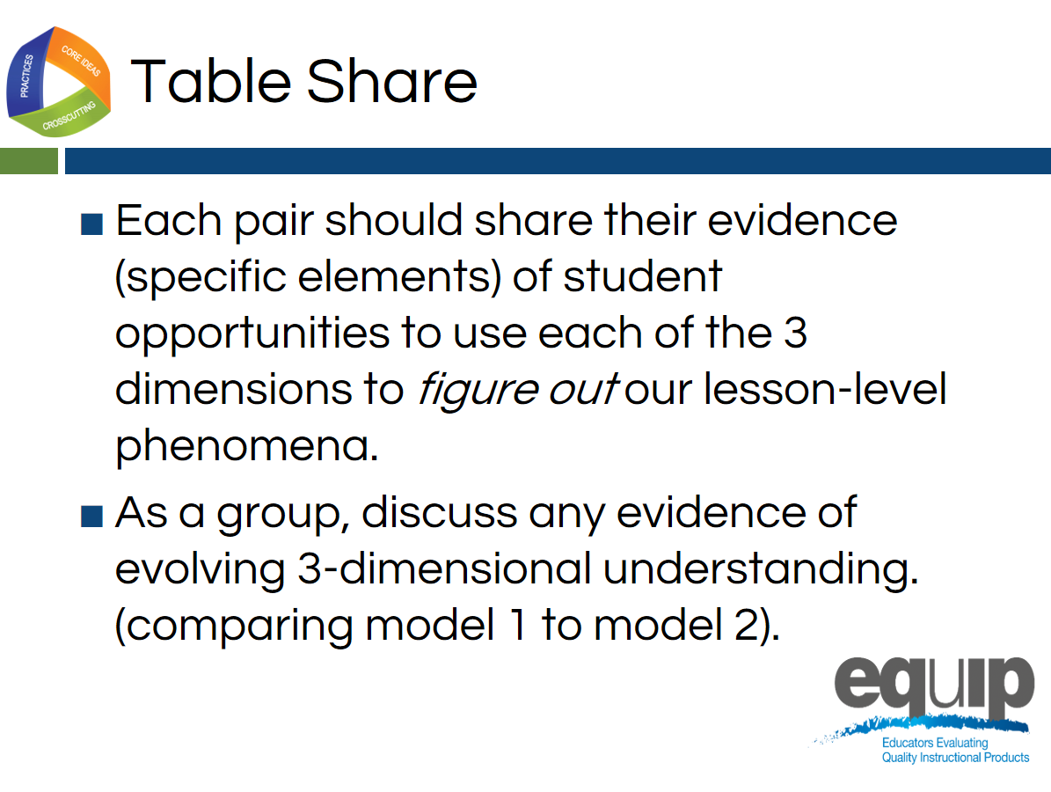
Slide 30
Talking Points
- Now let’s have a brief table level discussion. Since there are 4 sets of student work available at each table, a whole group discussion will enable the group to consider the evidence of student learning at both the individual and the whole class level with a table conversation.
- Each pair should take about a minute or so to share their takeaways from this experience and any conclusions they discussed about the set of student artifacts they evaluated. [Note to facilitators: Give participants 5–7 minutes to have a table discussion.]
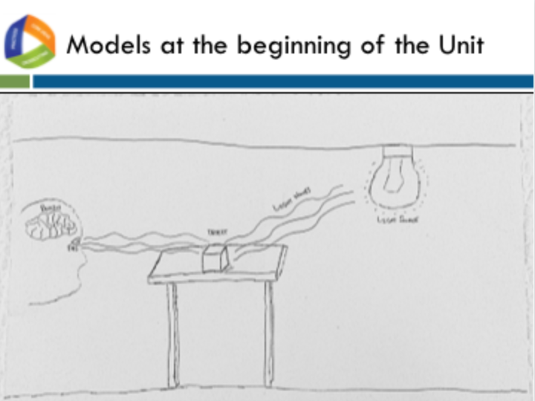
Slide 31
Talking Points
- Let’s discuss our immersion experience into 3-dimensional learning as well as the evaluation of student products.
- The focus of this discussion will be on the innovation of 3D learning as well as the student products as a means for students to make their thinking visible to themselves and others and to receive feedback to move further in their learning.
- The effectiveness of our NGSS-design planning and implementation of that plan is directly tied to student evidence of learning.
- What did that evidence tell us today? How can we use the guidance provided in the NGSS to evaluate these student products and improve our NGSS design?
- When we observe the initial consensus model on the screen, we see some misconceptions that were common in these models.
- For example, are those waves coming out of the eye or going in? What are the waving lines? Are all of the components of vision represented?
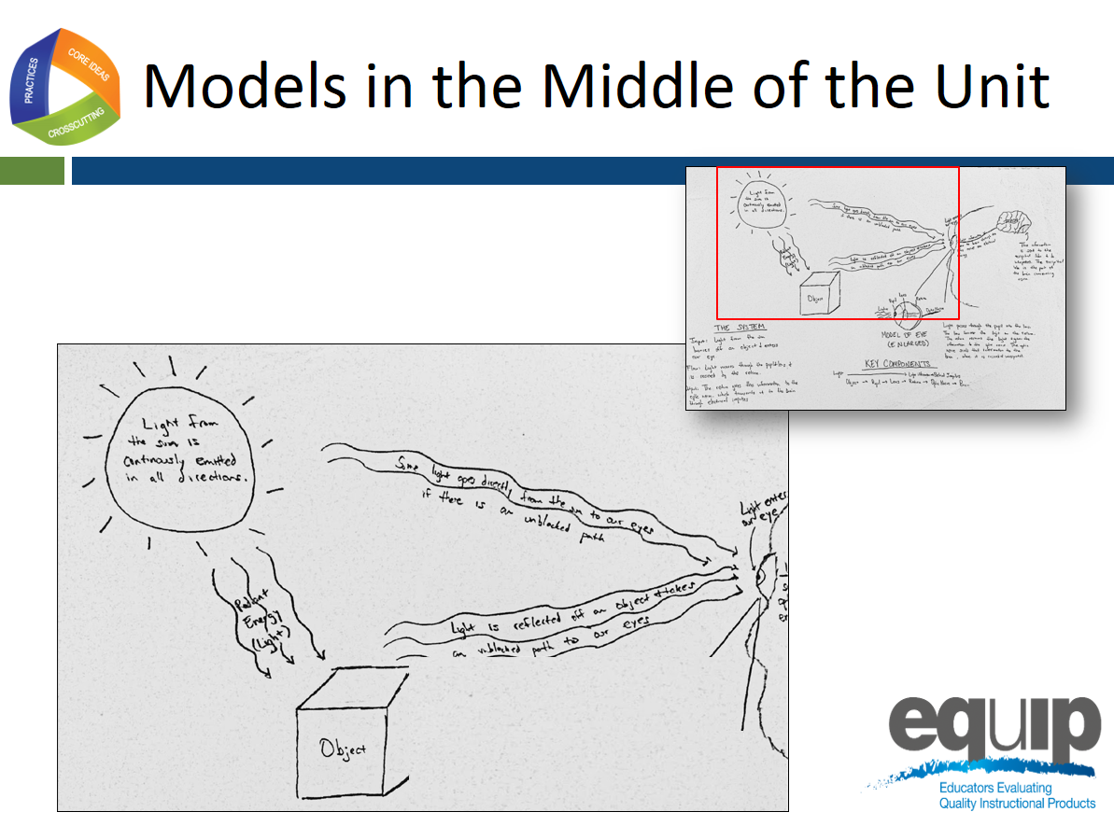
Slide 32

Talking Points
- Let’s look at the mid-unit models.
- The area in the red box has been enlarged to take up most of slide so we can discuss the components and relationships that the students made visible in their models to communicate how vision works.
- Comparing this mid-unit model to the initial model we just observed, we notice right away that the student has more commentary and is using more language to make his or her thinking visible.
- The language and commentary demonstrates some understanding of how light or radiant energy is emitted in all directions from a light source, how light is reflected off of objects, and how light must travel in a straight path to the eye in order to see.

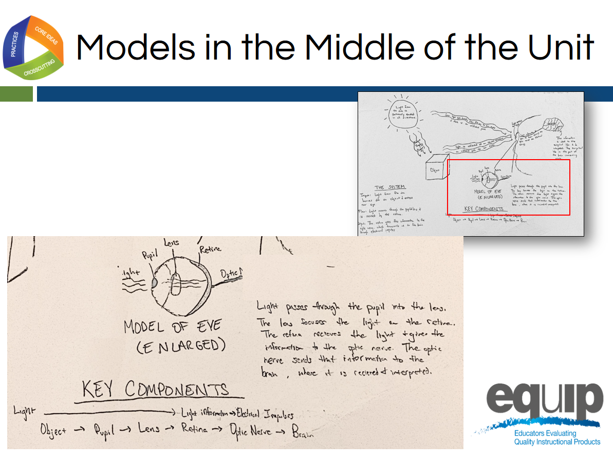
Slide 33
Talking Points
- In this model, the student felt it was essential to communicate the hierarchical organization of the eye itself, or in other words, that the eye is a part that is made up of sub-parts, and that each plays a role in vision.
- The student did not label all of the parts of the eye that might be learned through a typical study of this sensory organ. He or she only included the relevant parts, thus being very intentional. The commentary next to this labeled eye also communicates an understanding of the crosscutting concept and core idea of energy, indicating that light energy is being converted into electrical impulses by the eye on its way to the brain.

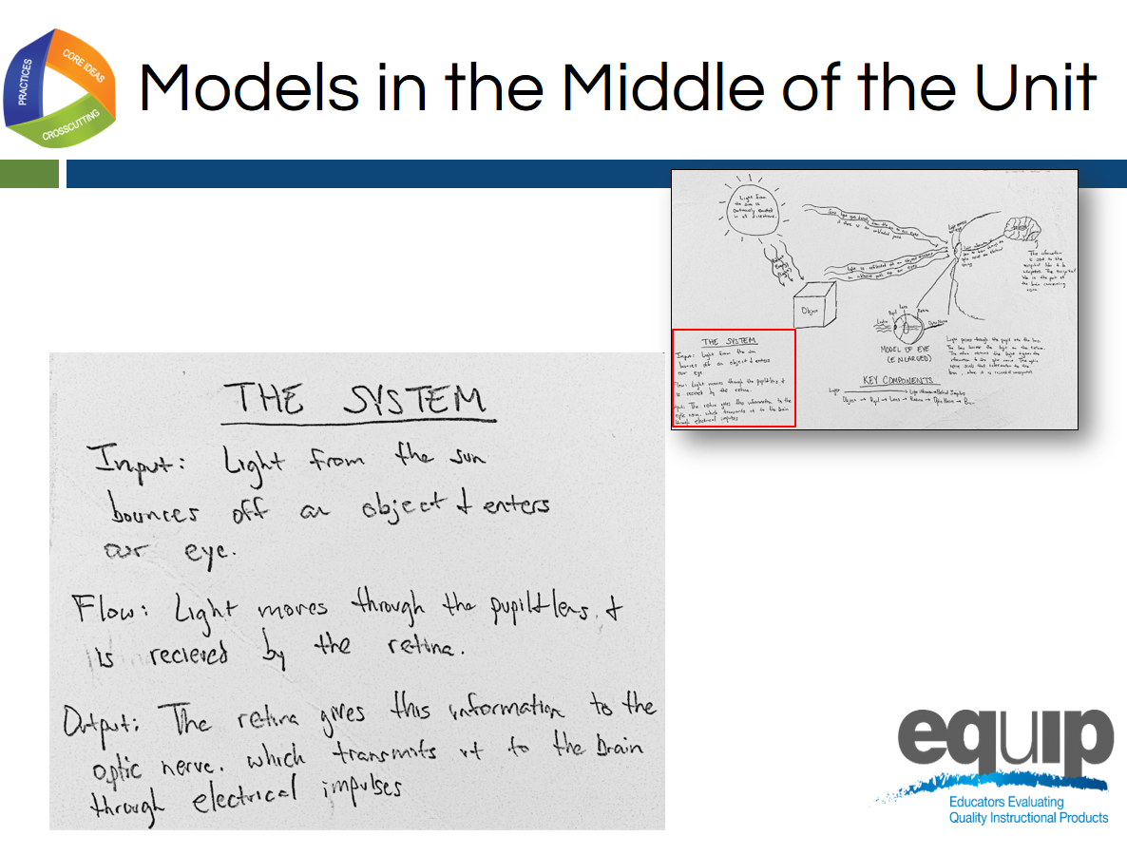
Slide 34
Talking Points
- This student model shows a similar understanding of energy concepts and core ideas as well as the crosscutting concept of system and system models as he or she identifies the relationships between the components as involving input, output, and flow of energy.
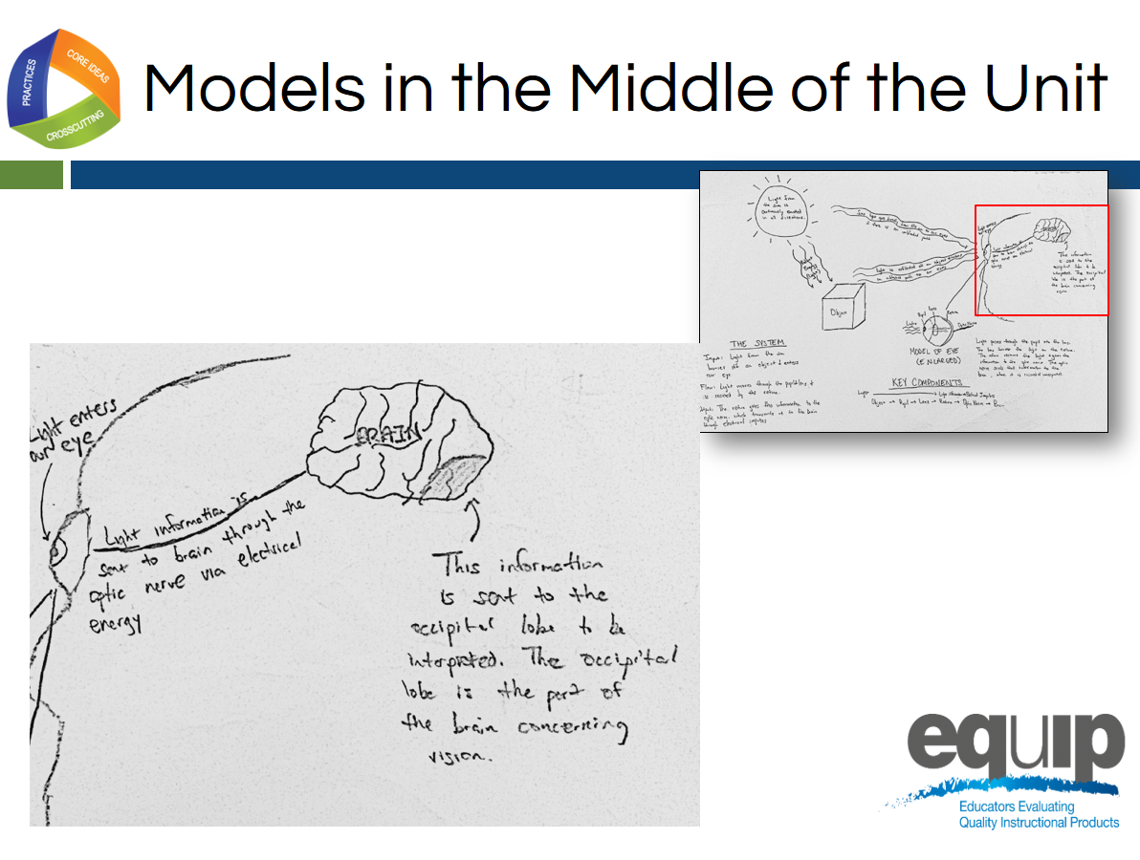
Slide 35
Talking Points
- In this final example, the student communicates a similar understanding of energy concepts and core ideas in conjunction with an understanding of hierarchy and how parts work together with specific reference to the specific part of the brain responsible for vision (the occipital lobe).

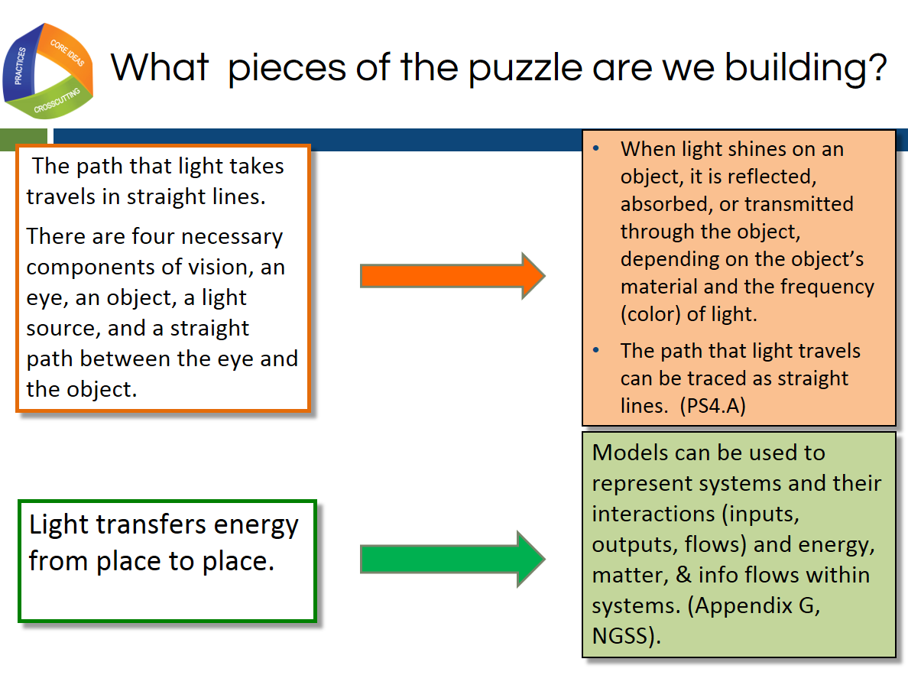
Slide 36
Talking Points
- How can we use the evidence we saw in the models to draw conclusions about student understanding and the quality of the lesson in regards to NGSS?
- Lesson 1 engages us with the anchor phenomenon of optical illusions by focusing on how we see, raises additional questions, and helps us to build some pieces of the disciplinary core ideas and crosscutting concepts.
- Each lesson should be necessary to students in constructing pieces of the puzzle to assemble later on and build an explanation of the phenomena.
!
- In order to build a scientific explanation about living things changing over time, we will need these pieces of science understanding.
  - The path that light takes travels in straight lines.
- There are 4 necessary components of vision, an eye, an object, a light source, and a straight path between the eye and the object.
- These four pieces are needed to explain optical illusions can be directly tied to the elements of disciplinary core ideas (PS4) and crosscutting concepts pictured on the screen.
!
- For a phenomenon to be instructionally productive, it must be connected to DCI’s and/or CCC’s.
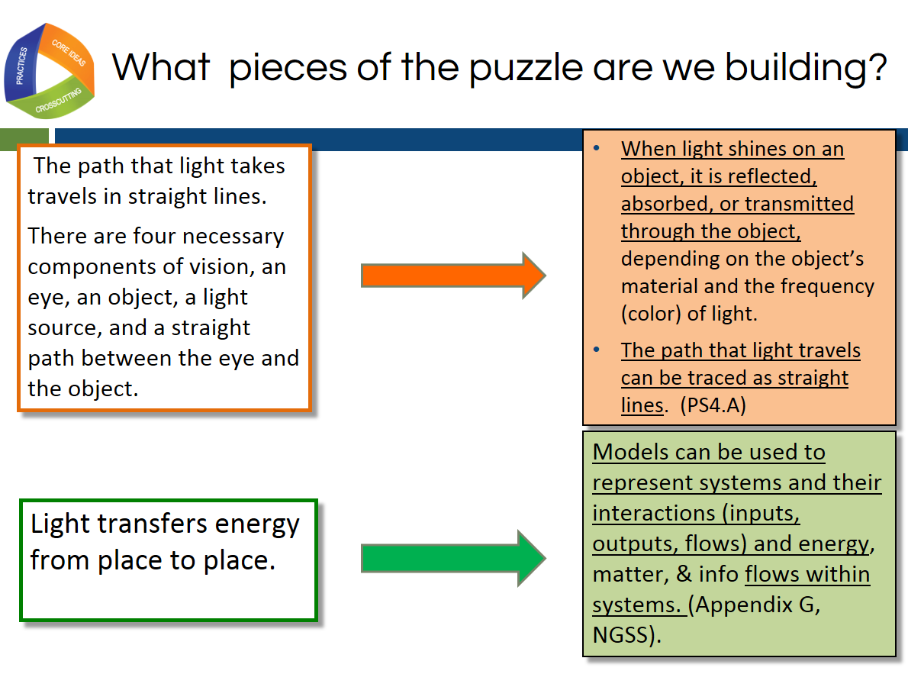
Slide 37

Talking Points
- Your table discussions may have concluded that there were some elements of the dimensions where you determined there was evidence of only a portion of that element.
- This slide shows that in this lesson, students were only using the underlined portions of these elements.
- It is important to document the evidence this way to give a clear communication of what evidence was or was not observed in the lesson or student product.
- This is acceptable in NGSS design. It is just essential that the teacher have an explicit awareness of which portion of the element has not been addressed so that it can be addressed in later lessons or units.
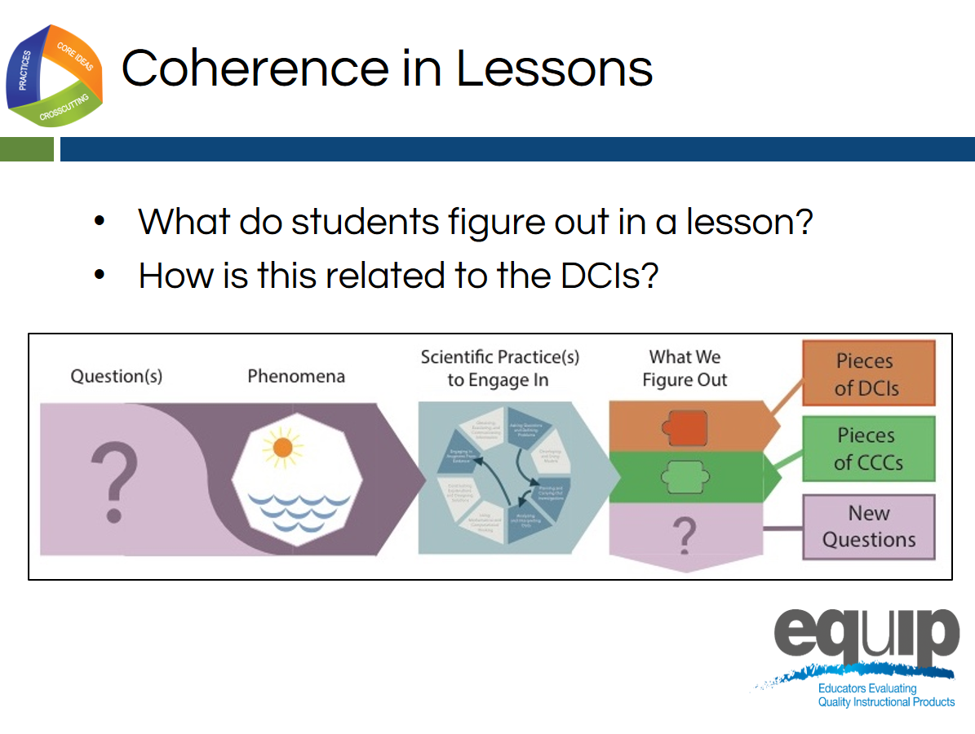
Slide 38
Talking Points
- This slide helps us think about the analogy of the elements of the DCIs and CCCs being like puzzle pieces that the student connects in their thinking so that he or she can ultimately explain the phenomenon.
- The last column of the storyline represents the pieces of the science we have figured out in each lesson that can be used to explain the world.
- A single row is a single lesson of a storyline.
- The four conditions for vision represented in the consensus model are a starting point to understand how light waves are reflected, absorbed, or transmitted through various materials.
- The students are engaged in the practice of developing and using models to build this understanding represented by the puzzle pieces or DCI and CCC elements.
- Data analysis is an important link between observations and claims. We used patterns found in observations to determine the evidence needed to explain the lesson-level phenomenon in our lesson: people can see objects.
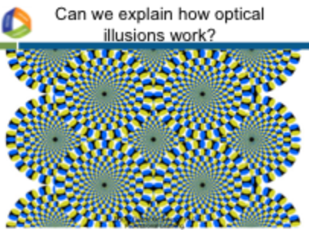
Slide 39
Talking Points
- Students have built some pieces of understanding in lesson one by investigating with the light box.
- However, can they construct an explanation about how optical illusions work? Were there other pieces of understanding evident in the student work that we did not experience in our immersion today?
- What do you think the lessons that came after the light box were focused on according to the student mid-unit models?
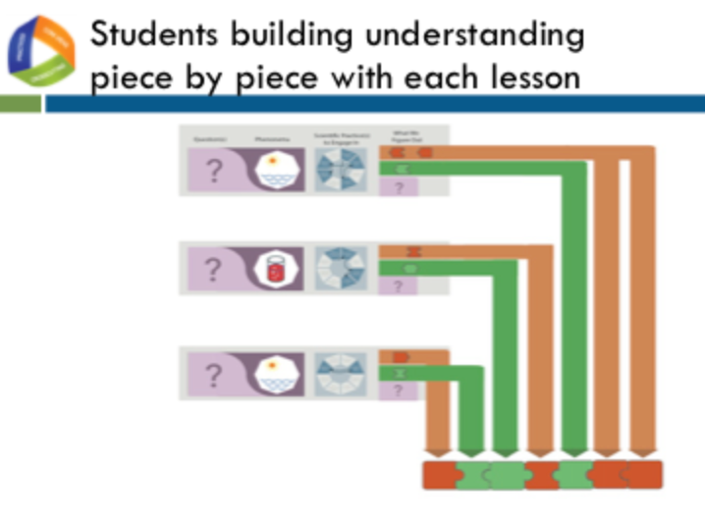
Slide 40
Talking Points
- The student models indicated that they engaged in investigations centered on the eye and brain.
- A full understanding of optical illusions involves the brain and the way it interprets signals sent from the eye from light receptors.
!
- This illustrates another important criterion about anchor phenomena that are instructionally productive. Students should be able to make sense of anchor phenomena, but not immediately or without investigating it using a sequence of science and engineering practices as indicated in this graphic organizer.
- Each lesson indicated by arrow in this graphic contributes critical pieces of information needed to explain the phenomena.
- With instruction and guidance, students should be able to figure out the phenomenon over time by connecting the pieces of the puzzle together in their own mind and communicating their understanding through a product like a model.
- The student models will evolve as their understanding evolves. Students will, with teacher guidance, confront their own misconceptions and gaps in understanding, as evidenced today in our evaluation and discussion.
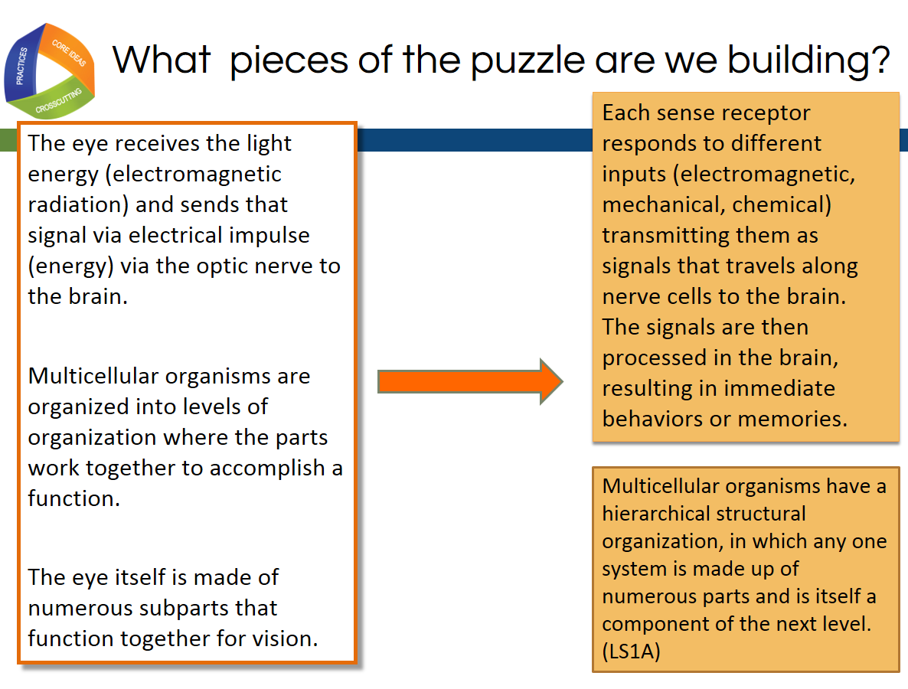
Slide 41
Talking Points
- This slide shows how, after lesson 1, the focus DCIs shifted from the physical sciences to the life sciences domain as indicated in the student products.
- This particular phenomenon required students to take an integrated approach to building the knowledge necessary to explain the phenomenon.
- This slide also emphasizes again how this lesson used DCI elements from the middle school (indicated in the top orange box) as well as high school (bottom orange box).
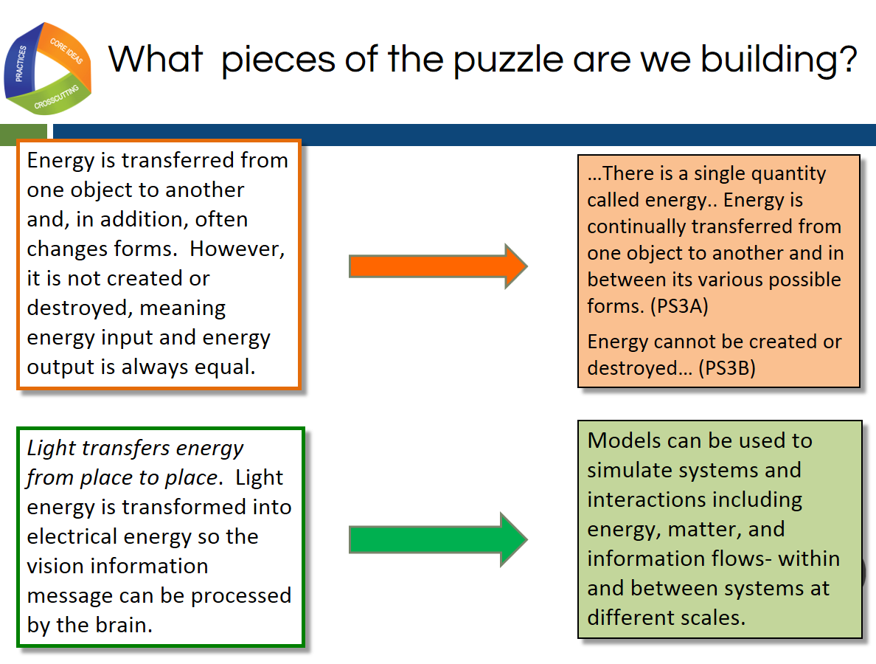
Slide 42
Talking Points
- In lesson one, we discussed how we were building middle school elements of physical sciences disciplinary core ideas (PS4).
- This slide shows that as the unit progresses, we also build understanding of high school physical sciences elements (PS3 and PS4).
- Anchor phenomena have complexity that results in the bundling of NGSS performance expectations.
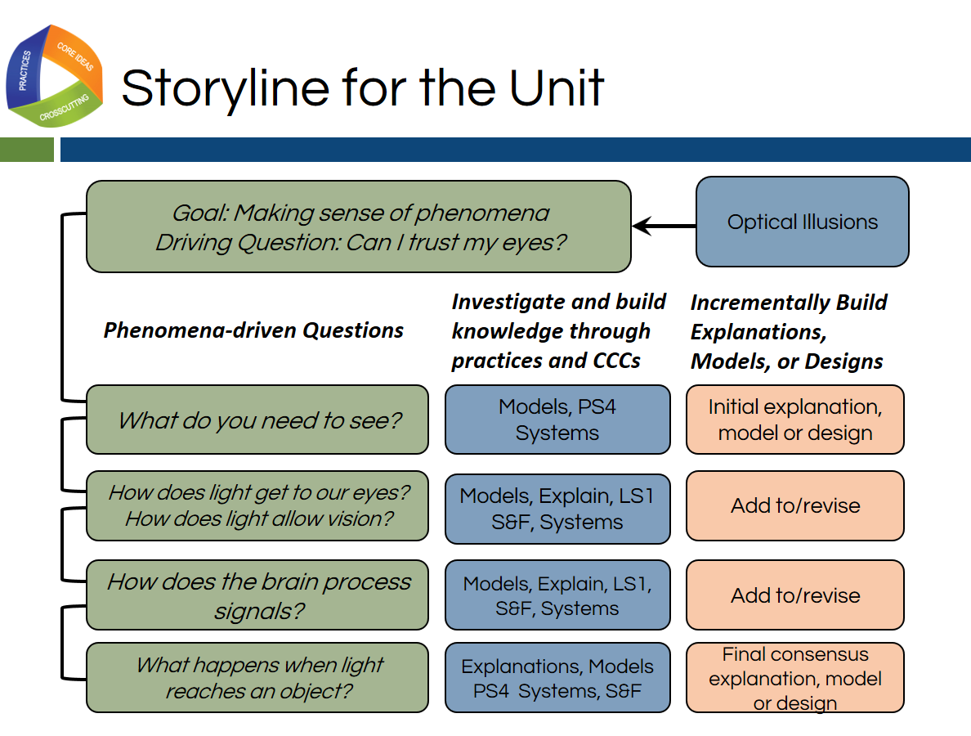
Slide 43
Talking Points
- When we look at the full unit in this graphic organizer, we can see how our initial observations of our anchor phenomenon and the questions we generated and nested under the sub questions on the driving question boards drive the teaching and learning in this classroom.
- This teacher selected a phenomenon that interested and engaged the students and built on their everyday experience.
- Although the students will not be able to fully explain the optical illusions phenomena by the end of the unit, they will understand the phenomena at a grade-appropriate level and will be equipped to ask more targeted questions in future neuroscience courses.
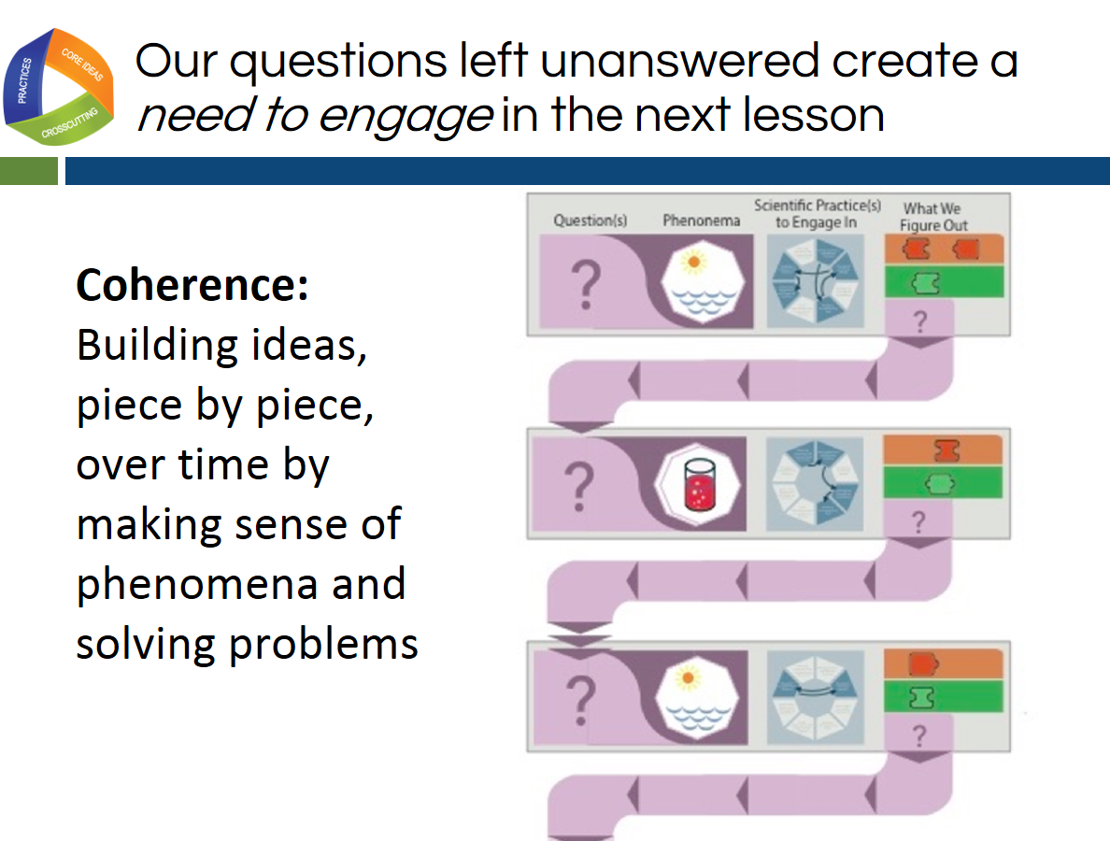
Slide 44
Talking Points
- This slide gives us another way to think about how students move between lessons indicated by the rows in this organizer.
- In each row or lesson, students have an investigative phenomenon that they are trying to make sense of in order to eventually build knowledge so they can explain the anchor phenomena.
- This lesson is driven by a question.
- By engaging in the science and engineering practices, students build knowledge of the DCIs and CCCs as indicated by the puzzle pieces.
- In addition to this new knowledge, students are left with new or unanswered questions that result in a need to engage in the next lesson.
!
- It is not just about lessons flowing together in an order, but about students hungering for that next piece of the story or piece of the explanation of phenomena.
- We can call this building ideas piece-by-piece over time “coherence”.
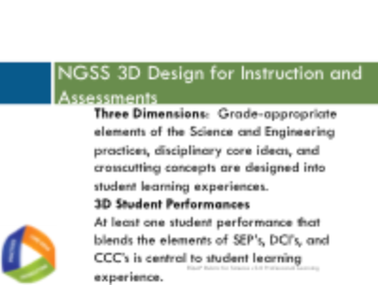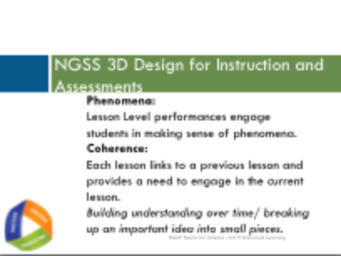
Slide 45 Slide 46
Talking Points
- Let’s close our immersion experience and debrief reminding ourselves about the elements of 3-dimensional lesson design that we experienced today.
- The biggest innovation in the NGSS is 3-dimensional learning.
- We design lessons that integrate the 3 dimensions so students can make sense of phenomena or develop solutions to problems.
!
- We can evaluate student performances and products that serve as direct observable evidence of 3D learning.
- Lesson level performances engage students in making sense of phenomena and creating these observable evidences of student learning.
- Units, however, build student ideas and understanding over time. This building understanding targeted to elements of all 3 dimensions over a unit driven by student questions about anchor phenomena is called coherence.
- Let’s transition from our immersion activity to an introduction to the EQuIP rubric as a tool for evaluating NGSS 3D Design.

Slide 47
Talking Points
- The implementation of the NGSS requires instructional materials that align with the shifts and increased rigor of these new standards.
- While there may be a shortage of high-quality materials thoughtfully designed for the NGSS, educators have found themselves inundated with materials claiming to be NGSS-aligned.
- As noted by Joe Krajcik, professor of science education and director of the CREATE for STEM Institute at Michigan State University, “Many developers and publishers of science materials claim that their materials align with the NGSS and feature the NGSS performance expectations. And while some publishers will make legitimate attempts at modifying their materials to do an appropriate alignment, you will need to have the appropriate tool to judge which materials better represent the intent of the NGSS and which materials just really don’t match up” (http:// nstacommunities.org/blog/2014/04/25/equip/).
!
- Case in point, Bill Schmidt of Michigan State University reviewed roughly 700 mathematics textbooks used by 60% of U.S. public school children and found that many claiming Common Core alignment were “page by page, paragraph by paragraph” the same as older versions, resulting in textbooks that reflect the standards minimally, if at all. In some of the texts, less than a quarter of the content matched the standards of the grade in question. As Schmidt notes, “It’s hard to imagine how this could support instruction” (http://www.hewlett.org/blog/posts/curriculum-core).
- As this research indicates, too often, new labels may be placed on old materials without any substantive changes having been made to those materials.
- To ensure the quality of the teaching and learning materials used with the NGSS, we need a basis for examining and evaluating these materials.
- The EQuIP Rubric provides this basis and allows educators to select the best and most appropriate instructional materials—whether commercially-published or educator-generated—for effective teaching and learning.
- The development of the EQuIP Rubric for NGSS was managed by Achieve in partnership with the NSTA. It was written and reviewed by groups of educators in several states, English Language Arts (ELA)/literacy and math EQuIP developers, standards writers, and other science and engineering education experts.
- Feedback from the thousands of educators across the United States using the EQuIP rubric version 2.0 over the last two years to evaluate lessons combined with feedback from those leading professional learning using the rubric led to the changes in the current version, the EQuIP rubric version 3.0.
- We want science educators to be critical evaluators and/or developers of quality science materials. Consequently, we want to train as many science educators as feasible to use the EQuIP Rubric effectively.
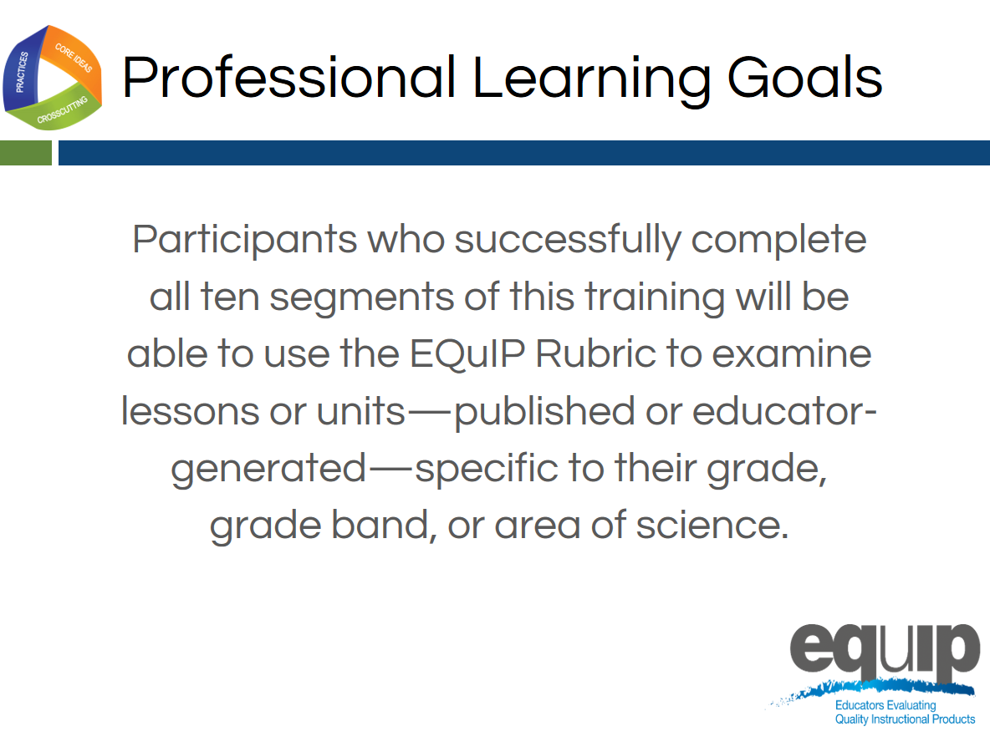
Slide 48
Talking Points
- Now that we have experienced 3-dimensional learning in service to phenomena, let’s consider our next professional learning goal that will involve us working with a common lesson.
- For the remainder of the training, all participants should work together with a single common lesson or unit. However, the knowledge, skills, and understandings acquired are transferable to materials in all disciplines and grade bands of science.
- Throughout this training, when we refer to the different disciplines of science, we mean physical sciences; life sciences; Earth and space sciences; and engineering, technology, and applications of science.
- Finally, the training provides participants with a process for reviewing materials and engaging in meaningful discussions about materials with their peers. These are rich discussions that require reviewers to use evidence and reasoning.
Slide 49
Talking Points
- The NGSS are not just new; they are innovative in how we expect students to demonstrate their understanding of science.
- Before we continue, let’s, take a couple of minutes to list what you think are the biggest innovations in the NGSS. [Note to facilitator: Allow two or three minutes for participants to document their thinking. If your participants participated in the introduction and immersion activity, you can ask them to reflect back on their experiences so far in the training when they were participating in the immersion experience and debrief.)

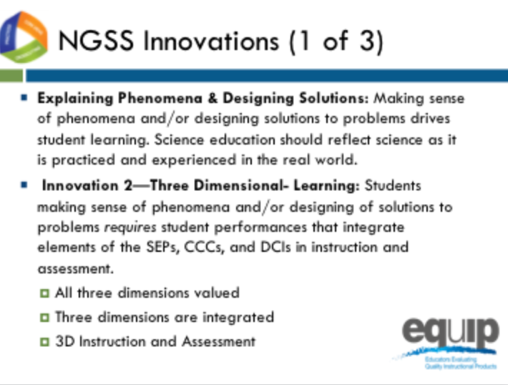
Slide 50
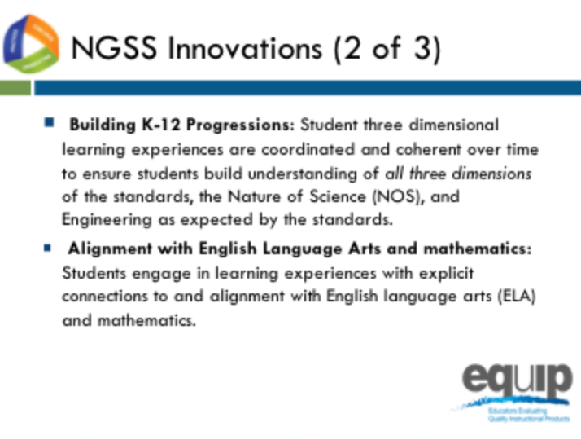
Slide 51
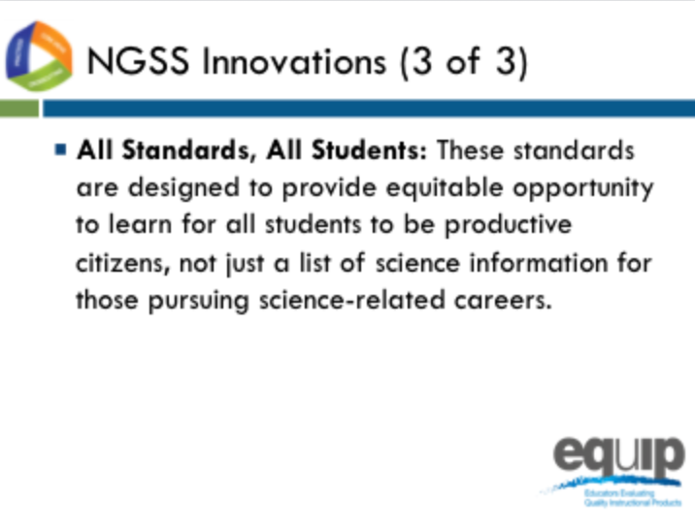
Slide 52

Talking Points slides 50–52
- Some of the major innovations of the NGSS compared to past standards are displayed on slides 50–52. Please compare your list with the list displayed on these slides.
- Note to facilitator: briefly discuss each innovation as you progress through slides 50–52.
- As we work together today, we will not only learn about a tool and evaluation process so we can select and design better units and lessons, but we will also identify these innovations that shift instruction that may be needed to better target the NGSS.

