MODULE
EQuIP for Science v3.0
7

Determining
Coherence
and Connections
Module 7: Determining Coherence and Connections
Module 7 builds on Module 6 by having participants discuss the remaining criteria in Category I: Alignment to the NGSS, which deal with coherence and connections. Participants will engage in an activity to think about coherence—specifically, the coherence of a set of questions in a series of lessons. Then they will continue examining the Common Lesson using the remaining criteria in Category I.
Materials Needed
- Module 7 PowerPoint slides or slides 145–162 of the full PowerPoint
- Handout 8: Module 7, “Graphic Example of Coherence” (1 page, preferably color copies)
- Handout 9: Module 7 “Debriefing Questions for Module 7” (1 page)
- Facilitator’s Resource—Storyline Cards. [Note to facilitator: Prior to beginning this module, prepare the envelopes for the coherence Storyline Cards task, slide 154.]
- Common Lesson: Urban Heat “Final” Version
- Handout 7: Module 4, “EQuIP Rubric, Version 3.0”* or a computer or tablet with the electronic version of the rubric (at least one person per table should record their group’s findings electronically)

*Introduced in a previous module.

Introduction to Module 7
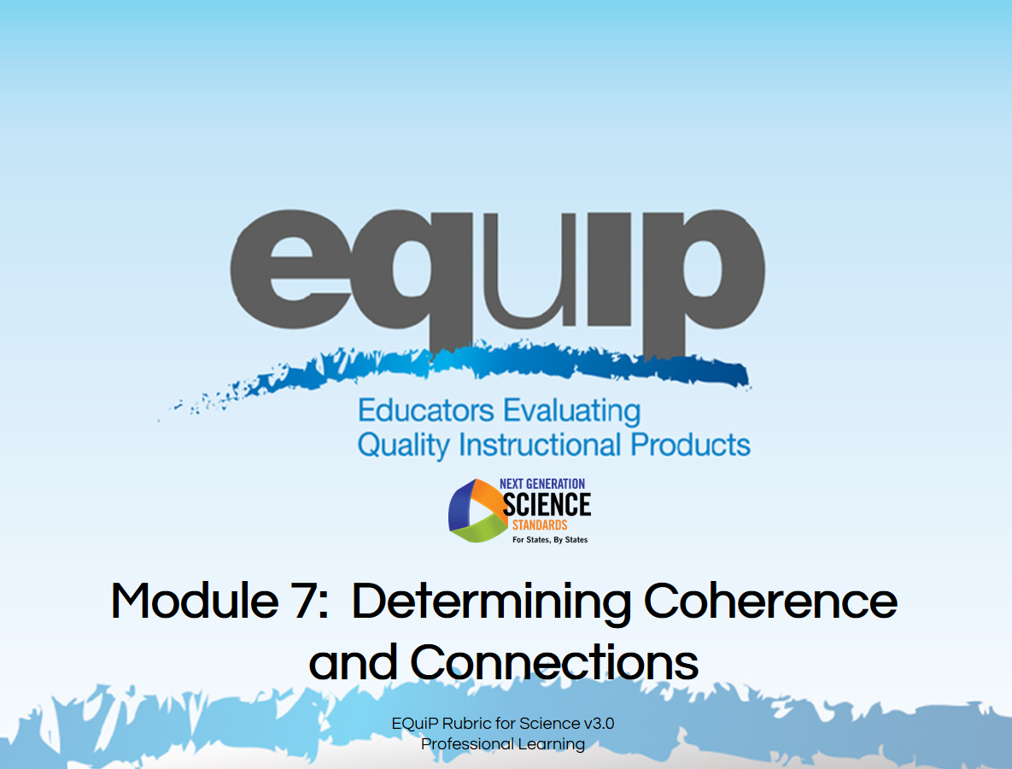
Slide 145
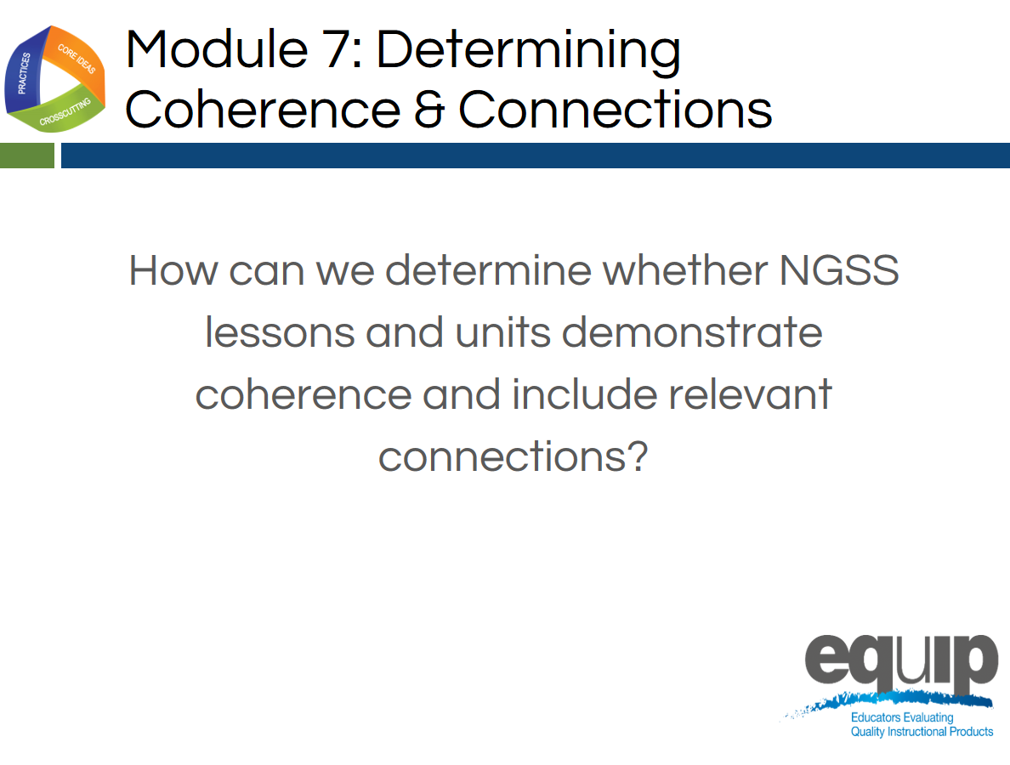
Slide 146
Talking Points
- In this module we’re going to move to the next part of Category I and look at coherence and connections in longer lessons or units.
- By the end of this module, you should be able not only to explain coherence in terms of the EQuIP Rubric, but also to explain how a graphic representation of a series of lessons demonstrates coherence, and to determine whether or not the common lesson shows explicit evidence of coherence.
- And you should be able to determine whether or not a lesson or unit includes connections to other science disciplines and/or to ELA/literacy or mathematics.
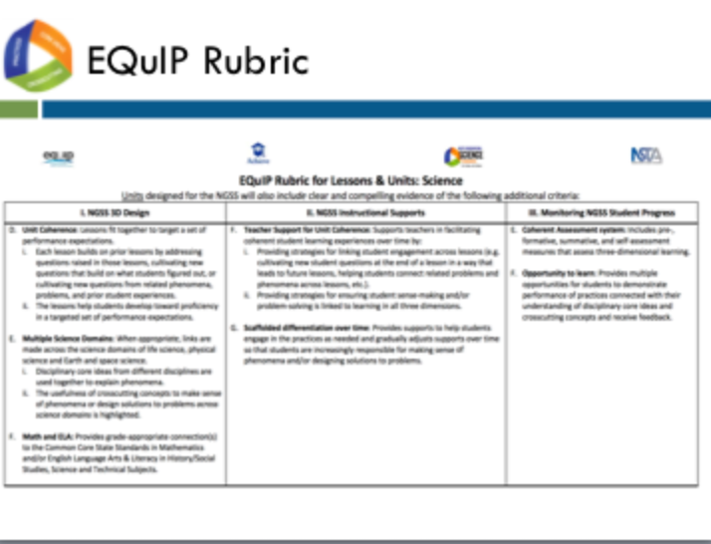
Slide 147
Talking Points
- Locate the criteria for coherence and connections on page 3 of your rubric.
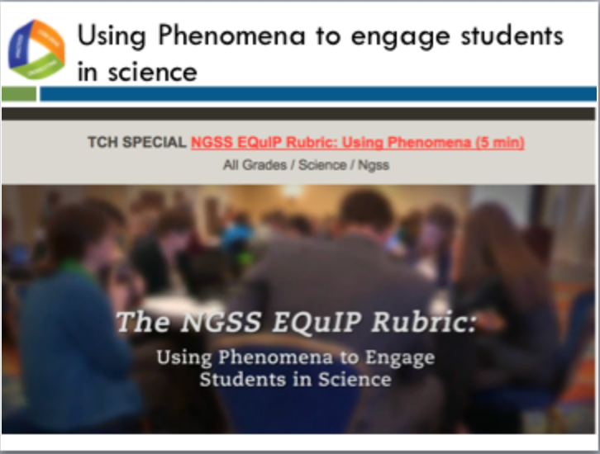
Slide 148
Facilitator Notes
- The video can be found at the following link http://www.nextgenscience.org/resources/ngss-equip-rubric-using-phenomena
Talking Points
- This video highlights the role of phenomena in multiple criteria of the EQuIP rubric, using phenomena to engage students in science.
- Let’s view this video together to help us determine how phenomena can support student engagement and drive instruction.
- Note to Facilitator: After the video Ask participants: “What is a phenomenon? How is it engaging? How can it be instructionally productive or drive a lesson?” Have a brief discussion (1–2 minutes).
- Note to Facilitator: After discussion about the first series of questions, ask “How can you leverage an engaging phenomenon to provide access points for all students? Have a brief discussion (1–2 minutes).

Slide 149
Talking Points
- As we saw in the video, the point of using phenomena to drive instruction is to help students engage in the practices to develop the knowledge necessary to explain and predict phenomena. Therefore, the focus is on both the phenomena and the student-generated questions about the phenomena that drive instruction.
- Let’s see how phenomena fit into the criteria about unit coherence.

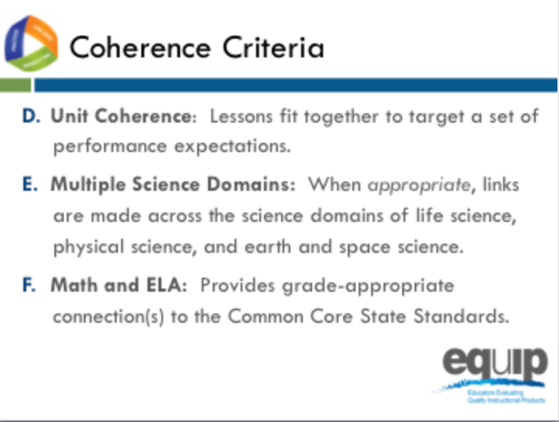
Slide 150
Talking Points
- Note how each of the bullets delineates different possibilities for coherence and connections:
  - [Note to facilitator: Click for animation.] Coherence can refer to how lessons fit together coherently to target a set of performance expectations.
  - [Note to facilitator: Click for animation.] Where appropriate, disciplinary core ideas from different disciplines are used together to explain phenomena.
  - [Note to facilitator: Click for animation.] Where appropriate, crosscutting concepts are used in the explanation of phenomena from a variety of disciplines.
  - [Note to facilitator: Click for animation.] Provide grade-appropriate connection(s) to the CCSS in ELA/literacy and mathematics and in history/social studies, science and technical subjects.

What is Coherence?
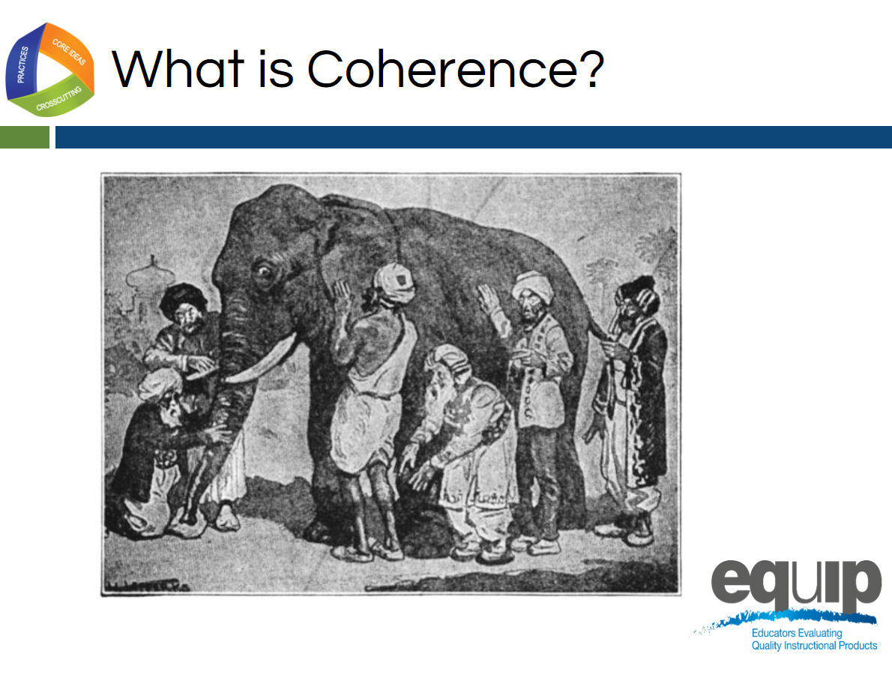
Slide 151
Talking Points
- Who knows the story of the blind men and the elephant? [Note to facilitator: Have someone share the story with the whole group. If no one volunteers, the facilitator should retell the story.]
- Although the men in this story certainly examined the parts of the elephant, their individual explanations did not depict a coherent representation of the elephant. Their various descriptions of the parts of an elephant did not fit together to create a picture of an entire elephant that made sense. Their individual descriptions, when examined as a whole, lacked coherence.
- So what is coherence? Take a few minutes to talk about what you think coherence might look like in a longer lesson, a series of lessons, or a unit in science. [Note to facilitator: Allow approximately five minutes before asking for volunteers to share. Allow several people to share. Facilitator should guide this discussion to ensure that s/he brings everything together to define coherence as intended in the EQuIP Rubric.]
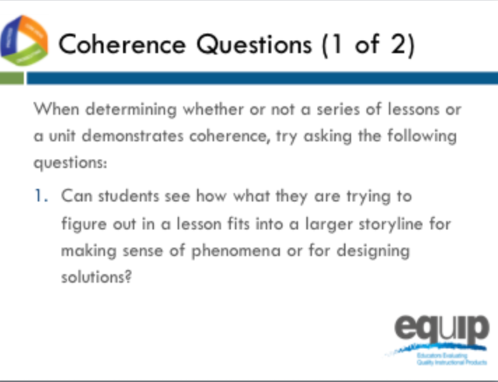
Slide 152
Talking Points
- As you examine lessons and units to determine whether they meet the rubric criteria for coherence, keep these two questions in mind:
  - Can students see how what they are trying to figure out in a lesson fits into a larger storyline for making sense of phenomena or for designing solutions to problems?
  - Is there a coherent story that, based on explicit evidence found in the lessons, builds across the unit to reach a bundle—a set of more than one—of performance expectations?
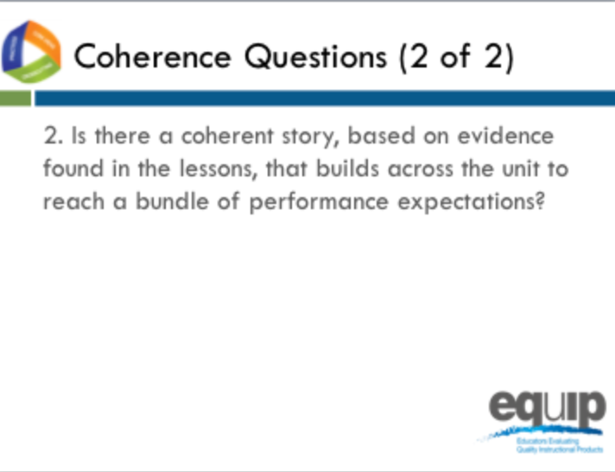
Slide 153
Talking Points
- So what exactly do we mean by a storyline or a coherent story?
- Think of your favorite episode of Law and Order or another TV mystery series you watch regularly. The episode begins with a question: “Who committed the crime?” From here the plot proceeds logically as evidence is collected, suspects are questioned, and a case is built. The show ends when everything comes together, the question we began with is answered, and the perpetrator of the crime is revealed.
- This exemplifies a coherent storyline.
- Now think back to a TV show or movie you’ve watched where you’ve reached the end only to discover that the answer to the question of who committed the crime comes straight out of left field. There was no way you could have figured out the ending because either it wasn’t logical or the crime ended up being committed by someone who wasn’t even present in the earlier portion of the show. You feel as if you’ve wasted your time because the storyline wasn’t coherent; one thing did not follow from another.
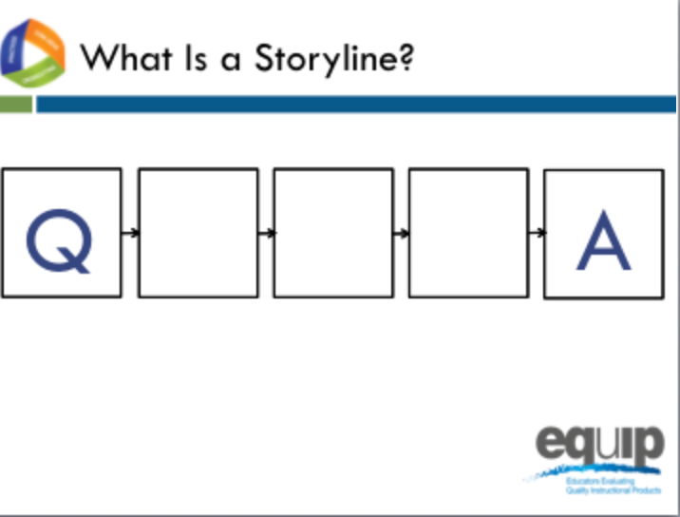
Slide 154
Facilitator Notes
Make sure each table group has an envelope with the Storyline Cards for this task.
Talking Points
- In the center of your table you’ll find an envelope. Inside are five slips of paper, each with a question on it.
- As a group, read through these questions and then put them in the order that you believe to be the most coherent storyline.
- As you work to make a coherent storyline from these cards, think about what this process would look like in a classroom where students are trying to make sense of phenomena and/or design solutions to problems.
- As you arrange the cards, ask yourself the following questions:
  - Can students see how what they are trying to figure out in a lesson fits into a larger storyline for making sense of phenomena and/or for designing solutions to problems?
  - Is there a coherent story that, based on explicit evidence found in the lessons, builds across the unit to reach a bundle of performance expectations?
- Can you arrange the questions so that students see how what they are trying to figure out in a lesson fits into a larger storyline for making sense of phenomena and/or for designing solutions?
- Can the questions be organized to build a series of lessons or a unit to reach a bundle of performance expectations? [Note to facilitator: Allow five minutes for the groups to work and then have two to three tables share.]

Lessons That Fit Together Coherently
Slide 155
Talking Points
- We have been evaluating the Intermediate version of the lesson sequence called Urban Heat. Based on your table discussion while you were organizing your cards into a coherent storyline, do you see ways this lesson sequence could be improved? What were your takeaways from this activity as it connects to our common lesson? [Note to facilitator: Have a few groups share responses.]
- The classification of our common lesson as intermediate indicates that there may be another version.
- We are going to continue our review with the final version of Urban Heat, a revision of the intermediate version. This classification of final is to indicate that it is the last revision thus far, as opposed to an indicator of quality.
- Before we resume with our rubric evaluation, let’s look at the role questions play in the organization of a unit with this graphic organizer and think about how it connects to our storyline cards table discussions.

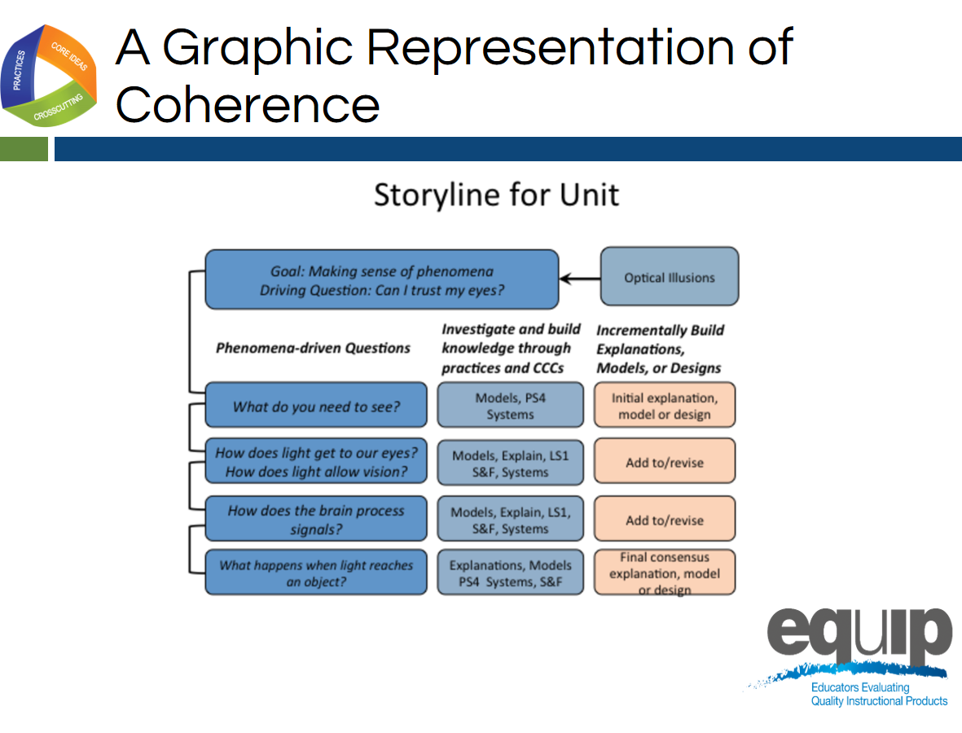
Slide 156
Talking Points
- Please refer to the handout entitled, “Graphic Example of Coherence,” which provides a larger version of this slide.
- Notice the “making sense question” at the top—the anchoring phenomenon.
- Now look at the order of the phenomena-driven questions—the questions at the beginning of each row.
- In this example, we can see coherence just by virtue of the fact that each subsequent phenomena-driven question relates directly back to our attempt to answer the making sense question or driving question.
- In other words, if we assume that each phenomena-driven question relates to one lesson in a series of lessons, all of which are designed to address the making sense question, then each lesson connects and builds onto the previous as students work to answer the making sense question.
- Here students engage in science practices to answer each of the phenomena-driven questions.
- And, since the phenomena-driven questions logically and sequentially build on one another, what the students figure out—the meaning they make—logically and sequentially builds as well. In other words, their learning is coherent because the students can see how what they are trying to figure out in one lesson fits into a larger storyline for making sense of phenomena.

Connections
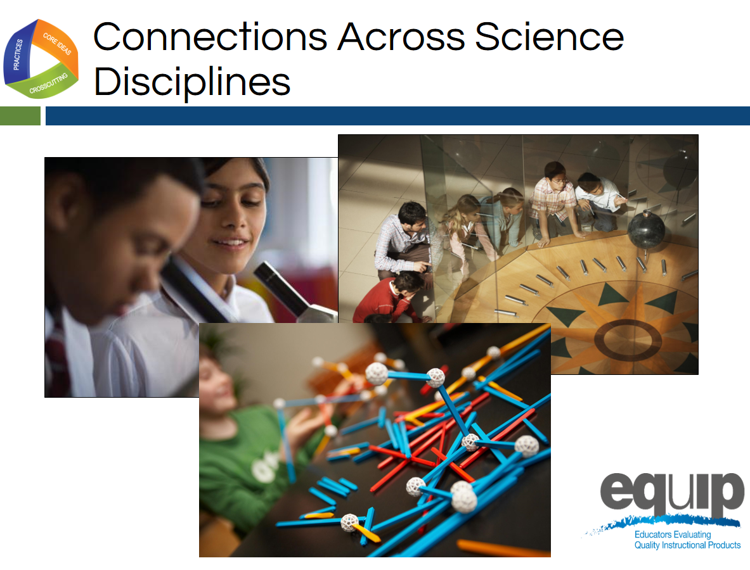
Slides 157
Talking Points
- Just as coherence occurs in a series of lessons, where appropriate, disciplinary core ideas from different science disciplines can be used together to explain phenomena.
- Likewise, where appropriate, crosscutting concepts can be used in the explanation of phenomena from a variety of science disciplines.
- Again, here we’re looking for connections that enable students to see the bigger picture or see how different science disciplines relate to form a larger storyline for making sense of the natural world or the human-designed world.
- As you look for this evidence, ask yourself the following questions:
  - Are students using what they have figured out in other disciplines of science to make sense of the phenomena and/or to design solutions to problems in current lessons and units?
  - Are students using crosscutting concepts to make sense of phenomena or design solutions across science domains?
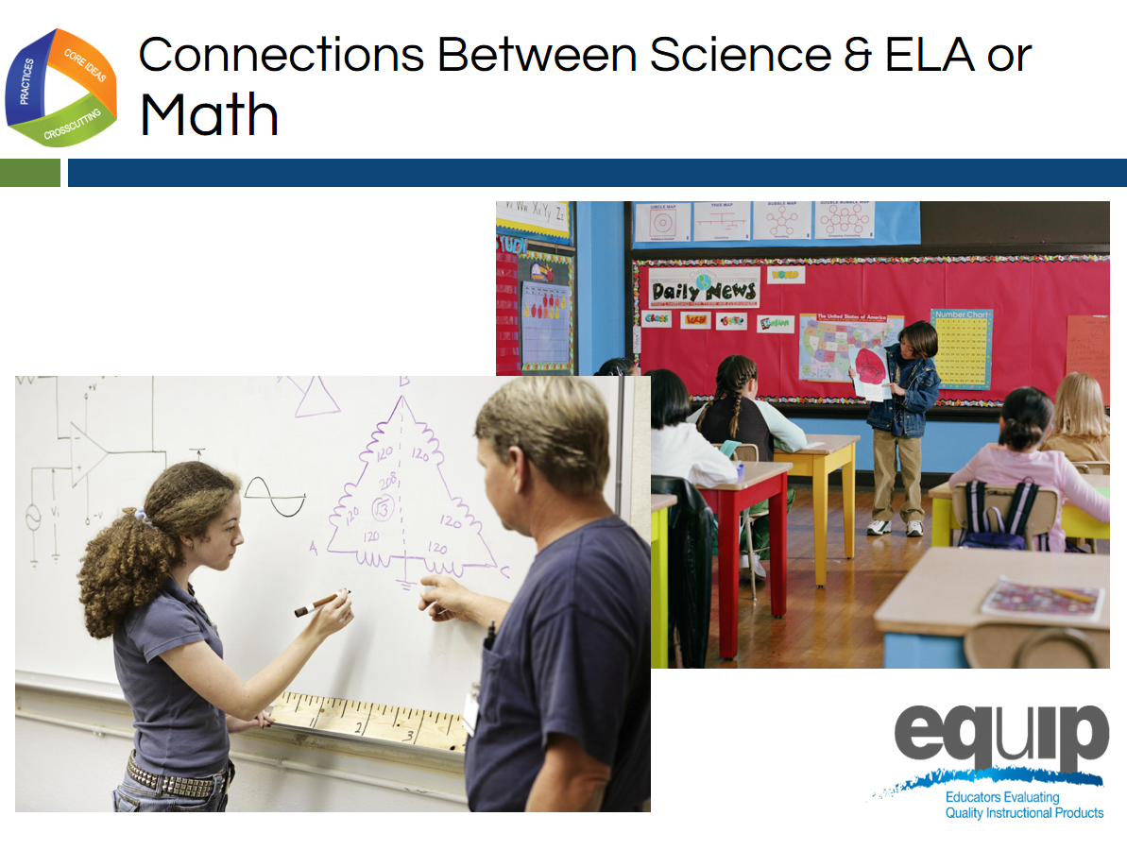
Slide 158
Talking Points
- Finally, connections can occur between science and ELA/literacy and science and mathematics.
- For example, students could create mathematical models to explain science phenomena, or write arguments to show how they reason from evidence to reach a logical conclusion in science.
- As before, we’re looking for connections that enable students to see the bigger picture or see how different areas of study relate to form a larger storyline for making sense of the natural world or the human-designed world.
- As you look for evidence of connections between science and mathematics and/or ELA/literacy, ask yourself the following questions:
  - Are students using what they have learned or are learning in ELA/literacy or mathematics as a tool to make sense of new phenomena or design solutions to problems? To express or convey the sense they make of phenomena or the solutions they design?
  - Are the students reflecting on the ELA/literacy and mathematics skills they are using and thus improving their skills in these areas?

Coherence and Connections Practice
Slide 159
Talking Points
- For this task, you will need:
  - The Common Lesson Urban Heat Final Version (we will now put aside the Intermediate version of Urban Heat and instead use the revised version for the rest of the training.
  - The EQuIP Rubric response sheet; and
  - A pen or pencil.
- As you work, keep in mind:
  - You’re working individually on the first two parts of the process, so don’t begin sharing and comparing until after you have completed these first two parts of the process.
  - Use the Arabic and Roman numerals associated with the rubric criteria to code the evidence you locate.
  - It’s exceedingly important to locate explicit evidence in the lessons first before you use reasoning to think about how this evidence connects to the rubric criteria.
  - The evaluations you then make as a group are based on the evidence you located and thought about as individuals.
  - All determinations are criteria-based.
  - As a group you are working to develop a common understanding of NGSS 3D Design and quality.

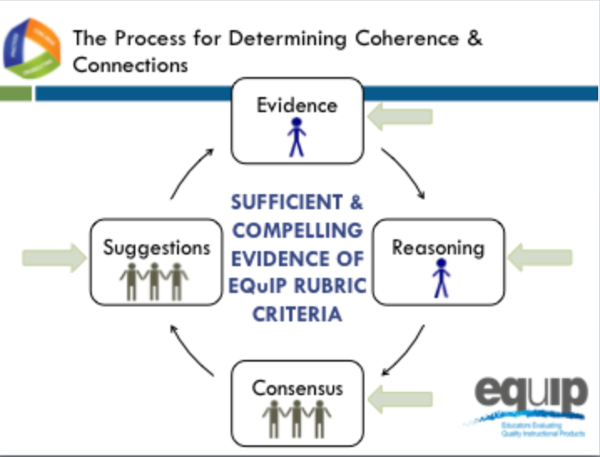
Slide 160
Talking Points
- In addition to the specific materials for this task, you will need the three debrief questions for this module, which you have on Handout 9, “Debriefing Questions for Module 7.”
- If you or your group finishes any part of this examination process early, please begin reflecting on or discussing these three debriefing questions.
- The process you will use to examine the common lesson for coherence and/or connections is the same as the process you used in an earlier module to examine the common lesson to determine whether or not it met the criteria for three-dimensional learning and explaining phenomena. You will have a specific amount of time for each part of the process.
  - First, look for the evidence in the lessons or unit individually. Use the Arabic and Roman numerals associated with the rubric criteria to code the evidence you locate. You have seven minutes for this part. [Note to facilitator: Set timer for seven minutes.]
  - Now, still individually, determine how the evidence fits together and connects to one or more criteria. You have four minutes for this part of the process. [Note to facilitator: Set timer for four minutes.]
  - Next, as a group, designate one person to record the group’s responses, and then share and discuss this evidence and reasoning and collaboratively make evaluations about whether or not the lesson or unit provides sufficient and compelling evidence of the criteria, and assign evidence of quality ratings for each of the criteria as well as for each category.
  - You have 15 minutes for this part of the process. [Note to facilitator: Set timer for 15 minutes.]
  - Finally, make suggestions for how the lesson or unit might be improved. You have four minutes for this part of the process. [Note to facilitator: Set timer for four minutes.]
  - [Note to facilitator: At the conclusion of the practice, ask several groups to share their evidence and reasoning. After several groups have shared, ask one or two to share a suggestion for improvement.]
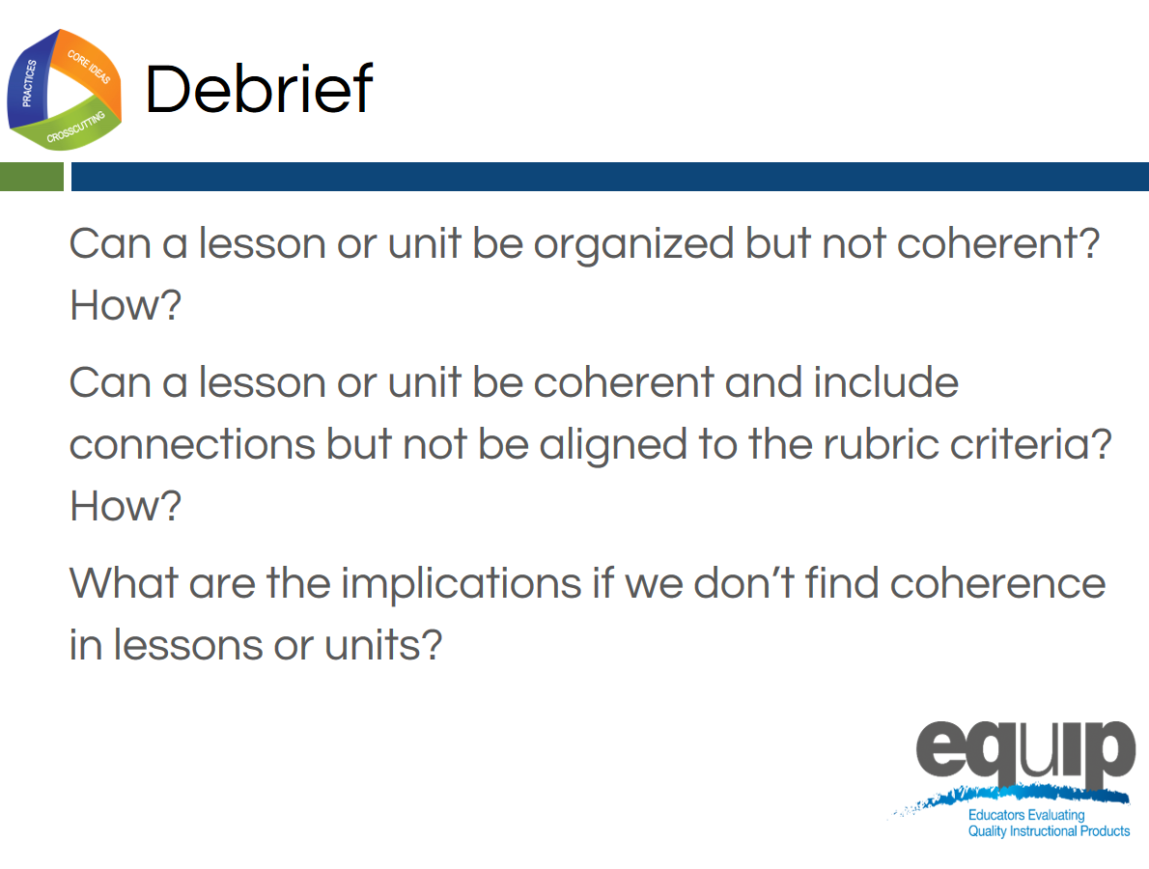
Slide 161
Talking Points
- So, now that you’ve examined a lesson for coherence and connections, what do you think?
  - Can a lesson or unit be organized but not coherent? How? [Note to facilitator: Allow participants to respond.]
  - Can a lesson or unit be coherent or include connections but not be aligned to the rubric criteria? How? [Note to facilitator: Allow participants to respond.]
  - What are the implications if we don’t find coherence in lessons or units? [Note to facilitator: Allow participants to respond.]
- [Note to facilitator: Ask each of the following questions separately and allow participants to respond.]
  - Was this easier or harder than determining three-dimensional learning?
  - Do you have any takeaways that might be useful for other groups to hear?
  - Are you beginning to feel more confident in using the rubric to examine science materials?

Concluding Slide for Module 7
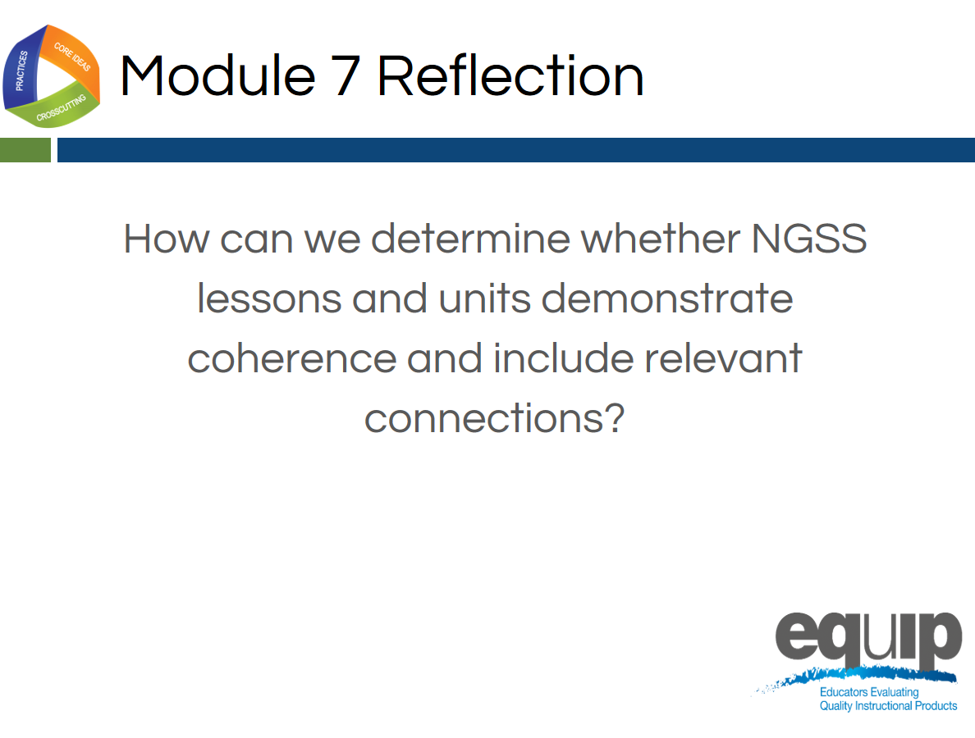
Slide 162
Talking Points
- Coherence and connections are criteria we use to evaluate whether or not a longer lesson or a unit aligns to the NGSS.
- While it may seem that we’re spending a lot of time working with Category I of the rubric, remember, if a lesson or unit is not closely aligned to the NGSS, it may not be appropriate to move on to the second and third categories. So, it’s important that we spend sufficient time here to build educator capacity, sharpen our professional judgment, and develop a common understanding of alignment and quality among reviewers.
- If you still have questions about what coherence and/or connections look like, please ask them now.
- Does anyone still have questions about using Category I of the rubric to determine NGSS 3D design, including determining coherence? [Note to facilitator: Address any questions that arise.]
- In the next module, we’ll be moving on to Category II and using the rubric criteria for Instructional Supports.

