MODULE
EQuIP for Science v3.0
8

Category II: Instructional
Supports

Module 8: Category II: Instructional Supports
Module 8 builds on Modules 6 and 7 by having participants continue examining the Common Lesson, this time using the criteria in Category II: Instructional Supports. Category II: Instructional Supports focuses on examining lessons and units to determine whether they include the kinds of instructional practices and supports necessary to allow all students to access the NGSS successfully.
Materials Needed
- Module 8 PowerPoint slides or slides 163–172 of the full PowerPoint
- Common Lesson: Urban Heat “Final” Version*
- Handout 7: Module 4, “EQuIP Rubric, Version 3.0”* or a computer or tablet with the electronic version of the rubric (at least one person per table should record their group’s findings electronically)

*Introduced in a previous module.

Introduction to Module 8
Slide 163
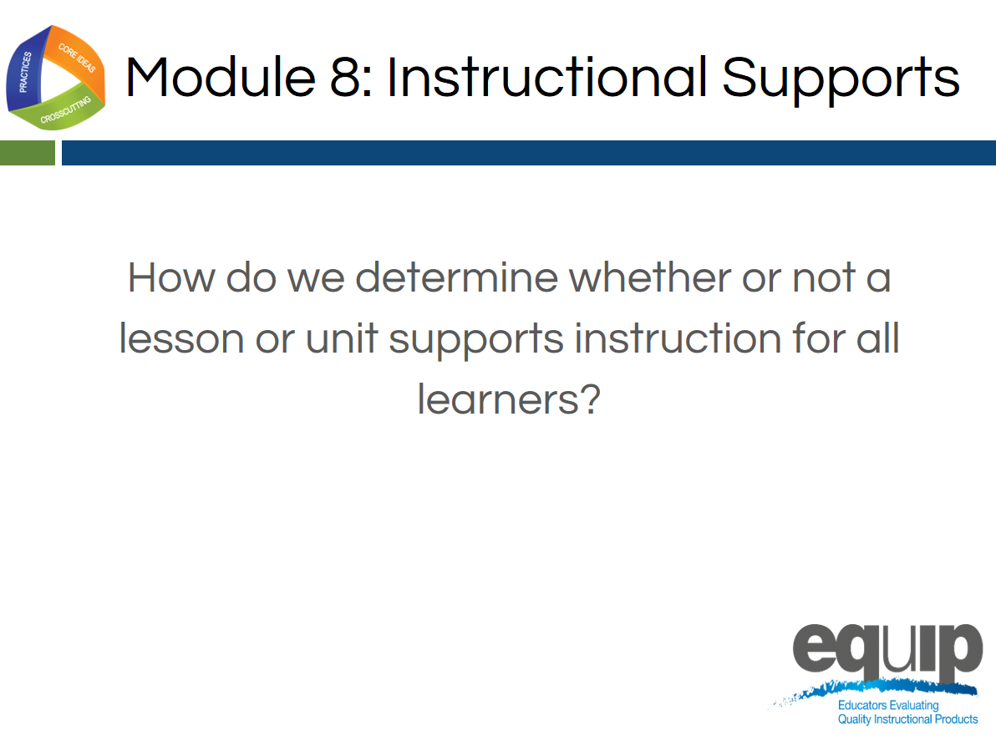
Slide 164
Talking Points
- In this module, we’ll be looking at Category II: Instructional Supports.
- By the conclusion of this module, you should be able to use the EQuIP Rubric to determine whether or not a lesson or unit supports instruction for all learners.
- Now, locate Category II on page 9 of your rubric.
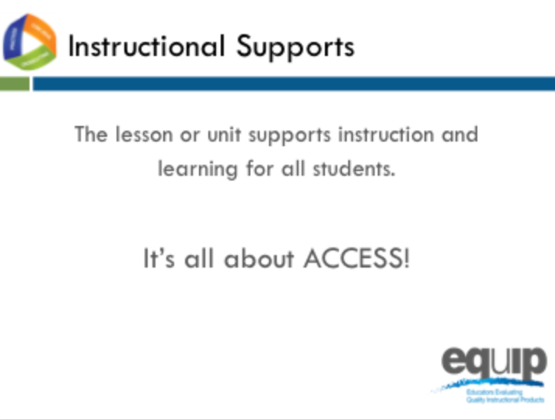
Slide 165
Talking Points
- Category II: Instructional Supports focuses on examining lessons and units to determine whether they include the kinds of instructional practices and supports necessary to allow all students to access the NGSS successfully.
- Take a few minutes to read through all of Category II quickly. [Note to facilitator: Allow three to five minutes.]
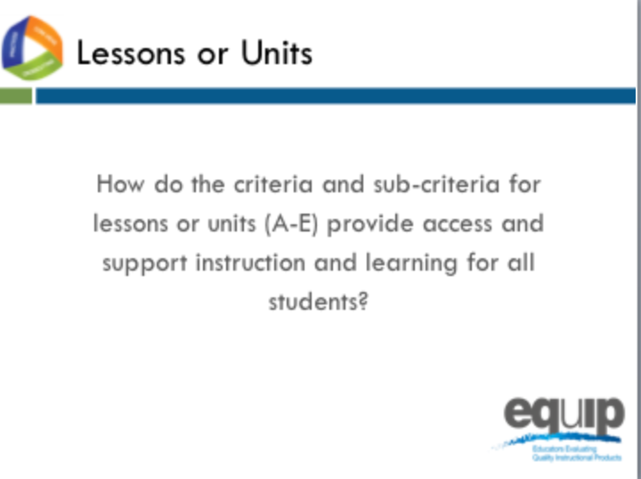
Slide 166
Talking Points
- Now that you’ve read through all of Category II, let’s look more closely at specific sections.
- First, read back through the first four criteria: A, B, C and, D, along with their sub-criteria, and circle key words. You have three minutes to do this. [Note to facilitator: Allow 3 minutes.]
- Noting what you’ve circled, what might evidence of criteria A through D look like in a lesson or unit? [Note to facilitator: Allow a few participants to share.]
- All of the EQuIP Rubric criteria are important, but in Category II, Criterion E, along with its sub-criteria, is particularly deep.
- So, take a few minutes at your tables just to discuss Criterion E and its sub-criteria. [Note to facilitator: Allow five minutes.]
- What are some of the points you discussed regarding Criterion E? And, based on what you see in Criterion E, what might evidence of Criterion E, along with its sub-criteria, look like in a lesson or unit? [Note to facilitator: Allow a few groups to share.]
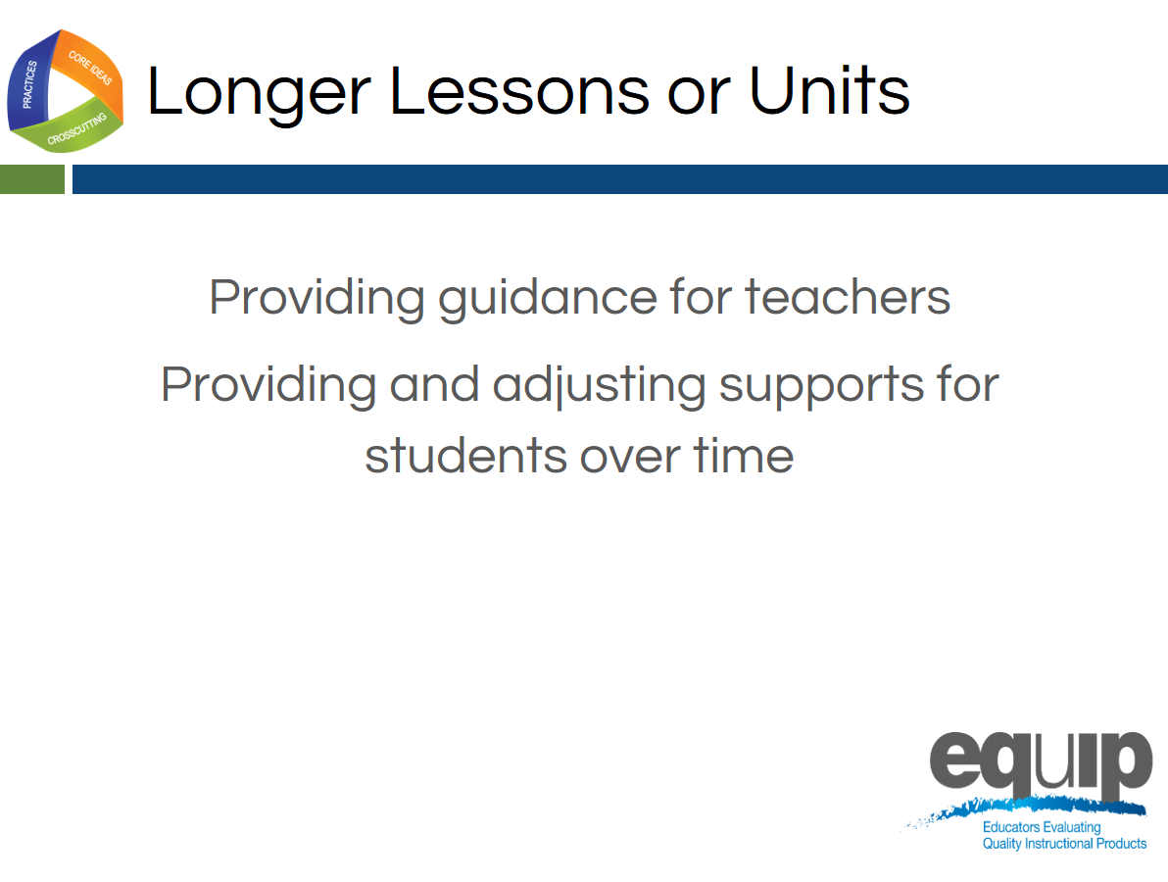
Slide 167
Talking Points
- In Category I the focus for a unit or longer lessons is on the coherence of the lessons—whether they were designed in a coherent way.
- In Category II, the first criterion for a unit or longer lessons focuses on whether there is built-in support for the teachers to ensure that students see the coherence and that this deepens their understanding. Consequently, some of the evidence you identified when looking for coherence in Category I may also provide evidence here.
- The second criterion for longer lessons and units focuses on providing and then gradually adjusting supports for students over time so that the students become increasingly responsible for making sense of phenomena and designing solutions to problems.

Instructional Supports Practice
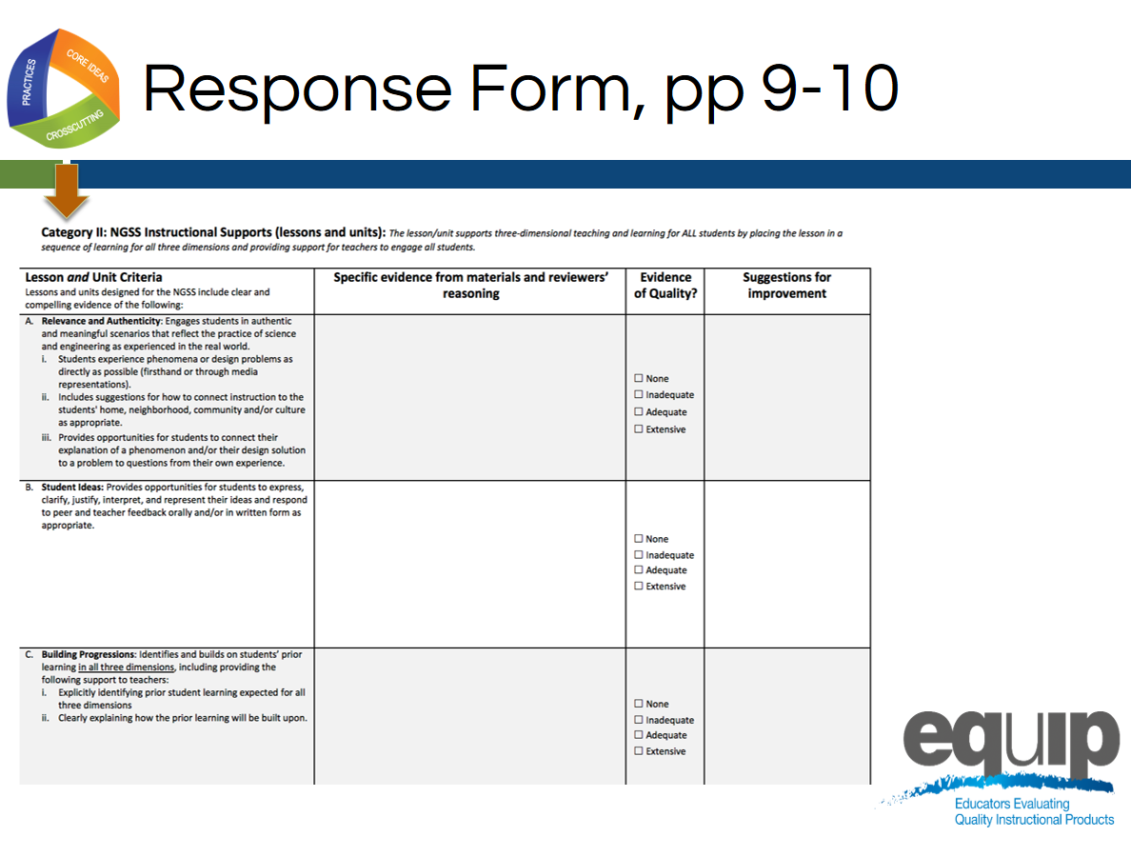
Slide 168
Talking Points
- The response form for Category II is located on pages 9 and 10 of your rubric document. Please note that this slide only shows page 9 of the response form, but you will need both page 9 and page 10.

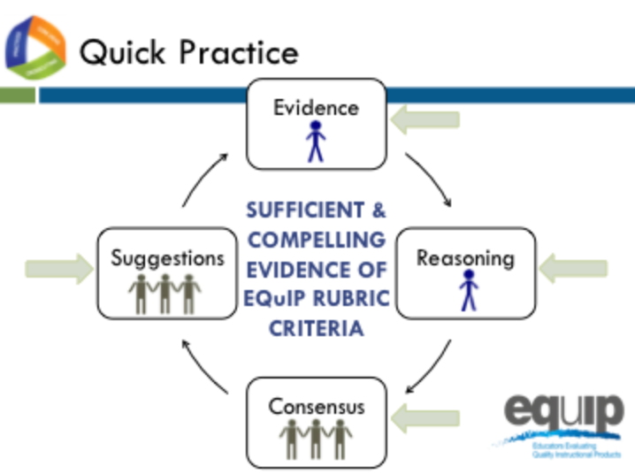
Slide 169
Talking Points
- For this quick practice you will need:
  - The response sheet for Category II;
  - The common lesson provided for this practice, Urban Heat Final Version; and
  - A pen or pencil to code the evidence you find with the Arabic or Roman numerals associated with the specific criteria and/or sub-criteria that the evidence supports.
- Please note that for this practice you will be examining the lesson for criteria A through E for a lesson.
- As you work through this practice, follow the same process you used earlier when examining a lesson or unit for three-dimensional learning, explaining phenomena, and coherence:
  - [Note to facilitator: Click for animation.] First, individually look for the evidence in the lessons or unit. Use the Arabic and Roman numerals associated with the rubric criteria to code the evidence you locate.
  - [Note to facilitator: Click for animation.] Next, still individually, determine how the evidence fits together and connects to one or more criteria.
  - [Note to facilitator: Click for animation.] Then, as a group, examine this evidence and reasoning and collaboratively make evaluations about whether or not the lesson or unit provides sufficient and compelling evidence of the criteria, and assign evidence of quality ratings for each of the criteria as well as for each category.
  - [Note to facilitator: Click for animation.] Finally, make suggestions for how the lesson or unit might be improved.
- You have 30 minutes for this task. Remember, you’re examining the lesson for criteria A through E for Category II.
- If your group finishes early, use the extra time to think about and discuss this question: “What are the implications if a lesson or unit does not meet the criteria for Category II?” [Note to facilitator: Set the timer for thirty minutes, but monitor the groups to determine if they need more or less time to complete the practice before moving on.]
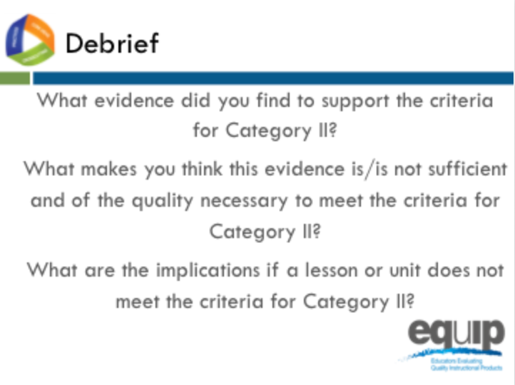
Slide 170
Talking Points
- So what determinations did you make at your tables? Does this lesson meet the criteria in Category II for criteria A through D?
- How? Why or why not? [Note to facilitator: Allow several tables to share.]
- What about for Criterion E? How or why not? [Note to facilitator: Allow a few tables to share.]
- What are the implications if a lesson or unit does not meet the criteria for Category II? [Note to facilitator: Allow a few tables to share.]

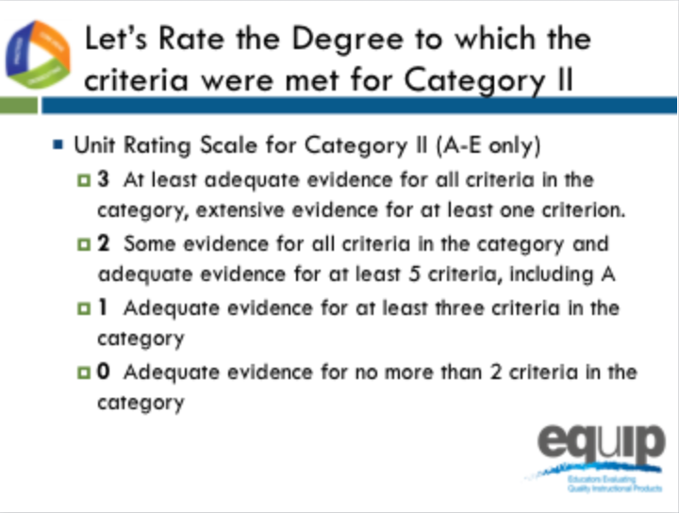
Slide 171
Talking Points
- Let’s rate the degree to which the criteria were met in Category II.
- Let’s only consider criteria A–E since we are examining a lesson, not a unit.
- At each table, let’s review the evidence of quality for categories A–E. Then, as a group, let’s determine a rating for Category II using the language on page 10 of the rubric.
- Notice that the possible ratings fall across a 0–3 scale.
- Facilitator, give groups about 5 minutes to discuss evidence of quality for each category A–C and determine a Category rating.
- By a show of fingers, would table facilitators indicate how many of the criteria you found at least adequate evidence of in the lesson? [Note to facilitator: Do a quick summary of the room and announce a consensus response.]
- Let's take a quick poll of the room, what rating did your group give to Category II? [Note to facilitator: Quickly survey the room by asking for a response from each group, and discuss a consensus answer.]

Concluding Slide for Module 8
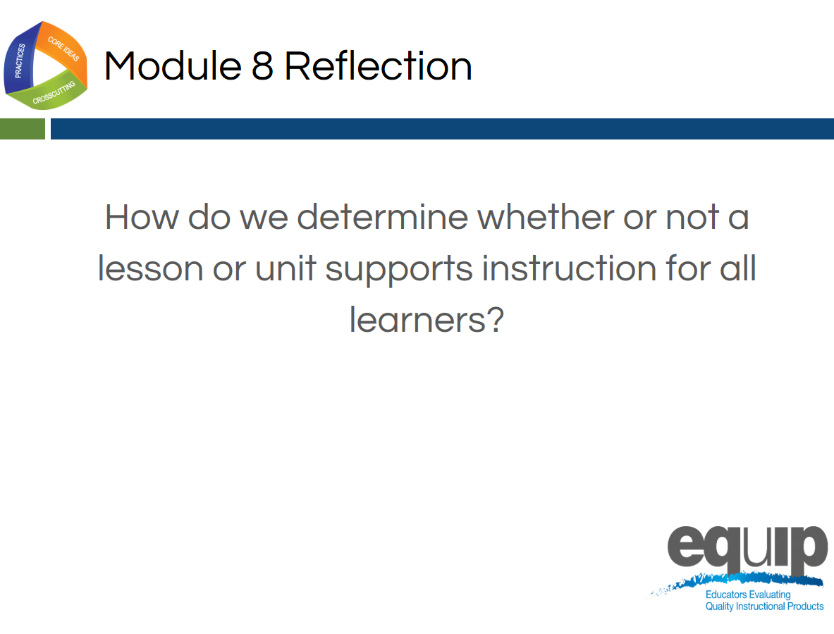
Slide 172
Talking Points
- Providing the kinds of instructional supports that allow all students to access the NGSS and engage in three-dimensional learning is very important.
- As a result of this module, you should feel comfortable using the rubric to determine whether or not a lesson or unit meets the criteria in Category II.
  - Are there any questions or additional comments before we move on? [Note to facilitator: Address question or comments if they arise.]

