MODULE
NGSS EQuIP
4
Overview of
the EQuIP Rubric
Module 4: Overview of the EQuIP Rubric
Module 4 provides an overview of the EQuIP Rubric including a background on its development, the purposes of the rubric, and basic information about its structure and contents. This module also includes information on the quality review process — a collegial process that centers on the use of the criteria-based rubric for examining science lessons and units — including the agreements required for participating in the review.
Materials Needed
- Module 4 PowerPoint slides or slides 38–48 of the full PowerPoint
- Handout 5: Module 4, Slide 42, “EQuIP Agreements” (1 page)
- Handout 6: Module 4, Slide 43, “EQuIP Rubric, Version 2” (4 pages)

Introduction to Module 4
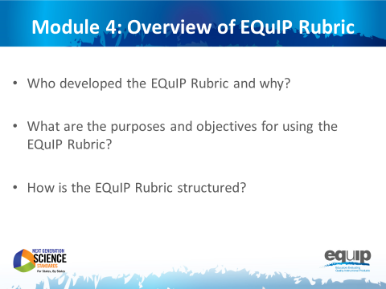
Slide 38
Talking Points
- In Module 4, we will begin looking at the EQuIP Rubric so that all participants will be able to answer the following questions confidently:
  - Who developed the EQuIP Rubric and why?
  - What are the purposes and objectives for using the EQuIP Rubric?
  - How is the EQuIP Rubric structured?

History of the EQuIP Rubric
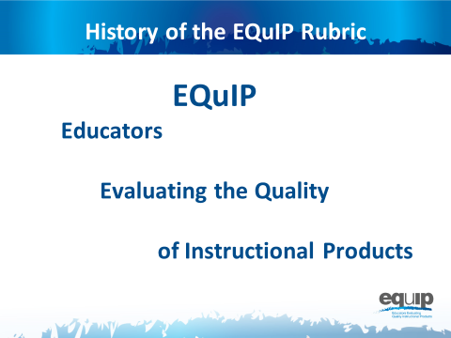
Slide 39
Talking Points
- EQuIP stands for Educators Evaluating the Quality of Instructional Products.
- The original criterion-based rubrics and review processes were developed to evaluate the quality of lessons and units for the CCSS for ELA/literacy and mathematics.
- The original ELA/literacy and mathematics rubrics were known as the Tri-State Rubrics because they were developed through a collaborative effort by Massachusetts, New York, and Rhode Island.
- This initial collaboration was facilitated by Achieve. There was so much interest in the rubric that Achieve facilitated a convening of states that wanted to learn more about the rubrics and use them to identify high-quality, aligned materials. The original states using the rubric were deemed the EQuIP Collaborative and the rubrics became known as the EQuIP Rubrics. Many more states have learned about and used the EQuIP Rubrics for ELA/literacy and mathematics since the original collaborative.
- EQuIP for NGSS builds on the work of EQuIP for CCSS and has been developed to be similar to the EQuIP Rubrics for CCSS while, at the same time, addressing the specific needs of the science standards.
- The development of the EQuIP Rubric for NGSS was managed by Achieve in partnership with NSTA. It was written and reviewed by science education experts in several states, CCSS EQuIP developers, standards writers, and other science and engineering education experts.
- The EQuIP Rubric for NGSS also has been tested with teacher focus groups.

Purposes and Objectives of the EQuIP Rubric
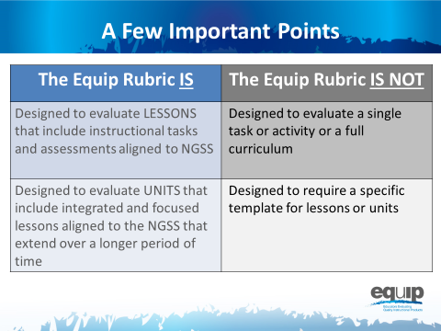
Slide 40
Talking Points
- As defined by the EQuIP Rubric:
!
  - A lesson is a coherent set of instructional activities and assessments aligned to the NGSS that may extend over a few to several class periods or days; and
  - A unit is a coherent set of lessons aligned to the NGSS that extend over a longer period of time.
- An integrated instructional sequence is rooted in an explanatory question aimed at making sense of a phenomena and/or designing a solution to a problem.
- With these definitions in mind, it is important to note that the lessons the EQuIP Rubric is designed to evaluate may extend over a few class periods or days.
- Any single task, activity, or mini-lesson would not be suitable for use with the EQuIP Rubric as it would likely not include instructional supports and assessments, two of the categories of the rubric.
- Likewise, the EQuIP Rubric is not appropriate for reviewing a full curriculum; however, the rubric could be used to review specific lessons or units within the curriculum. A tool is currently being developed to look at full curricula.
!
- Finally, the EQuIP Rubric does not require that lessons or units be put into a specific format in order to be evaluated against the rubric criteria.
Slide 41
Talking Points
!
- The EQuIP quality review process is a collegial process that centers on the use of the criterion-based rubric for examining science lessons and units.
- While an individual certainly might use the rubric to examine a lesson or unit, the effective evaluation of lessons and units is the product of examination and discussion by a group of people using the rubric collaboratively.
- The specific, stated purposes of the EQuIP rubric are to:
  - Review existing lessons and units to determine what revisions are needed;
  - Provide constructive criterion-based feedback and suggestions for improvement to developers;
  - Identify exemplars/models for teachers’ use within and across states; and
  - Inform the development of new lessons and units.
- Other implicit goals of the rubric include:
  - Assisting teachers and district staff in the selection of high-quality instructional materials that are aligned to the NGSS; and
  - Serving as a professional learning tool for analyzing lessons and units and deepening understanding of the NGSS.
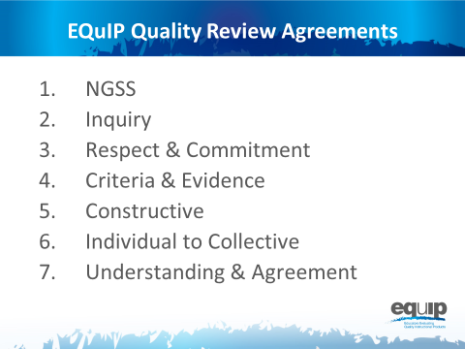
Note to facilitator: Refer participants to Handout 5, Module 4, Slide 42, “EQuIP Agreements.”
Slide 42
Talking Points
- All persons using the EQuIP Rubric to examine NGSS lessons and units must commit to the following agreements:
  - NGSS Understanding: Before beginning a review, all members of a review team have an understanding of the NGSS and the Framework.
  - Inquiry: Review processes emphasize inquiry rather than advocacy and are organized in steps around a set of guiding questions.
  - Respect and Commitment: Each member of a review team is respected as a valued colleague and contributor who makes a commitment to the EQuIP process.
  - Criteria and Evidence: All observations, evaluations, discussions, and recommendations are criterion- and evidence-based.
  - Constructive Feedback: Lessons and units to be reviewed are seen as “works in progress.” Reviewers are respectful of contributors’ work and make constructive observations and suggestions based on evidence from the work.
  - Individual to Collective Reviews: Each member of a review team independently records his/her observations prior to discussion. Discussions focus on understanding all reviewers’ interpretations of the criteria and the evidence they have found.
  - Understanding and Agreement: The goal of the process is to compare and eventually calibrate evaluations to move toward agreement about quality with respect to the NGSS.
- A rule of thumb for maintaining a respectful, collegial discussion might be to behave as if someone at your table has written or collaborated on a lesson or unit you are examining. Sometimes this may even be the case.
The Three-Category Structure of the Rubric
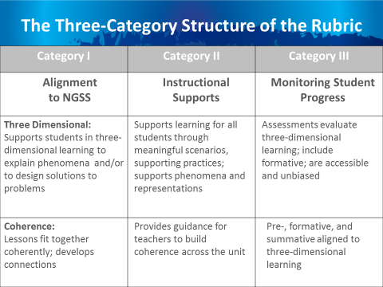
Note to facilitator: Refer participants to Handout 6, Module 4, Slide 43, “EQuIP Rubric.”
Slide 43
Talking Points
- Get out your copy of the EQuIP Rubric.
- Before we begin talking about the structure of the EQuIP Rubric, turn to page four of the rubric — the back of the second page — and take a few minutes to circle important terms that jump out at you as you read through the document. [Note to facilitator: Allow three to five minutes for participants to circle terms then ask several to share. Keep this sharing non-evaluative and avoid responding to participants with words such as “good” or “great,” which tend to signify right or wrong answers.]
- Now let’s dive deeper into the rubric.
- All educators will examine instructional materials against the criteria in each category.
- As you can see, each category is structured with criteria for a lesson or unit at the top and additional criteria for a unit or longer lesson at the bottom.
- Within each category, specific criteria and sub-criteria are delineated, with uppercase Arabic letters (A, B, C, etc.) representing the main criteria and lowercase Roman numerals (i, ii, iii, etc.) representing the sub-criteria.
- Working collaboratively, educators are able to use common standards for quality and to generate evidence-based commentary on the quality and alignment of materials.
- A rating scale will eventually be added to each category as well as to the entire rubric. However, during this early stage of NGSS implementation the focus should be on creating materials or transitioning materials to be more aligned with the NGSS as opposed to assigning materials a rating.
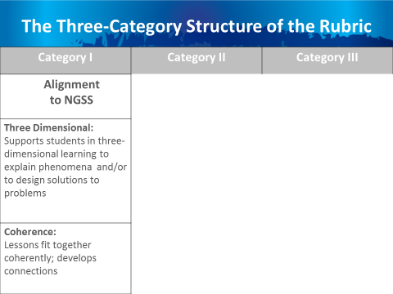
Slide 44
Talking Points
  - The first category is Alignment to NGSS. This includes supporting students in three-dimensional learning to explain phenomena or design solutions and ensuring lessons fit together coherently and develop connections.
- We will use the EQuIP Rubric to examine NGSS materials — lessons and units — carefully and in detail to determine whether or not they align with the conceptual shifts of the NGSS, including Category I, criteria A, which states that “grade-appropriate elements of the science and engineering practice(s), disciplinary core idea(s), and crosscutting concept(s) work together to support students in three-dimensional learning to make sense of phenomena and/or to design solutions to problems.”
- Examining a lesson or unit against the criteria in Category I: Alignment to NGSS, may reveal evidence related to Category II: Instructional Supports and/or Category III: Monitoring Student Progress; however, the EQuIP process involves examining a lesson or unit against the criteria for Category I before moving on to Category II and finally to Category III.
- If, as a result of examining a lesson or unit in relation to the criteria for Category I, we determine this alignment does exist, we will then examine that lesson or unit further in relation to the criteria for Categories II and III.
- If, however, we determine this alignment does not exist, we may elect to discontinue any examination of the lesson or unit; or, if we determine that a lesson or unit has the potential to align with specific, targeted revisions, we may continue with our examination and provide guidance for the lesson or unit designer or user in regard to the changes that need to be made to bring the lesson or unit into alignment.
- Tricia Shelton, science teacher at Boone County Schools in Kentucky, explains this further in this short video.
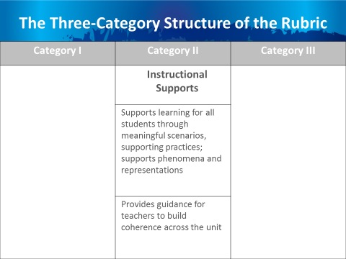
Slide 45
Talking Points
  - Now let’s look more closely at Category II: Instructional Supports. Category II focuses on supporting learning for all students through meaningful scenarios and supporting practices, as well as supporting phenomena and representations. Criteria and sub-criteria focus on engaging students in three-dimensional learning that is relevant, authentic and connected to students’ experiences.
  - In addition, this category includes criteria related to providing guidance to help teachers build coherence and to provide and adjust supports for students in order to make students increasingly responsible for their learning.
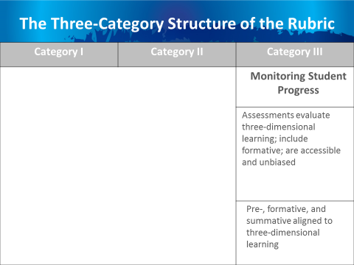
Slide 46
Talking Points
  - The third category, Monitoring Student Progress, ensures that assessments elicit observable evidence of three-dimensional learning, include formative assessments, and are accessible and unbiased.
  - It also ensures that all assessments — pre-, formative and summative — are aligned to three-dimensional learning.
Slide 47
Talking Points
- By working collaboratively, educators can use common definitions of quality to generate evidence-based commentary on the quality and alignment of materials.
- We’ve just begun looking at the EQuIP Rubric by examining how it’s structured. Each of these three categories of the EQuIP Rubric will be discussed in greater detail in subsequent modules.

Concluding Slide for Module 4
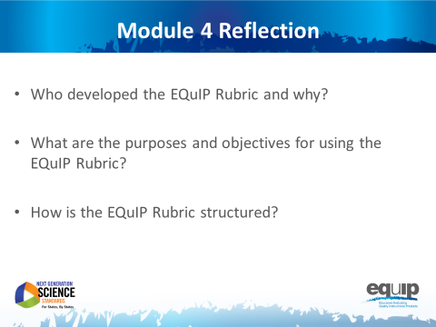
Slide 48
Talking Points
- Take a minute or two to look over the EQuIP Rubric again, noting the words you circled at the start of this module.
- Would you still circle the same words? Are there words you wouldn’t circle? Are there more words you would circle? Why or why not?
- How has what you’ve learned in this module informed your understanding of the EQuIP Rubric? What questions do you still have? [Note to facilitator: After three to four minutes, allow participants to share their thoughts and ask any remaining questions.]
- In the next module, we’ll take a look at what we mean when we talk about such things as evidence and reasoning in relation to using the EQuIP Rubric.

