MODULE
NGSS EQuIP
5
Providing
Feedback, Evaluation, and Guidance
Module 5: Providing Feedback, Evaluation, and Guidance
Module 5 provides common language that is essential for using the rubric. The terms evidence, reasoning, feedback, evaluation, and guidance are often used in the rubric and in the remaining modules; therefore, it is important for all participants to have a common understanding of these terms before moving on.
Materials Needed
- Module 5 PowerPoint slides or slides 49–57 of the full PowerPoint
- Handout 6: Module 4, Slide 43, “EQuIP Rubric, Version 2” (4 pages)*

*Introduced in a previous module.
Introduction to Module 5
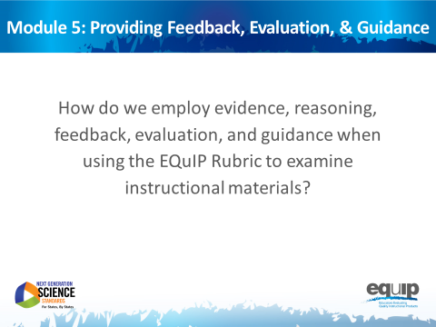
Slide 49
Talking Points
- Before we actually use the rubric to examine a lesson or unit, it’s important to take time to agree on what we mean by some of the language we’re using.
- While it’s easy to assume that everyone means the same thing when, for example, we talk about evidence, in reality people often have different ideas about what constitutes evidence and what does not.
- So, for the purpose of using the EQuIP Rubric to examine lessons and units, we need to develop a common understanding of specific terminology.
- Once we have a common understanding of the terms we’ll be using frequently, we can then begin to use the rubric to examine lessons and units.
- Before we begin, take three to five minutes at your tables to talk about what you think each of these terms means:
  - Evidence
  - Reasoning
  - Feedback
  - Evaluation
  - Guidance
[Note to facilitator: Allow three to five minutes before going on.]
- We’re not going to share your ideas here, but as we talk about how we will use these terms with the EQuIP Rubric, compare and contrast your initial perceptions with the ways we’re actually going to use these terms with the rubric to examine lessons and units.
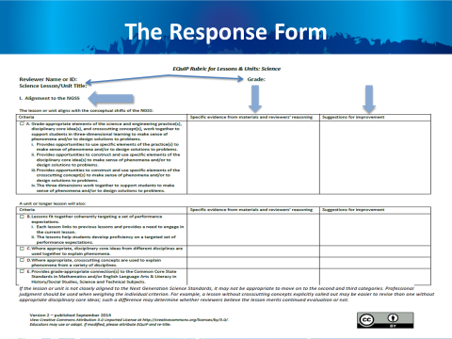
Slide 50
Talking Points
- Before we talk about the terms, let’s take a quick look at the response form section of the rubric. This begins on the page five of the rubric document.
- When using the response form, you will first record your name as the reviewer, the title of the lesson or unit, and the grade level for which the lesson or unit is intended at the top of the form. [Note to facilitator: Click for animation.]
- The first column of the response form lists the category and the criteria to which you are responding. [Note to facilitator: Click for animation.] The example on this slide shows Category I. Subsequent pages of the response form have Categories II and III.
- As you examine instructional materials, the second column of the response form is used to record evidence and reasoning. [Note to facilitator: Click for animation.]
- Finally, the last column of the form is used to record suggestions for improvement. [Note to facilitator: Click for animation.]
- Now let’s take a look at what these terms mean when we’re using the EQuIP Rubric.
- Again, as we look at how we will use these terms with the EQuIP Rubric, think about your initial perception of the meanings of these words and how these initial perceptions are similar to and/or different from how we’re going to use the terms with the rubric.

Defining Terms
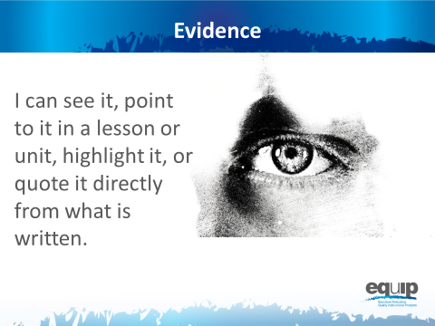
Slide 51
Talking Points
- Now we’re ready to determine a common understanding of what we mean when we talk about evidence.
- What should we be recording when we’re looking for evidence?
!
- Evidence is what is stated or described explicitly in a lesson or unit. If it is evidence, you can see it, point directly to it in the lesson or unit, highlight it, cite it, or quote it directly from what is written.
- When using the EQuIP Rubric, it is essential look for evidence of the different criteria in the lesson or unit itself before we start putting that evidence together to evaluate the lesson or unit.
- On a cautionary note, it is very common to want to “fill in the blanks” in a lesson or unit and add what we think the developer intended or what we would do if teaching the lesson and call it evidence; but to be very clear, we can only examine what we can see. If it’s not there, we cannot add it in and call it evidence. Think, for example, of asking a student to evaluate an argument. Students should only evaluate the argument as it exists and not “fill in the blanks” about what they think the person who made the argument intended. It is tempting for students to want to apply their own experiences and understanding to fill in the blanks, but the application of their expertise is better suited for making suggestions about how to improve the argument. Likewise, you cannot make assumptions about a lesson or unit developer’s intentions. Evidence must be explicitly stated in the materials you are examining. Later in the process, you will use professional judgment to decide whether the evidence is sufficient to say the criteria have been met and to make criterion-based suggestions for improvement. But for the purpose of finding evidence, it is essential to consider only what is explicit in the lesson or unit.
!
!
- In addition, it’s also common to skip right over the evidence and move directly to making judgments about whether or not a lesson or unit meets the rubric criteria or to offering suggestions on how to improve the lesson. We need to be careful to avoid this pitfall.
- Before we go on, let’s listen to Joe Krajcik address the importance of identifying evidence before determining whether a criterion has been met in this video.
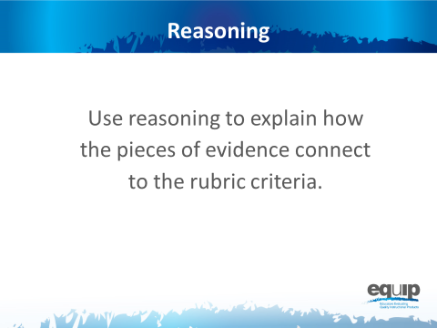
Slide 52
Talking Points
- Once we’ve located evidence of the criteria we’re looking for in a lesson or unit, we then use reasoning to explain how that evidence connects to the criteria in the rubric.
- Again, at this point we’re not yet evaluating whether the evidence is sufficient to say that the lesson or unit aligns to the NGSS in terms of three-dimensional learning or other criteria. We’re just stating that “x is an example of modeling”; “modeling is a science and engineering practice”; “so, therefore, this lesson/unit includes a science and engineering practice.”
- It’s important to reason through these connections because it’s not at all uncommon for different people to see the same exact thing in a lesson or unit without making the exact same connections to the rubric criteria.
- We use reasoning to put the different pieces of evidence we find in the lesson or unit together and then to connect that evidence to the rubric criteria so that we can, ultimately, work collaboratively to evaluate the lesson or unit.
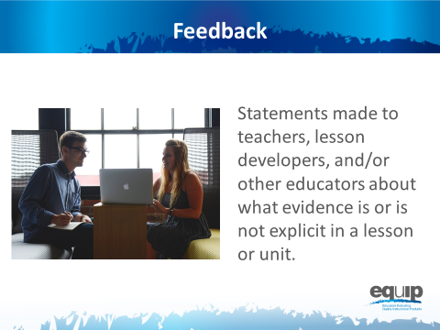
Slide 53

Talking Points
- In essence, feedback refers to statements made to teachers, lesson and unit developers, or other educators about what evidence is or is not explicit in a lesson or unit. Feedback is always criterion-based.
- Feedback may also include reasoning that explains how the evidence we see connects to one or more criteria in the rubric itself. For example, we might say something like, “Having the students develop a representation that presents a causal account to show that plants have similar life cycles is an example of modeling, and since modeling is one of the science and engineering practices, this lesson does include practices.” We may have similar evidence and reasoning for core ideas and crosscutting concepts.
- It also is critical to address whether the three dimensions are working together. For example, we might say something like, “Though each of the dimensions is present, they are each in isolation. I see no evidence that they are working together for three-dimensional learning.” In both of these examples we’re just stating what is or what is not explicit in the lesson or unit but not yet concluding whether or not the evidence is sufficient or of the quality necessary to state whether or not the lesson aligns with the NGSS.
- While it’s not uncommon to lump feedback, evaluation, and guidance together when making comments about a lesson or unit, it is important to be cognizant of how they are different from one another. We’ll talk more about evaluation and guidance in this module.
- For now, if we want to provide good feedback, we need to locate evidence determine how that evidence connects to the criteria on the rubric, and share this with the developer of the lesson.
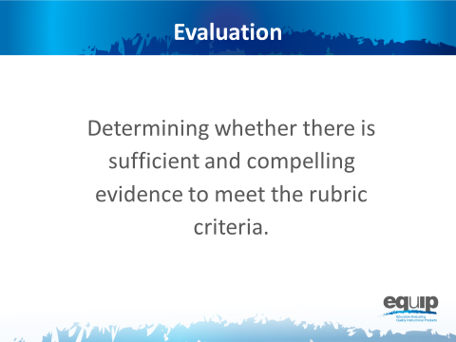
Slide 54
Talking Points
- Only after a group of people has individually examined a lesson or unit, identified the evidence of specific criteria in that lesson or unit, and used reasoning to establish the connections between the evidence and the criteria, can these individuals share their findings with the group. Then they can collaboratively determine whether they have sufficient and compelling evidence to say that the lesson or unit meets the rubric criteria and to check the boxes next to these different criteria on the response form.
- These evaluations can range from such things as whether something is an appropriate or sufficient example of a practice, a core idea, or a crosscutting concept; to whether the practices, core ideas, and crosscutting concepts in a lesson or unit work together appropriately to support students in three-dimensional learning; to whether the three dimensions actually function effectively to help students make sense of phenomena and/or design solutions to problems.
- Note that evaluation differs from reasoning as we defined it previously. Reasoning just makes the connection between the explicit evidence and what that evidence represents—for example, practices, disciplinary core ideas and/or crosscutting concepts. In this step, we evaluate whether the evidence is sufficient and compelling enough to say, for example, that the practices, disciplinary core ideas and crosscutting concepts work together to support students in three-dimensional learning to make sense of phenomena and/or design solutions to problems — in other words, sufficient and compelling enough to meet the stated rubric criteria.
!
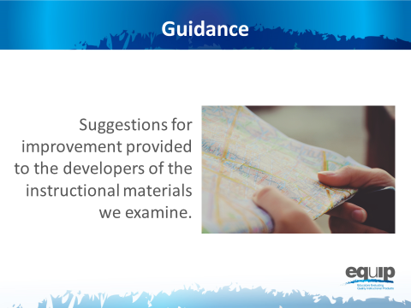
Slide 55
Talking Points
- Finally, guidance refers to those suggestions for improvement that we provide to the developer of the lessons or units we are examining. These suggestions for improvement go in the third column of the response form. Feedback — statements about what is or is not in the lesson or unit — often provides the basis for suggestions for improvement.
- These suggestions should be stated positively as actions to be taken rather than statements about what is wrong with the lesson or unit.

Concluding Slides for Module 5
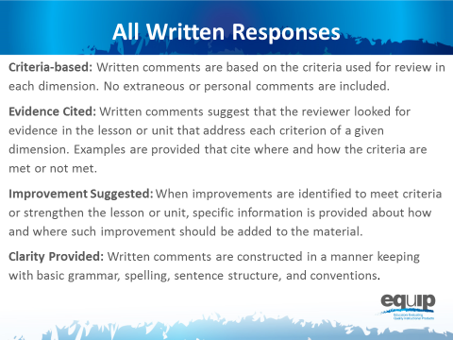
Slide 56
Talking Points
- Regardless of whether the comments provided on the response sheet are feedback, evaluation, or guidance, all comments should adhere to the following guidelines:
  - Be Criteria-Based: Written comments are based on the criteria used for review in each dimension. No extraneous or personal comments are included.
  - Cite Evidence: Written comments suggest that the reviewer looked for evidence in the lesson or unit that address each criterion of a given dimension. Examples are provided that cite where and how the criteria are met or not met.
  - Suggest Improvement: When improvements are identified to meet criteria or strengthen the lesson or unit, specific information is provided about how and where such improvement should be added to the material.
  - Provide Clarity: Written comments are constructed in a manner keeping with basic grammar, spelling, and sentence structure conventions.
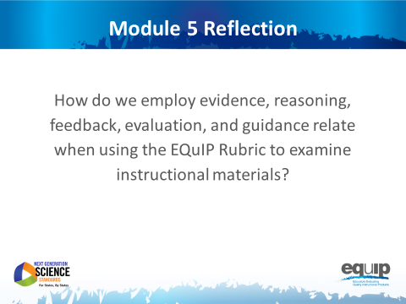
Slide 57
Talking Points
- In the next module, we’ll actually apply these definitions and examine a short lesson.
- Now, look back on the definitions you came up with at your tables at the beginning of this module. Has your understanding of these terms changed? What are the most important differences between what you thought at the beginning of this module and what you now know about how we’ll be using these terms with the EQuIP Rubric? [Note to facilitator: Have participants share as time allows.]

